Bible Study Methods
Part 016 - Observing God’s Word - WHAT DOES IT SAY?

Leaders Notes

Lesson Purpose
The purpose of this lesson is to model how to study the Bible through the inductive Bible study principle of “observation.”

Main Points
- Successful Bible study should be surrounded by prayer.
- Context is extremely important.
- There are six key questions to ask about any passage.

Desired Outcomes
- When the content of this lesson has been mastered, each participant should:
- Know how to prepare inductive Bible study observation questions.
- Be committed to study the Word of God diligently.

Suggestions to Leaders
This lesson is followed by a one-hour workshop that will focus on applying the principles of observation.
This lesson includes sample observation questions for Jeremiah 1. You should emphasise the kinds of questions asked, because the trainees will be required to make up their own questions in the workshop lesson.

INTRODUCTION
All Christians need to be able to study the Bible for their own spiritual growth as well as for the growth of those under their spiritual care.
Nobody can do that of us - to grow we need to study the word. You may be hoping to grow without that - not going to happen.
God has given every believer the Holy Spirit to be his or her principal teacher.
Let us never forget the importance of our dependence upon God’s Spirit to teach us and to empower us to obey what we learn. With God’s help, it is possible for every believer to understand the Bible, even if the only book we have is the Bible.
In addition, God has given some people the special role of helping His people discover the truths of Scripture and apply them correctly to their lives. It is especially important that a church leader knows how to help others discover God’s truth through Bible study.
One of the best ways to systematically discover, understand, and apply God’s truth is the “Inductive Bible study method”.
We looked at this method last time and compared it to the Deductive method.
The Deductive Method starts with something we know to be true and then finds an argument that backs that up. The trouble with it, is if our “fact” is incorrect, then our conclusion will be incorrect.
Inductive starts with the text and uses it to form what we know to be true. If we take the inductive view we are more open to the text changing us and challenging us, rather than just finding alienation for what we already thought.
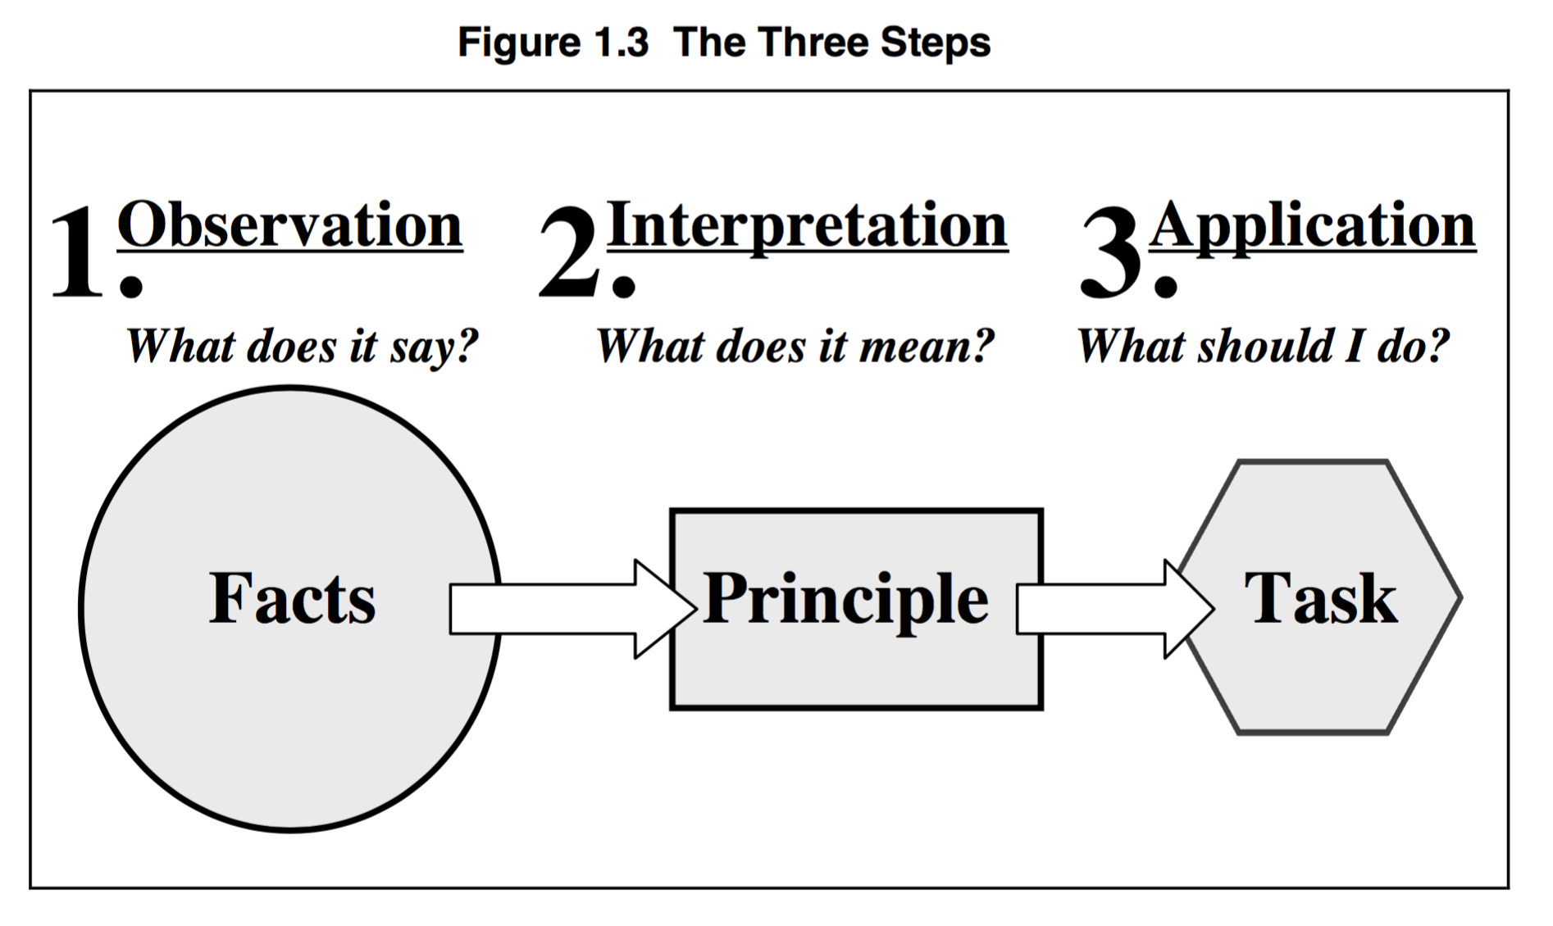
The inductive Bible study method leads to this process of discovery through three basic steps that are called “observation”, “interpretation”, and “application.”
Observe - what does it say? That’s the facts. Not what do we think it says, but what is there. We start with observation.

Interpret - this is where we ask what it means. What did it mean at the time it was written - how does the principle translate to today? It’s from here we find the biblical principle.

Apply - what do I do with this? How can this principle be used in my life - study without application is pointless.

The Holy Spirit teaches us, but God also expects us to study His Word diligently using all the resources He has put at our disposal.
We should never choose between studying hard or depending on the Holy Spirit—both are important!
This lesson focuses on the first step of inductive Bible study—observation. As we go through and look at some examples, remember the focus is to observe. We won’t be interpreting anything or asking what it means - just what does it say - what is the context?
As the previous lesson stated, observation is like the base of a pyramid. If we do a thorough and careful job of observation, the resulting interpretation and application will be much more accurate.
It’s tempting to skip this and go straight to the interpretation - but if you don’t have a solid foundation you have a shaky conclusion.
Our goal should be to understand exactly what God wants us to know and do, and therefore observation is a critical step in the process.

- OBSERVATION—WHAT DOES THE TEXT SAY?
Observation concerns the details and facts that are seen in a selected Bible passage. It answers the question “What does the text say?”
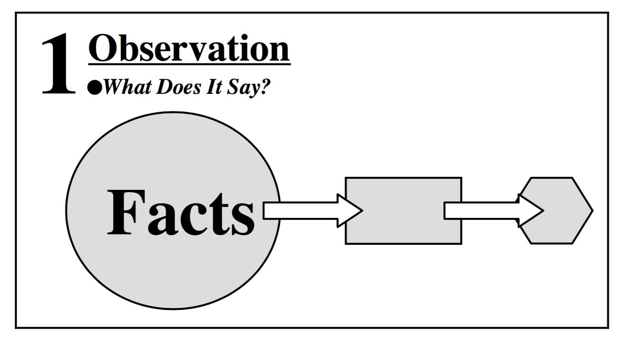
It clearly shows the people, places, events, circumstances, objects, time, relationships, personal opinions, ideas, etc., which were in the writer’s mind and the context when the text was written.

Students of secular classical literature have spent countless hours trying to decipher the meaning of great texts written by men.
In many cases, this process has continued for hundreds or even thousands of years since the writing of the texts, with new understanding constantly emerging. Take a minute to think about some of the great classical authors of your country, and the search for the meaning of their writings.
Our English literature classes that we all had to do at school were just about doing that.
If this effort is warranted, how much more we should strive to understand the living, active, bottomless Word of the Almighty God.
To quickly read a Bible passage, and assume that we understand it completely is utterly foolish.
There is always more to understand.

Prepare for Observation
Since the Bible is the inspired Word of God, we cannot approach it like any other book. There are several factors that will affect whether or not we understand it.

Belief
The Scripture says that a “man without the Spirit” cannot understand the things that come from God (1Co 2:14).
Since only those who have repented of their sin and trusted Christ for salvation have the Holy Spirit, an unbeliever cannot fully comprehend the Bible.
This does not mean that only believers may be involved in a Bible study. It does mean that when unbelievers are present, they are limited in what they will be able to understand.
The Holy Spirit desires to show them the truths of sin, righteousness, and judgment from the Word, in order to lead them to salvation. Therefore, a Bible study for unbelievers should focus on the basic truths of the Gospel.

Prayer
Proper Bible study will always be surrounded by prayer.
Before starting the study, we should pray and confess any sin or other obstacle that prevents us from learning from the Word.
We should also pray for enlightenment (Ps 119:18; Eph 1:18).
During our study, it is also helpful to pray for clarity whenever we see something that we do not understand.
And finally, when we have finished the study, we should pray about how God would have us apply what we have learned to our own life and to the lives of others.

Readiness to Obey
James tells us that we must not only listen to the Word, but also obey it (Jas 1:22-25).
Jesus also said that putting His words into practice was like building a house on a rock (Mt 7:24). Not obeying them, however, was like building on sand (Mt 7:26).
In fact, Jesus seems to say that giving spiritual truth to those who are not willing to obey it is as foolish as giving pearls to pigs (Mt 7:6).
God is very serious about how we respond to His Word. The more we know, the more severely we will be judged.

Self-examination
It is true that a pastor is responsible to teach the Word to others.
We are told to “feed the sheep” (Jn 21:17). But this does not excuse him from first applying it to his own life.
Every good cook samples the food as it cooks to determine whether or not it is ready to serve to others. At the very least, we should always look for application to ourselves, even when our goal is to preach to others.
However, it is even more profitable if we also partake heartily of the meal, rather than just sample it.
The student of the Scriptures should never feel that he or she has reached the point of understanding the Word fully—this is not possible.
It is much better to be a “learner,” growing daily through study of the Word and prayer, than to masquerade as an “expert.”
A teaching ministry will be more rich and rewarding if the teacher is sharing out of the abundance of truth that he or she is learning from the Lord on a daily basis.

Willingness to Learn
Approach the Scriptures with an open mind. Be willing to let God teach you what His Word really says. Always be willing to expose your personally held belief to the light of God’s Word. Don’t be afraid of changing your viewpoint if God’s shows you the truth about an issue.

Take Enough Time
There are some proven principles for understanding the general focus of the passage. If the process is rushed, the result will be a shallow understanding of the text.
It is important to exercise the patience and determination to keep working until the text is understood.
The first step is to read the text over several times to get an overall understanding of the passage. This takes time, but bears much fruit.
There are many passages where it is easy to get bogged down in details unless you can discern the general theme through several readings.
A good understanding of the passage’s overall focus will help you to keep a proper balance and divide your time appropriately for the different parts under study.

Look at the Context
The term ‘context’ refers to the verses that surround the passage being studied. Understanding the context is one of the most valuable tools of Bible study, and yet it is often ignored.
When you take verse out of context you can make it say almost anything, including endorsing slavery.
When we look at the context, we are seeking to understand what is the theme or subject of the book, chapter, and paragraph of the verses that we are studying. Looking at the context means examining.

- What do the preceding and following verses talk about?
- What is the theme of the paragraph?
- What is the theme of the chapter?
- What is the purpose and theme of the book?
- Is the passage in the Old or New Testament and what does this mean?

A good example of the importance of context is Philippians 4:19, where Paul promises that God will “meet all your needs.”
Many understand this to be an unconditional promise to everyone. Many would recognise that since Philippians is written to believers, this promise is only for Christians.
However, a more in-depth study of the context reveals that Philippians is a “thank-you letter” to the Philippian church for the gift they sent to Paul through Epaphroditus.
The context of chapter four is specifically talking about this generous gift that they had sent to Paul out of their poverty.
The context of verse 18 shows that God was pleased with this gift. Therefore, the context indicates that verse 19 is a promise to those who have sacrificed to financially support a missionary church planter (Paul) who was preaching the Gospel to the lost (in Rome, at that time).
Does that mean it can’t apply to more? Well, we can get to that with interpretation - but in observing we just ask that question about the original context.
Some Bibles have notes before each book that explain what the particular book is about. These can be helpful.
There are also other commentaries and books available that discuss the setting and background of a particular Bible book or chapter. However, it is better to limit the use of these resources until the interpretation stage.
There is no substitute for reading the Scriptures yourself and allowing them to speak to you with the guidance of the Holy Spirit. During the observation stage, focus on what you see in the passage and the context.
Take the time to listen to God before you move on to the commentary of men, even if they might be gifted teachers or authors.
Observing the context involves reading more than just the passage being studied—it includes the surrounding verses, chapter, or book.
We step back and look at the passage from a distance before we move in for a closer look. Insights and notes about the context should be carefully recorded. They will be of major importance in the interpretation stage.

Examine the Structure
Having looked at the passage from a distance, it is now time to look more closely. Read the passage several times, looking for and recording any of the following details of the structure:

Key words - Note any word or words that are repeated. Often this indicates the theme.
Comparisons or contrasts - Is something the same as something else, or the opposite?
Progression of an idea - Does one thing builds upon another? Are they linked to other ideas like a chain?
Verbs – Is there some kind of action? Is there a command we must obey?
Conjunctions - Is something equal to something? Often the conjunction “but” appears in contrast, and the words “like” or “as” may indicate comparison.
Illustrations - Visualize in your mind the thing or action that is being described.
Kind of literature – A passage may be history, prophecy, allegory, didactic truth, logic, parable, or many other possibilities. we shall look at a list of many more of these. Noting the type of literature in the passage will also affect the interpretation in the next stage, so it should be recorded carefully now.

The Language of the Bible
When we study the Word of God, we are looking for its intended, literal meaning. We want to understand the message that the Lord desires to communicate through it.
But it is important to realise that, like all great literature, the Bible writers often used figures of speech to communicate truth.
In addition, they used many different kinds of literature in their writing. Studying the Bible accurately requires that we recognise these differences, and treat each passage according to the kinds of language and literature used.
Not doing this has led in the past to dodgy theology, heresy and the formation of cults. So good to make sure we don’t follow the example.
Some things in the bible MUST be figurative - otherwise only sheep are getting into heaven. But you can’t just make something figurative to fit your need - you have to examine it properly.

KINDS OF FIGURATIVE LANGUAGE IN THE BIBLE

Simile
A simile compares two dissimilar things, using words such as “like,” “as” or “than." Psalm 1 compares the righteous man to a tree planted by streams of water. Both bear fruit and prosper - but a man is not exactly the same as a tree and we know that.

Parable
A parable is a simile in a longer story form. Jesus helped the disciples understand His kingdom by telling a parable about workers who were paid equally though some had worked longer than others had.
He begins with the words, “For the kingdom of heaven is like a landowner who went out early in the morning to hire men to work in his vineyard...” (Mt 20:1).

Metaphor
A metaphor compares two dissimilar things without using obvious words such as “like” or “as." In Jeremiah 1:18, the Lord said to Jeremiah, “Today I have made you a fortified city, an iron pillar and a bronze wall...”

Allegory
An allegory is a long metaphor. In Judges 9:7-15, Jotham tells a story about a worthless thorn bush being king over the other productive trees to describe a corrupt political leader.

Hyperbole
Hyperbole expresses something in extreme terms to make a point.
When Jesus says that a judgmental person has a log in his eye and doesn’t know it, he is saying something that is physically impossible. His point, however, is that a person who is unaware of his own sins is totally unable to evaluate another person’s sins.
If you want another example of Hyperbole, just look at any news headline ever - or any link that asks you to click it on the internet. It always takes it to the extreme.

Sarcasm
Sarcasm criticises by using undeserved or ridiculous praise. Paul criticises the Corinthians’ pride by writing,“Already you have all you want! Already you have become rich! You have become kings – and that without us!” (1Co 4:8).

Deciding when the biblical writers were using language figuratively or literally is serious work.
It would be a grievous error to ignore one of God’s commands by claiming it to be figurative language.
On the other hand, to say that every verse in the Bible should be interpreted literally leads to some perplexing problems.
When the Lord referred to Jeremiah as “a fortified city, an iron pillar and a bronze wall..” He obviously wasn’t speaking in a literal sense (Jer 1:18). The same is true when the Lord said he was appointing Jeremiah to “uproot and tear down, to destroy and overthrow...” (Jer 1:10).
It’s also true in many other places - and be glad about it, otherwise only Sheep will get into heaven!

How can we know the difference between literal and figurative language? You can ask some simple questions like these:

- Does the passage state that it is figurative? (“Listen to another parable…” “The Kingdom of Heaven is like” Mt 21:33).
- Does the passage become absurd or impossible if it is interpreted literally? (“I see a boiling pot, tilting away from the north... from the north disaster will be poured out on all who live in the land...” Jer 1:13-14).
- Does the passage describe God, who is Spirit, as if He had a physical body and other strictly human qualities? (“Then the Lord reached out His hand and touched my mouth..." Jer 1:9).
If the above questions don’t apply, then the verse can most probably be interpreted literally.

KINDS OF LITERATURE IN THE BIBLE
The bible is not just one book - or even one type of book. Therefore we need to always ask a question of what type of book is it we are reading this passage in?

History
The Bible is full of historical accounts and biographies.
For example, the book of Judges tells the history of Israel between the time of Joshua’s conquest of the land and King Saul’s reign.
The book of Nehemiah is Nehemiah’s diary of the rebuilding of the walls of Jerusalem. The Gospels are Jesus’ biographies and include His teachings.
The book of Acts records the significant happenings in the early history of the Church.
Often people can attribute terrible things to the bible - but in the context of a book of History, is description something rather than prescribing something. And there is a huge difference.

Instruction
Throughout the Bible you will find guidelines, commands, principles, proverbs, doctrines and practical advice.
The major part of the book of Leviticus contains detailed instructions for the Israelite priests.
Proverbs gives advice on finances, relationships, and work.
Paul’s letters to specific churches are full of both doctrine and practical guidelines for the Christian life.

Prophecy
Most prophetic literature is a written account of sermons originally preached to God’s people.
Isaiah, Jeremiah, and Ezekiel, the larger prophetic books, are collections of sermons spanning the careers of these prophets.
These books were not meant to be read from start to finish as a single unit.
The secret to understanding these books is finding the beginning and ending of the individual sermons and reading from one sermon to the next.
Nearly all the sermons dealt with the historic periods of the writers. Some of the sermons dealt with the future beyond the lifetimes of the prophets.

Poetry
In the poetic literature of the Bible every human emotion is expressed.
Many biblical books contain poetry. The Psalms and the Song of Songs are entirely poetry and many of the prophetic books are predominately poetic.
Sometimes those writers express feelings that whilst human and understandable are not prescriptive.

Apocalypse
Some prophecy is written in a special kind of literature known as apocalyptic. The word apocalyptic means “unveiling” because it reveals events that will take place in the future.
Apocalypse does not mean destruction, as the world has often misinterpreted it to be. Is means to reveal. The book of Revelation is also called the book of the apocalypse. It’s official called the apocalypse, or the Revelation of Jesus Christ. And that’s what it’s about - Jesus becoming revealed. Yes it’s talking about the end of time - but it’s chief purpose is revealing Christ and His kingdom.
The book of Daniel and the book of Revelation are good examples of this literature. Apocalyptic passages are highly symbolic and it is necessary to understand the symbolism in order to interpret the message.
The central message in apocalyptic literature is the second coming of Christ and his ultimate victory over Satan. Typically, the whole of creation is involved in the coming events.

Ask Questions: Who?, What?, Where?, When?, How?, and Why?

The best method of discovering the content and meaning of a passage of Scripture is to ask key questions about it, and record the answers.
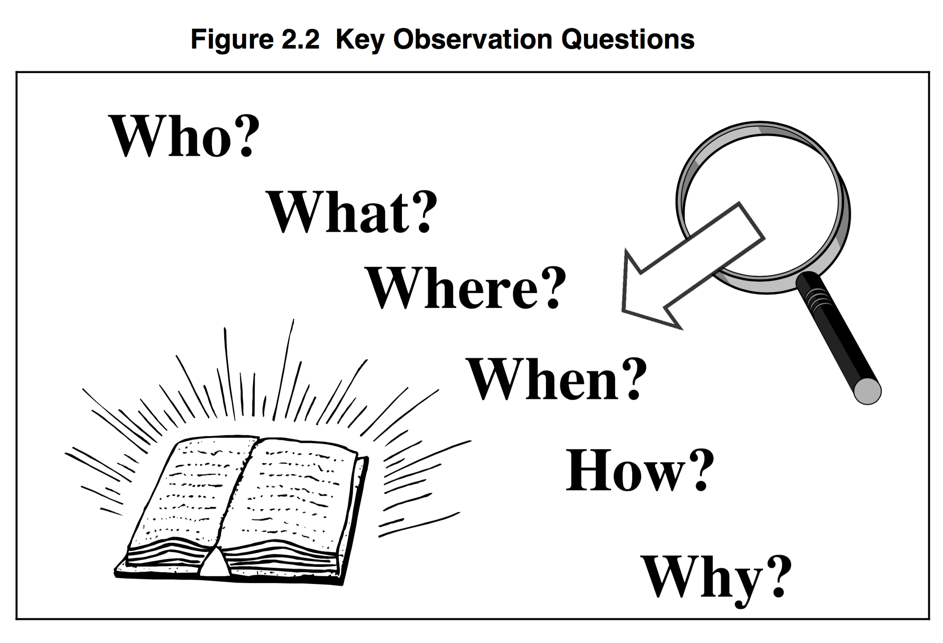
Figure 2.2 shows the six key questions that should be asked and answered.
There are, of course, other possible questions, but these are the most important ones.
Other questions tend to be variations of these six.
Ideally, you should ask every form of these questions that you can think of (the more the better).
Sample variations of these questions are shown in the next section. As you ask questions, carefully record the questions and the answers on a sheet of paper. You will need to refer to them in the interpretation stage.
If you ask a question and cannot find the answer, note the question and come back to it at a later time. Do not disregard those questions. They may be important.
Instead, pray about them, meditate on them, and ask God to show you the answers. Be prepared for this to take time and effort, but it will be worth it when you arrive at a clearer understanding of the passage.
Only then will you be able to apply it with confidence in your own life, and teach “thus says the Lord . . . ” to others.

- SAMPLE OBSERVATION
We are going to use the six questions to see what we can discover about God’s truth in an Old Testament passage about a young man called to serve God.
As we study this passage, it will become very clear that he was being called to take a stand that was radically different from his contemporaries.
No doubt some of you will be able to identify with the struggles this young man had to face as he responded to God’s call.

The passage is Jeremiah 1.

Open your Bible to that passage, pray for enlightenment, and then look for the answers to the following questions.
Take special note of the kinds of questions that are asked. In your own study later, you will need to make up similar questions to ask of other passages as you study them. Write the answers next to each question.

Do this exercise as a group
REMEMBER - THIS PART IS JUST OBSERVATION. WE ARE NOT MAKING ANY ASSESSMENT AS TO WHAT IS MEANS _ JUST WHAT IT SAYS AT THIS POINT.

Who?
- To whom is this part of Scripture attributed (verse 1)?
- Who are the persons mentioned in this passage (verses 1-2)?
- Who are the kings noted in verses 2-3?
- Who are the people God is summoning to bring disaster on the land (v.15)?
- Verses 18-19 list Jeremiah’s main opposition. Who will these people be?
- (Other?)

What?
- What special event is noted at the beginning of verse 2?
- Is it possible to deduce what Jeremiah’s role was from verse 2?
- If so, what was that role?
- According to verse 2, what event took place at the end of the reign of Zedekiah?
- What happened to Jeremiah in verse 3?
- What was the “word of the Lord” that came to him (verse 5)?
- What are the four specific actions attributed by God to Himself in verse 5?
- In verse 5, what was to be Jeremiah’s role?
- What was the extent of Jeremiah’s role? Limited to the nation of Israel, or much broader?
- What was Jeremiah’s response in verse 6?
- What was God’s response to Jeremiah in verses 7-8?
- What are the two imperatives God gives to Jeremiah in verses 7-8?
- What options does Jeremiah have according to verse 7?
- What is Jeremiah’s emotion that God addresses in the first part of verse 8?
- What two reasons are given to Jeremiah for not being afraid (verse 8)?
- What does the Lord do to Jeremiah in verse 9?
- Verse 10 describes Jeremiah’s task. What were the elements of that task? What is the progression noted in verse 10?
- What were the two things God showed Jeremiah in verses 11-16?
- What does verse 12 describe God doing?
- According to verses 14-16, what is about to happen to the people of God? What are the specific reasons God is bringing judgment on His people (v.16)? What are the instructions God gives to Jeremiah in verse 17?
- What commands have been repeated from earlier?
- What is the new promise (verse 17)?
- What will the people of verse 18 do to Jeremiah (verse 19)?
- What is the promise God gives Jeremiah for the battles ahead (verse 19)? (Other?)

Where?
- Where is the setting of this passage according to verse 1?
- Where is this located?
- Where will the people described in verse 15 come from?
- (Other?)

When?
- When is the time period described for the overall contents of this book?
- In verse 5, when did God know (choose) Jeremiah?
- In verse 5, when did God set Jeremiah apart for ministry?
- When did the action in verse 18 take place?
- (Other?)

Why?
- Why is God “watching” in verse 12?
- Why is God pronouncing judgment on His people (v.16)?
- (Other?)

How?
- How is Jeremiah described in verse 1?
- How is his father Hilkiah described?
- How does Jeremiah address God in verse 6?
- How does Jeremiah respond to God’s word in verse 6?
- How does God describe Jeremiah in verse 18?

Use the space provided below to list any other observations you made concerning Jeremiah 1:

QUESTIONS
- What does ‘context’ mean?
- What are the six key questions to ask a passage?
- When, during a Bible study, should we pray?

ACTION PLAN
If you did not have time to complete the observation of Jeremiah 1, do so before the next meeting. See if you can ask other appropriate questions of the same passage.

