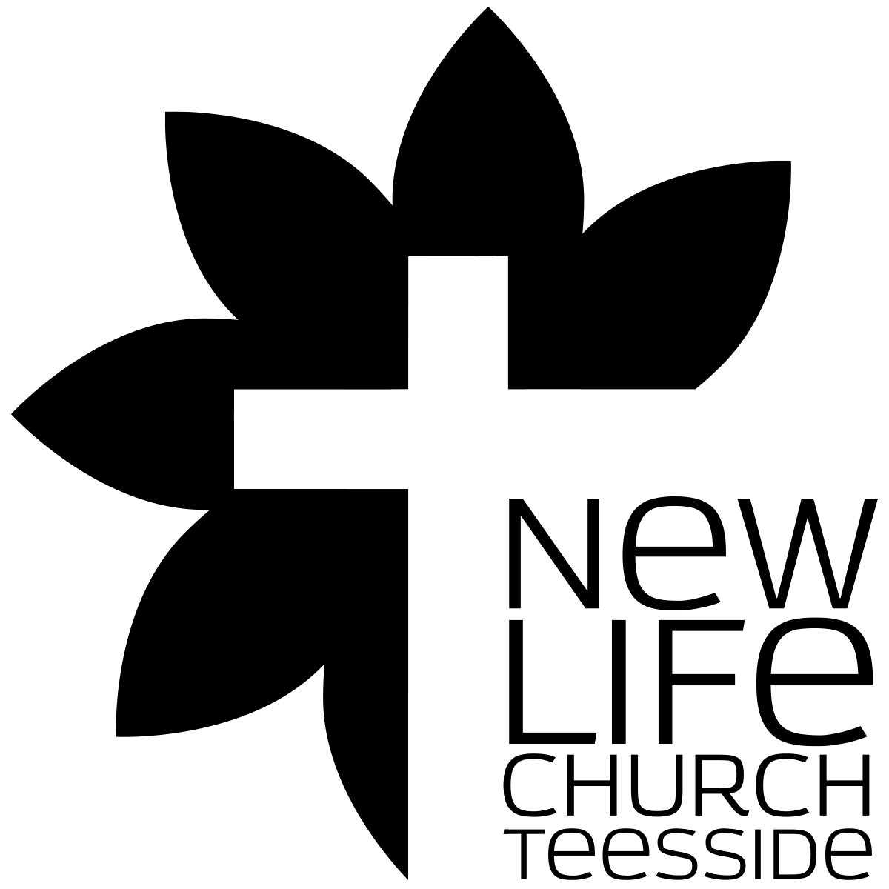
Bible Study Methods
Part 015 - Introduction to the Inductive Bible Study Method - LETTING THE BIBLE TEACH US

Leaders Notes

Lesson Purpose
The purpose of this lesson is to introduce the inductive Bible study method, and explain why it is superior to other methods of Bible study.

Main Points
When the content of this lesson has been mastered, each participant should:
- Understand the difference between deduction and induction.
- Be convinced that the inductive method is a better method than the “common” approach to studying the Word.
- Know the three stages of the inductive method.

Desired Outcomes
- Deduction and induction move in opposite logical directions.
- The inductive method is the best method for learning something new from the Word.
- The steps of the inductive method are: Observation, Interpretation, Application.
- When the inductive method is not rushed, it provides a solid foundation for understanding the Bible.

INTRODUCTION
The Bible is the most important book ever written. It claims to be the very words of the almighty, infinite God, given to reveal Himself to finite man. That is a huge claim and one we need to take seriously as Christians.
The Bible is also the most important tool for the modern church planter or pastor or member. The “living and active” Word of God is able to penetrate the hearts and souls of those whom we seek to win for the Lord.
It equips us for every good work, which certainly describes our ministry of multiplying churches across the land.
It serves as a standard by which we measure and evaluate every doctrine, practice, tradition, and every other book.
History, tradition and the human intellect may lead astray, but the Bible stands firm as the truth of God.
Its teaching is always correct. Even if you don’t agree with it. Actually, especially when you don’t agree with it.
Its prophecies always come to pass.
Its words help us to win the lost and to resist the devil.
The Bible is indispensable to our Christian life and ministry.
Since we believe that the Bible was given to us by God for our instruction, we need to approach it carefully and handle it accurately.

(2Ti 2:15)
15 Do your best to present yourself to God as one approved, a worker who has no need to be ashamed, rightly handling the word of truth.

The divine nature of the Scriptures demands that we read it with the intent of learning from it, rather than making it say what we want to hear.
How can we be sure we rightly understand the Word?
The inductive Bible study method is designed to help every believer—whether layman or pastor—better understand the teaching of the Word of God.
This lesson will introduce this simple and effective method, and following lessons will describe each step in more detail.
But first - let’s look at where this word comes from. Where did we get it?

HOW WE RECEIVED THE BIBLE
The Lord has acted, and still acts to bring a reliable Bible to us. This process began with the original authors, and continues when we open His Word today. There are several stages to this process.

- Inspiration
The term inspiration literally means God "breathed" or “breathed out,” and affirms that the Bible is the product of the living God

(2Ti 3:16)
All Scripture is breathed out by God and profitable for teaching, for reproof, for correction, and for training in righteousness,

Because the Bible is a divine product, it must be approached as such.
The Bible is not merely the product of human thought, but God's Word, spoken through man's lips and written with man's pen.
The prophets and apostles all claimed to speak and write the words of another: God Himself. Even Jesus, the Son of God professed that he spoke only those words given him by his Father. According to 2 Peter 1:20-21, "men spoke from God as they were carried along by the Holy Spirit." It is important to note that it is the Bible itself that is inspired, not the human writers of the Bible.
Furthermore, inspiration refers not to the literary quality of that which is written but to its divine origin and character.

- Preservation
From the beginning, the unique nature of the Bible was understood.
Faithful men have always exercised great care in accurately copying the biblical text. They made very few errors, and the massive number of manuscripts discovered has enabled us to find and fix mistakes that were made.
The sections in the Bible where we lack enough evidence to positively know the original text are very few, and none of these sections involve any significant issues or doctrines. That’s important to remember when people question the errors they think are in the bible.
Considering the multitudes of copyists, the thousands of years of copying, the numerous languages into which the Bible was copied, the wide geographical area, and the numerous attempts to destroy the Bible, it is amazing that we have such a reliable, accurate text.
God has clearly worked to preserve it for our use.

- Canonisation
The term 'canon' is borrowed from a Greek word that means rule or standard.
The Canon has been used by Christians since the 4th century to identify an authoritative list of books belonging to the Old or New Testament by which all other books were measured.
Many early church fathers and church councils contributed to the task of canonisation, with God’s help.
They examined the witness of the books themselves, the credentials of the author, the agreement of the book with other accepted books, and the books’ acceptance by the church. That last one is vital to get - books were not left out by a small few and the rest of the church denied them - no, the church didn’t accept them so the councils left them out. Big difference.
The formation of the Old and New Testament canons was a process rather than an event and transpired under the supervision of the Holy Spirit.
By the time of Jesus, the Old Testament consisted of the law, prophets and writings. By the beginning of the Christian era, all 39 Old Testament books were generally accepted, with the oldest surviving canonical list dating about AD 170.
The formation of the New Testament canon, with the current 27 books, was completed in the 4th century. There has been general agreement within the church that the Bible is composed of the current 66 books.
The exception to this harmony concerns the Apocrypha.
The Apocrypha is rejected by the Protestants, but accepted by the Orthodox and Roman Catholic Churches.
However, there is a significant difference between the Apocrypha and the other 66 books. The Apocrypha does not claim to be Scripture, contains obvious errors, and was denied canonical status by the Jewish community.
However, the Apocrypha has a devotional style that appeals to the liturgical worship of the Orthodox and Roman Catholic Churches.
The Apocrypha contains several works which the Roman Church found helpful during the Reformation in the struggle against the Protestants, which may have influenced the Council of Trent to include them in the Canon of the Roman Catholic Church in AD 1548.
At New Life we reject the Apocrypha as Scripture and do not recommend it for study or devotion.

- Translation
Godly men have laboured so that each person might hear the Word in his own language. The task is huge, and ongoing.
Modern languages and cultures often vary greatly from biblical times, and constantly change. Translators must choose the best words and phrases to carry the meaning of the original languages and still be easy for someone of any age or educational level to understand.
No translation is perfect, but modern scholarship, discovery of new manuscripts, and growth in biblical understanding help in this never-ending task.
Constant comparison with the original language texts is necessary to ensure that any particular translation accurately carries the meaning of the Word of God. God uses talented, educated, capable men, who depend on His direction and wisdom in this ongoing, vital step.

- Illumination
As the Christian reads, studies, and meditates on the Word, the Holy Spirit reveals the meaning to him.
The process of illumination is also never-ending, or should be. It is a joint effort. Man cannot learn without the Spirit (1Co 2:11-14; Ps 119:18), and the Spirit does not teach without a man’s effort (2Ti 2:15; Ps 119:97-99; Pr 2:1-5).
Teaching God’s Word is a special honour (2Ti 4:17) but also a serious responsibility (Jas 3:1). It should never be undertaken without serious, prayerful preparation. And yet, God has made all the necessary provisions for us to have a reliable text in our language, and has enabled us to understand His Word through the Spirit’s help.
Nothing is lacking other than our decision to handle it correctly, and faithfully use it to develop our own Christian life first of all, and then our ministry to others. What a privilege to be part of this process of bringing the living Word of God to a needy, perishing world!
God has supervised the transmission of His Word from the time of the initial writing until we open it to seek instruction for our lives.

The copy we have in our hands is reliable for use in both personal growth and ministry. However, it is a living, spiritual book, and can only be understood as we prayerfully and reverently approach it and allow the Holy Spirit to open our eyes to the truths contained in it. Thanks to the Lord for this wonderful book to guide us.
And that’s why how we approach the study of this word is so very important. So let’s look at bible study methods.

INDUCTIVE VS. DEDUCTIVE
Deduction and induction are two kinds of logic or reasoning. Both deal with the general and the specific.
They are both methods of arriving at a conclusion. However, they do so in exactly the opposite manner.
Deductive reasoning moves from the general to the specific, and inductive goes from the specific to the general.
Both methods are used by Christians to study the Bible, but usually they are not aware of how each method affects their study and conclusions.

- The Deductive Approach
Deductive reasoning is used by people in wide variety of professions.
Deduction is a valuable skill, and many books have been written on the subject. The intent of this lesson is not to minimise the validity of deduction, but to suggest that it is an inferior method of Bible study.

Deductive Reasoning
In general, deductive reasoning moves from the general to the specific. That is, it starts with a known and accepted idea or premise.
That pre-existing understanding is then compared to a particular situation, and a conclusion is formed.
The basis for this conclusion is the fact that the general idea is true, and that the specific situation resembles it. In other words, the general idea controls, or at least strongly influences the way we look at the particular situation.
For example, since snow-covered steps are usually slippery, we will approach any set of snow- covered steps with caution—even if we have never slipped on that particular set of steps. That’s deductive reasoning.
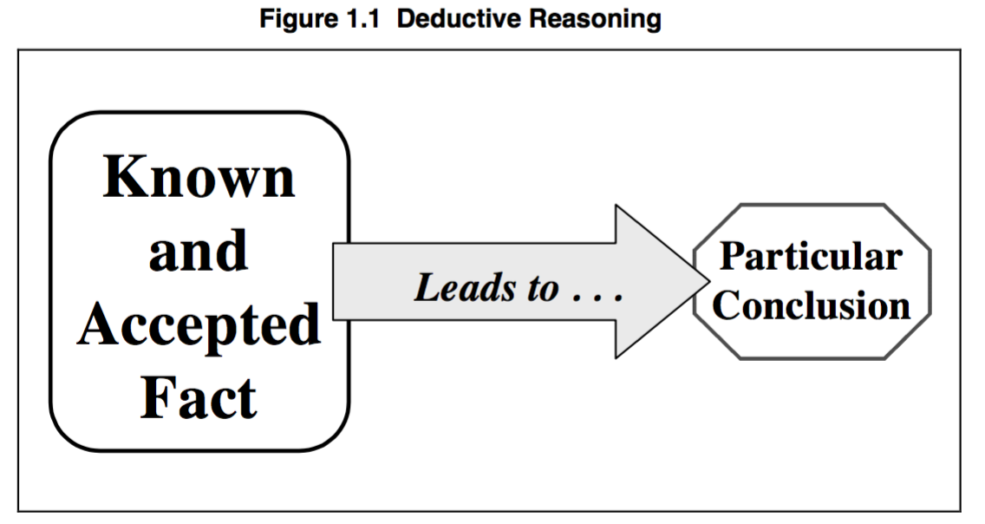
Our general experience with snowy steps leads us to this logical and reasonable conclusion. Figure 1.1 shows the direction of deductive reasoning.

Deduction has a major weakness.
If our general understanding is wrong, so will be our conclusion.

For example, suppose a Russian hears someone talk about a doctor. In Russia, most doctors are women. Therefore, it would be logical for him to deduce that the doctor is a woman. Often, however, he will be wrong.
There are also male doctors in Russia, and in some countries most doctors are men. In this case, the influence of our prior experience can often lead us in the wrong direction.

We assume we know the answer, rather than continuing to look for other clues to the correct answer.
If we start out with the wrong assumption, we will get the wrong answer.

Deductive Bible Study
The deductive method can be used to study the Bible, but its weakness limits its usefulness. When we study the Bible, it is important to understand what God is saying, rather than to impose our understanding on the text.
This has happened time and again throughout History - and through that the bible has been used to justify things that are not correct. Every generation reads the bible a different way - that is true - but what the bible really says does NOT change with every generation.
When we impose our understanding on the bible - we can mis-understand the bible.
There are occasions when we cannot understand a difficult verse, and we rely on our general understanding of the Scriptures to deduce what it “probably means." However, this should be a “last resort.”
Our first step should be to pray, meditate on the verse, and continually reread it in order to try to understand what it wants to say. If we quickly “give up” and assume it is “just like the other similar verses,” we may seriously distort the Word of God.
For instance, ten of the eleven times the New Testament uses the word “yeast,” it refers to sin. It would therefore be reasonable and logical to assume that the eleventh time (Mt 13:33) also refers to sin. It would, however, be wrong.
An examination of the context of Matthew 13:33 shows that in that verse, it refers to the Kingdom of God!

The “Normal” Method
Unfortunately, deduction is probably the most common method of Bible study. As a result, few learn very much from the Bible. Instead they often find ways to read the bible that support what they thought in the first place.
Since they come to the Scripture with their preconceived understanding of what it means, they are not able to notice and learn from the details of a particular text.
Bible teachers often know what they want to say beforehand, and simply come to the Bible to find a verse that seems to support their understanding. The Word of God is then used to prop up our message, rather than being allowed to communicate the ideas that the Lord intended for it to say.

- The Inductive Approach
The inductive method is in many ways the opposite of the deductive method.
It examines the particulars of a situation, and then attempts to form a general principle from them.
It is normally used in those situations where we do not have a general principle that seems to fit, and are therefore unable to use deduction.

Inductive Reasoning
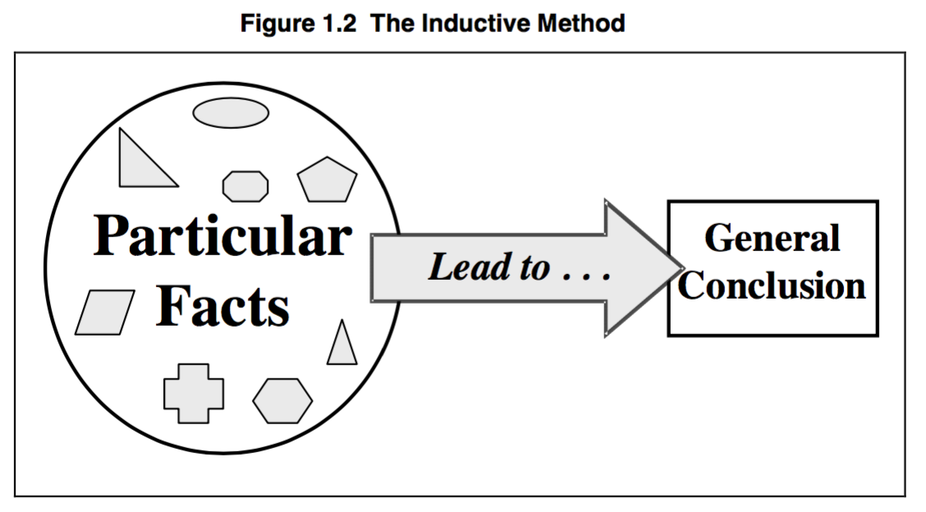
Deduction is essentially the process of using our pre-existing knowledge.
Induction, by contrast, is about learning. We assume that we do not yet know the answers, and examine the facts closely in order to try to understand what they mean. In this method, the emphasis is on the specific details and facts of the situation.
Figure 1.2 shows the progression of the inductive method.

Inductive Bible Study
When we use the inductive method to study the Bible, we come to the Scripture as learners.
We acknowledge to God and to ourselves that we do not yet know all the answers. Our purpose is to gain understanding.
We come with a commitment to carefully examine the text, and allow the Lord to speak to us through it.
The deductive method usually leads to a quick sermon—the inductive method leads to spiritual growth.

A Better Method
The inductive method is superior to the deductive method because it makes the Scriptures the authority, rather than our understanding.
Too often we lean on our own understanding even though the bible tells us not to. We try to make sense of things according to what we already think, rather than what to word says. Whereas this method changes what we think to fit with what the word says.
It is also better because it matches the process of understanding and applying biblical principles to our lives.
As we study the Bible, we look at how God dealt with people in a particular situation, at a particular time, and in a particular culture.
Our task is to take these facts and to form from them a biblical principle. We then translate that principle into our equivalent situation so that we can correctly apply it to our lives.

The process of the inductive Bible study method is therefore:

- Observation of the facts in the Scriptural context.
- Interpretation to find the principle that the passage teaches.
- Application of the principle to equivalent situations in our lives.

STEPS OF INDUCTIVE BIBLE STUDY
The three steps of the inductive Bible study method are each important. They build progressively on each other to lead us from the Bible text to a correct application to our lives. Essentially, the three steps ask three different questions about the text.

- What does it say? [Observation]
- What does it mean? [Interpretation]
- What should I do? [Application]

The relationship between each of these steps is shown in Figure 1.3.
Notice the logical progression through the three steps, beginning with the Bible text and ending with application to our Christian life.

If the steps are not completed in the proper order, the result is flawed.
Let’s look at these stages:

- Observation – What Does It Say?
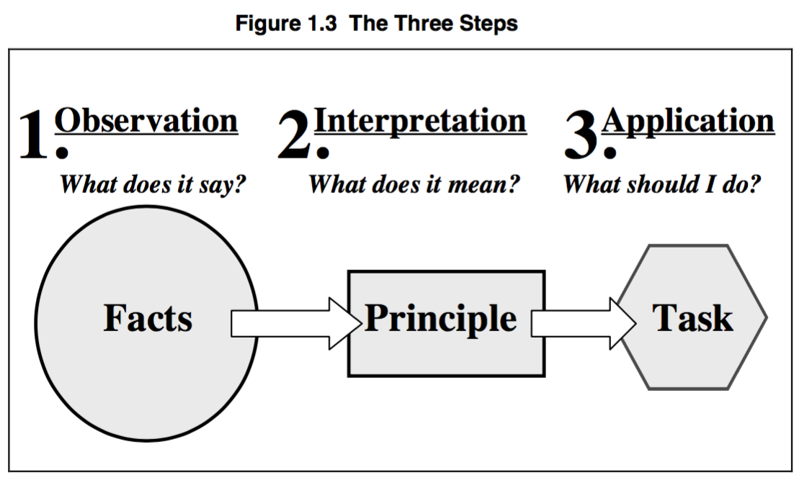
The first step of the inductive method is observation.
It is also the most important step—in the same way a solid foundation is critical to the construction of a house.
At this stage, we observe the text, looking for every detail we can find in it, and recording our observations.
The key to this step is to ask an endless series of questions such as “Who?, What?, Why?, Where?, When?, etc.”
These questions help us focus on what the Bible says, rather than bringing our ideas to it.
We also look closely at the context of the verse, paragraph, chapter, and book to discover and understand the situation in which it was written.
At this stage, it is very important not to interpret or apply the text - even though it’s tempting to do so. This is just observing.
We must discover all the information first—in the next step (interpretation) we will look at what it means.

- Interpretation – What Does It Mean?
The process of interpretation has two parts.
The first part is to determine what the passage was intended to say to the original audience.
The second part is to formulate the message of the passage as a biblical principle that can be applied to other similar situations.
Original intention - then biblical principle.
This is a difficult stage, requiring serious and prayerful thought, and the leading of the Holy Spirit.
At this point, we need to compare all our understanding of the original historical, geographical, political, cultural, and religious situation with the facts that we unearthed in the observation stage.
Any facts that we have missed in the observation stage will hinder our work here.
Now is also the time to compare this text with other similar passages to see if they can help us understand it—being careful that they do not distort the facts of the text we are studying. If the meaning of the passage is still unclear, it might be necessary to return to the observation stage and keep digging for more information.

- Application – What Should I Do?
The final stage of the inductive method is application.
At this point, we take the result of the interpretation stage and decide how the principle might apply in our situation. Since we have carefully looked at the original context, and know the details of it, we can look for similar contexts in our day.
The difficulty of this stage is to determine what situation today is really comparable to the original situation.
We can only say “thus says the Lord” if we can demonstrate that this similarity exists.
If our situation is truly the same as a biblical passage, then we can assume that the Lord expects us to apply the message to ourselves.
If the situation is SIMILAR - we can see how The Lord will probably expect us to act. Remember, He is the same Yesterday, Today and Forever - even if the situation isn’t.
In that case, the important task is to state specifically and clearly “what we should do."

- BUILDING A SOLID PYRAMID
It is important not to skip any of the steps, or to change the order.
It is impossible to correctly say what a passage means without first fully observing it, and futile to ask what we should do without knowing what the text means.
Therefore, it is critical that we take the necessary time to use the inductive method properly.

- Rushing the Process
The most common mistake in using the inductive method is to spend too little time on the observation phase.
The person studying the Bible takes a quick glance at the passage and assumes that he or she knows what it says.
This defeats the learning process.
The result is an understanding of the passage that is exactly the same as it was when the process started.
The Scripture has not been allowed to speak to us or to teach us. If we approach the Word of God in this way, our biblical understanding will stagnate.
The Bible is living and active.
We can never fully understand the depths of its teaching. There is always something more for any student of the Word to learn—if we will take the time and effort to understand it.
Christian workers often rush the process because they are in a hurry to prepare a message for others. Or, they may be lazy.
Either way, the result of this poor preparation is weak preaching, without the power of the Lord behind it.
Skimping on the process can be compared to the inverted pyramid in the left side of Figure 1.4.
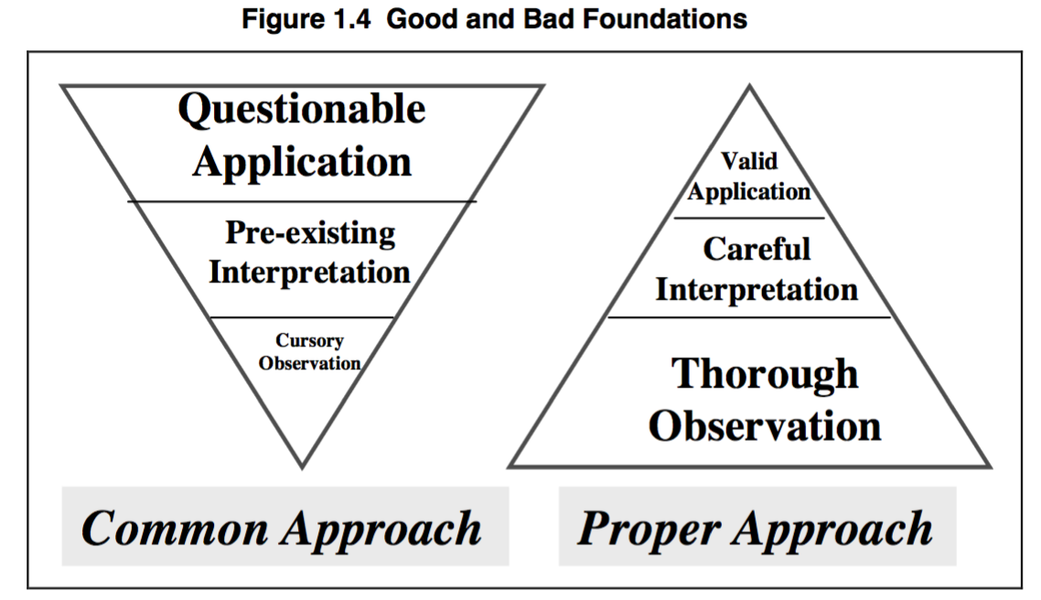
A cursory observation is expanded into a quick interpretation, or a pre-existing interpretation is “hung” on a text that may or may not support it.
Finally, a sermon or message is build upon this shaky foundation. Sadly, this may be the most common kind of teaching in churches today and it’s just not enough.

- A Solid Foundation
The pyramid in the right side of Figure 1.4 demonstrates the proper use of the inductive method. Notice that observation is the largest section, followed by interpretation, and that application is the smallest.
However, the application is solid and valid—being based on a thorough study of the Word.
The inductive method can be compared to mining for gold:

First, tons of gold-bearing rocks are crushed into manageable pieces and washed (observation).

Next, the crush rock is sifted to find the gold nuggets (interpretation).

Finally, the gold nuggets are melted down and shaped into useable jewellery of other objects for the consumer (application).

The process produces only a small amount of gold compared to the weight of the original rock. However, the result is of great value. In the same way, the result of studying the Word using the inductive method is worth all the effort required.

CONCLUSION
The inductive Bible study method is a superior method of studying the Word.
It leads to a more accurate understanding of the Bible, and promotes true spiritual growth and learning.
As such, it is the best method not only for pastors and preachers, but also for every Christian.
We are all to be learning from the Scriptures.
The following lessons will describe in more detail exactly how to use each of the three steps of the inductive method. Time will also be provided to practice and become comfortable with each stage of the process. The effort required will be more than balanced by the resulting new understanding of the Word of the Living God.

QUESTIONS

- What is the basic difference between deduction and induction?
- Why is the inductive method a superior method of studying the Bible, compared to the deductive method?
- What are the dangers of the “common” approach to Bible study and preaching?

ACTION PLAN
When you next study the Bible, record how much time you spend on observation, interpretation, and application. On the basis of these times, evaluate whether you are using the inductive method, the deductive, or something in between.

In preparation for the next lesson on observation, pick a sample short passage of Scripture to study (no more than a paragraph or so). Spend at least two hours prayerfully observing the passage and asking God to open your eyes to things that you have not yet seen. Record your observations. What did you learn?

