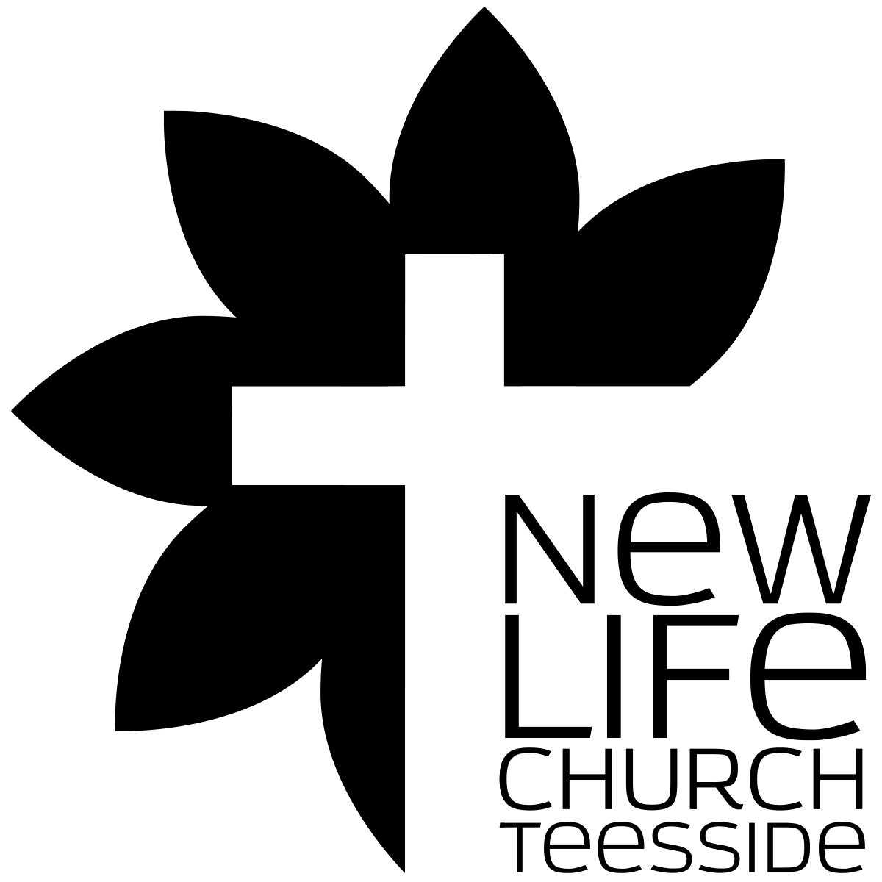
SPIRITUAL CHARACTER
Part 012 - The Transforming Power of the Gospel - FREEDOM FROM THE MASTERY OF SIN

Leaders Notes

Lesson Purpose
The purpose of this lesson is to explain how we were set free from the mastery of sin as we were united to Christ, in His death and resurrection, so that we might experience the power of the Gospel in our lives as we walk by faith in this new reality.

Main Points
- Our salvation means we have been transformed internally.
- Because of our new nature in Christ we have the power to overcome sin.
- God wants us to walk in the Spirit so that we will not fulfill the desires of the flesh.

Desired Outcomes
When the content of this lesson has been mastered, each participant should:
Understand the significance of union with Christ and the power available to render the flesh dead, no longer mastered by sin.
Walk by faith in the personal, spiritual death and resurrection experienced in Christ and in salvation from the power of sin.

Suggestion to Leaders:
This lesson makes many references to Romans 6:3-10. Carefully studying these passages in preparation will enable you to teach this lesson effectively.

Introduction
We are going to start with a section from Romans 6. This passage is going to be our focus tonight and we may go through it serval times.
So let’s get to know it first.

Rom 6:3-10
Do you not know that all of us who have been baptised into Christ Jesus were baptised into his death? We were buried therefore with him by baptism into death, in order that, just as Christ was raised from the dead by the glory of the Father, we too might walk in newness of life.
For if we have been united with him in a death like his, we shall certainly be united with him in a resurrection like his.
We know that our old self was crucified with him in order that the body of sin might be brought to nothing, so that we would no longer be enslaved to sin. For one who has died has been set free from sin. Now if we have died with Christ, we believe that we will also live with him. We know that Christ, being raised from the dead, will never die again; death no longer has dominion over him. For the death he died he died to sin, once for all, but the life he lives he lives to God.

The Gospel is the foundation of our relationship with God. Everything, as we have seen is built up on the Gospel, from our salvation and conversion to our daily walk.
From God’s perspective, our relationship is built solely upon Christ’s forgiveness and perfect righteousness given to us by faith, not by any of our works.
This truth should bring the ability to conquer sin in our lives resulting in profound personal transformation.
Yet most of us still struggle with sin and sometimes wonder how we can be transformed today. Why do believers sin? And, what can be done about it? How can we be truly transformed according to the Gospel?
These are really important questions in the life of a believer.
Misunderstanding this can bring anxiety and doubt. It can also bring a lax attitude to sin where it’s effects are not considered. This brings us to our first point:

- THE GRACE OF GOD AND THE PRACTICE OF SIN

Can We Go on Sinning?

Bear in mind this question - it’s not “do we go on sinning”? But can we?
If God’s grace truly abounds beyond all our sin and we are justified by faith apart from our obedience, can we go on practicing sin?
If God’s grace is offered to those who don’t even deserve it but receive it because of their faith in Jesus Christ, it is only natural to ask this question.
May we go on sinning and expect God’s grace to cover it? After all, God’s grace covers everything, does it not?
Now, we could debate and debate about this, many do. But thankfully Paul clearly knew this question would arise.
The apostle Paul anticipated this question in his letter to the Galatians when he said,

(Gal 5:13).
“Do not use your freedom to indulge the sinful nature”

And this is the very question Paul responds to in Romans 6 when he asks,

(Ro 6:1b, 2)
“Shall we go on sinning so that grace may increase? By no means! We died to sin; how can we live in it any longer?”

The Biblical Answer

The answer to this question is clearly "no", we shall not go on sinning.
This should not have come as a massive surprise to anyone here I’d have hoped.
We understand this and try hard not to sin. Self-discipline and rules become the norm for the serious Christian who wants to avoid sinning.
When someone knows the areas in which they are weak, the use self governed rules to keep them away from these areas. That makes total sense. We try not to get ourselves into trouble.
But the real corrective for sin is related, not to discipline or rules but to the inner transformation of the believer.
As we study Paul’s answer in Romans 6, we understand not only why we cannot go on practicing sin, but also discover the new freedom we have from the power of sin.
This is a vital part of victorious Christian living.
In our salvation, God has provided the solution to our two most fundamental needs: He has delivered us from the penalty of sin, reconciling us to Himself, and He has delivered us from the power of sin, that we might live in true freedom to love Him.
Romans 6:1-2 instructs us that we cannot continue in the practice of sin, as we did before we were Christians, because we have “died to sin.”

- BAPTISED INTO HIS DEATH—RAISED IN HIS RESURRECTION

In his letter to the Romans as he answers the question concerning sin, Paul uses baptism to illustrate the change that takes place when a person becomes a child of God.
Let’s Read Romans 6:3-10 carefully again - we need to keep this passage at the forefront of our minds as we look at this.

Rom 6:3-10
Do you not know that all of us who have been baptised into Christ Jesus were baptised into his death? We were buried therefore with him by baptism into death, in order that, just as Christ was raised from the dead by the glory of the Father, we too might walk in newness of life.
For if we have been united with him in a death like his, we shall certainly be united with him in a resurrection like his.
We know that our old self was crucified with him in order that the body of sin might be brought to nothing, so that we would no longer be enslaved to sin. For one who has died has been set free from sin. Now if we have died with Christ, we believe that we will also live with him. We know that Christ, being raised from the dead, will never die again; death no longer has dominion over him. For the death he died he died to sin, once for all, but the life he lives he lives to God.

Get to know this passage well. It’s so important.

Our Death with Christ

How did we die?
In Romans 6:2-5 Paul explains how we died to sin.
We were united with Christ and we were baptised into His death. Before we consider our baptism into Christ’s death, we ought to focus on the real issue that brought about our death to sin. It happened through our union with Christ.
There are several action statements in this passage, which express the union between Christ and ourselves.
In verse 3 we see that “all of us who were baptised into Christ Jesus were baptised into His death". In verse 4, “we were . . . buried with Him”.
In verse 5, “we have been united with Him,”
And in verse 8, we have “died with Christ.”
All of these statements make it clear that through our union with Christ in His death we have died ourselves.
If we want to be free from the sin nature within us, we have to experience death in our inner man.
When God supernaturally united us to Christ, He put to death the inner man even though the outer man continues to live.

“For if we have been united with him in a death like his”

The term “united” (sumfutoi in Greek) in verse 5, “. . . we have become united with Him . . . ” is a term that was used to describe the grafting together of two separate plants.
When a foreign branch was grafted to a tree, at the time it began to take life from the tree it was said to have been sumfutoi, “united” with it.
It means to have become conjoined.
This was a living, organic union.
It doesn’t just mean joined. It’s two words that it’s derived from, sun and phuo. Sun means joined with. Phuo means to grow. We are joined and grow with.
It doesn’t just mean stuck on, but stuck to in such a way that causes us to grow and thrive. Just like when a plant is grafted - the new part gets it’s sustenance - it’s life, form the main plant.
This is the kind of living union that takes place when we believe in Christ. We are supernaturally united to Jesus Christ, and His life gives life to our inner man.
But before we can live in freedom, we must first die, so that our inner man can be separated from the sin nature. So we are united to Christ in His death.
So, our death with Christ caused the separation between our inner man and the sin nature, which resulted in our freedom from the mastery of sin.
Though the sin nature still exists, and is a very evil force within us - let’s never overlook that, its mastery over us has been broken and we are no longer chained to its power.
This is our certain, new reality and we must believe its truth if we are to successfully live the Christian life.

Discussion:
Discuss how responding to an altar call and actually dying to the old self are different. What effect will this have on the life of someone who has responded?

What happened because of our death with Christ?
Romans 6:6 tells us what happened as a result of our death with Christ: our “old self” was crucified.
The old self is simply the inner man that existed before we believed in Jesus Christ and were given new life by Him.
It is the old man that was enslaved to sin. However, when we were united to Christ in His death, this inner man was crucified with the result that our body of sin was “done away with.”
The Greek word katarge, “done away with,” does not suggest annihilation, as though sin has been eliminated from within us.
However, it does mean, “to render inoperative or invalid,” in that something is made ineffective by removing its power of control.
It doesn’t mean destroyed, but annulled. Discharged.
Paul uses the same word in Romans 3:3 when he says that man’s unbelief does not “render inoperative” the faithfulness of God. In Romans 7:2, he says that a woman is “released” from her husband if he dies.
This is the meaning in our context:
We have been released from the mastery of sin because its power to control has been removed. The chains of sin have been broken and we are no longer slaves to it. We have been released.

The End Result: New Life with Christ
There is one final idea communicated in this passage that explains the transformation our inner man has gone through.
We are told that we are not only united with Christ in His death, but also in His resurrection. We have not only died, but we have also been resurrected to new life.
Through our union with Christ, because Christ lives, our inner man now lives. Romans 6:4 tells us that as the power of the Father was demonstrated in raising Christ from the dead, so we are made to walk in newness of life as a demonstration of this same power.
The same power that raised Christ from the dead has now also raised us from the dead.
The result of all this is that something very powerful and supernatural has happened to us, and our inner man is no longer what it used to be.
The old man has died and a new man lives. What kind of new man is this? In verses 6 and 7 of Romans 6 we learn that this new inner man is free from sin and no longer a slave to it.
This is who we now are in Christ.
It might not be how you feel sometimes, but the reality is, it is who you now are.

Question:
How do you allow your feelings instead of your faith in God’s Word to affect the way that you view your life in Christ?
If your feelings and experience give you a different view than the word of God… which do you trust?

Reckoning by Faith Our New Life in Christ
It is imperative for Christians to bring these truths into their everyday lives.
Let’s be real and honest. We all know that sin still exists within us, and as we continue in our earthly struggle with sin, we can lose sight of our new life that truly exists in Christ.
There are times when we don’t feel very free from sin, and we wonder if anything supernatural has happened in us at all.
We can agree with the Apostle Paul who said,

(Ro 7:19)
"For what I do is not the good I want to do; no, the evil I do not want to do—this I keep on doing”.

You are not alone in this.
Paul is not alone in this.
This is why Paul’s closing words in Romans 6 are so important to us.
Three times in this passage Paul has commanded us to “know” this truth (vv. 3, 6, 9). He wants us to understand what has truly happened to us in Christ.
Then, in verse 11, Paul concludes, “In the same way, count yourselves dead to sin but alive to God in Christ Jesus.”
In this verse, the Greek word logizomai, “count,” was a mathematical term used when someone was calculating a problem or counting numbers.
It’s a word that means to conclude - to decide. It’s the root word where in English we get the word logic from. It means this is the reasonable conclusion you can now come to.
It is used figuratively in this passage to “fully affirm” the truths that are taught here. We are being exhorted by Paul to put our confidence in and fully believe this fundamental truth about us.
The old man no longer lives within us.
In other words, we can now conclude, logically, it can now be decided - we are dead to sin but alive in Christ.
He is writing people who were struggling with sin. He builds this whole passage as an argument and end with - so we can therefore conclude - we are dead to sin.
He was a slave to sin, but he has been crucified as we have been united to Christ in His death and resurrection, and we are now transformed into new men and women.
We now must affirm and believe that we have been made alive in Christ and that we have been made new creatures inside.
Our Christian life is a life in which we walk by faith in this truth. Even though we don’t perfectly experience this all the time, it does not change the reality of what has happened.
We must continue every day to repent of our sin and believe that we are one with Christ, and that we now live in union with Him.

- THE POWER NOT TO SIN
According to Romans 6, because we are united to Christ, we died and were resurrected with Him. His victory over sin was our victory over sin.
Sin is no longer our master. But this great Christian reality does not mean that sin no longer seeks to enslave us.
We all know that it does.
Sin is not our master, even though it is always striving to regain its authority and power over us.
You might be thinking, "But I constantly struggle with sin. How can I beat it?”
First, be sure that no list of rules or self-discipline alone can lead to a victorious Christian life.
We can try and try in the power of the flesh and we will eventually fail because our flesh is prone to sin. The real corrective for sin is related to the inner transformation of the believer.
We fight sin by strengthening our awareness of who we are in Christ.

Understand the New Nature
When you became a Christian, you didn't add a divine nature to your old sinful nature. You exchanged natures—you became a new creation

(2 Co 5:17)
Therefore, if anyone is in Christ, he is a new creation. The old has passed away; behold, the new has come.

You were transferred from the kingdom of darkness to the kingdom of light, when you became a child of God. "Our old self (old nature) was crucified with him" (Ro. 6:6). The old nature is powerless!
If we have a new nature, why do we sin?
There's a Greek word used many, many times throughout the New Testament as a source of sin in the believer's life. It's the word flesh.
What is the flesh? It's the part of our mind, emotions and will that has been conditioned or trained to sin.
Habits and patterns of thinking are passed on to us by the world, by ungodly teachers, and by Satan's direct attacks.
Our worldly experiences programmed our brains to live independent from God and according to the world's ways.

QUESTION:
What has happened to your sinful nature according to Paul’s letter to the Romans?

Live in the Spirit
Romans 8:5-7 contrasts those who live according to the flesh with those who live according to the Spirit.

Romans 8:5-7
For those who live according to the flesh set their minds on the things of the flesh, but those who live according to the Spirit set their minds on the things of the Spirit. For to set the mind on the flesh is death, but to set the mind on the Spirit is life and peace. For the mind that is set on the flesh is hostile to God, for it does not submit to God's law; indeed, it cannot.

There you find that it's the mind that's set on either the flesh or the Spirit. Your flesh, which was trained by the world, generates worldly thoughts and ideas leading you to sin. As believers, we are no longer to be in the flesh, but in the Spirit (Ro 8:9, Gal 5:16).
But it's possible for us to walk according to the flesh

(Ro 8:12,13)
12 So then, brothers, we are debtors, not to the flesh, to live according to the flesh. 13 For if you live according to the flesh you will die, but if by the Spirit you put to death the deeds of the body, you will live.

This is written to “brothers” and Paul is warning them not to walk according to the flesh. Believers have a choice.
Unbelievers have no choice—they walk in the flesh because they live in the flesh.
But we are not obligated to the flesh... we have a choice.
We must learn and choose to walk by the Spirit, not the flesh.
As Paul says: "live by the Spirit, and you will not gratify the desires of the sinful nature" (Gal 5:16).

QUESTION:
How can you live by the Spirit?

Identify Yourself as a Child of God
Before knowing Christ we were sinners, but when we became God’s children we became ‘saints.’
Are we saints or are we sinners?
The answer can be difficult. But if you think of yourself as part saint and part sinner, part light and part darkness, you will continue to struggle and to live a defeated life.
We should never describe a believer or ourselves as “no saint”. What are we putting on people when we say that?
Having come to understand the transformation that has taken place, believers should strive to maintain the awareness of who they are in the resurrected Christ.
When we face sin, we should think of ourselves as children of God.
If we think of ourselves as sinners, we will tend to live like sinners. We must see ourselves as saints, as children of God, in order to live like children of God.

Renew Your Mind
Many sinful patterns begin with bad thought life.
Sinful patterns of thinking must be "transformed by the renewing of the mind" (Ro 12:2).
The mind is the focus of the battle against sin.
2 Corinthians 11:3 indicates that just as Eve was deceived by Satan, our minds can be led astray from a sincere and pure devotion to Christ. Satan influenced the minds of David, Solomon, Ananias, the Christians in Corinth, and he can influence your mind as well.
He can bring his thoughts into your mind and deceive you into thinking they are your thoughts, or even God's thoughts.
But we “take every thought captive to make it obedient to Christ" (2Co 10:5).
Your mind is the biggest battleground you will face. It’s where battles are lost and won.
Look at people when they play Tennis - the game is not just decided on the court, but in the mind.
Once someone’s lost the battle in the mind they have lost the game. Once you admit defeat in the mind, you’ve lost.
Take every thought captive.
Renew your mind - continually.

Know the Truth
Where is sin's power?
Satan, according to John 8:44, "is a liar and the father of lies.”
When we are tempted to sin there is always a lie behind it. Even the very first sin had a lire behind it - “You will not surely die”. So many sins have that lie embedded in them - God will be ok with this. That is a lie - the oldest lie and one we keep falling for.
But Jesus says in the same chapter of John, "and you shall know the truth, and the truth shall make you free" (Jn 8:32).
Our defence against sin is the truth. By knowing our true, victorious identity as believers in Christ, we find freedom from the power of sin.

Question:
When fighting against sin, which brings more power into your life: trying harder or believing more?

CONCLUSION
The Gospel is the foundation of our relationship with God not just at the start but every single step of the way.
From God’s perspective, our relationship is built solely upon Christ’s forgiveness and perfect righteousness given to us by faith.
This truth should bring the ability to be honest about our sin before God, and the assurance of His abundant grace toward us.
It should inspire us to live as righteous ones not because we have made ourselves righteous, but because that is what God, by His grace, has declared us to be.
What is truly important concerning victory over sin is a growing, dynamic faith in Christ, a faith that is founded on Christ’s accomplishments on the cross, so that His power mightily works in us revealing sins and weaknesses more clearly.
This faith understands and appreciates the grace of God more deeply and leads us to know God more intimately.
This is the truth we need to anchor our lives to and the truth we need to help others discover too.

AT THIS POINT YOU MAY WANT TO HAVE A TIME OF MINISTRY WHERE PEOPLE CONFRONT AND DEAL WITH SIN.

