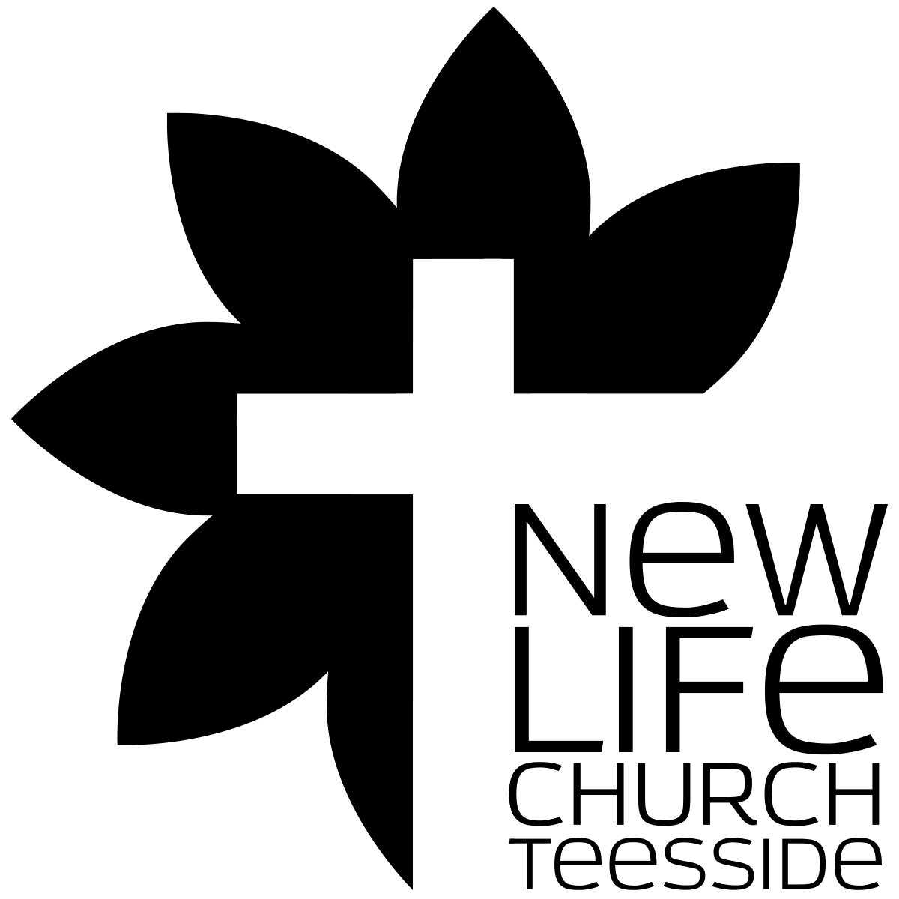
Spiritual Character
Part 011 - Christian Growth - Making Christ the focal point of our lives

Leaders Notes

Lesson Purpose
The purpose of this lesson is to see that the cross must become the focal point of our lives if we are to truly grow.

Main Points
- There are many misunderstandings concerning spiritual growth.
- The cross plays a critical role in spiritual growth.
- Our misunderstandings hinder growth.

Desired Outcomes
When the content of this lesson has been mastered, each participant should:
- Be a Christian who glories in Christ.
- Know that to grow, he must focus upon the cross- relating all of life to the work of Christ.
- Lay his self-reliance at the feet of Christ and, by faith, claim the power that only his risen Saviour can provide.

Introduction
Tonight is a very important session - it concerns how we live here and now. In this spiritual character part of the Life Group Teaching, we seek to build a foundation for dynamic Christian living.
That’s what we’ve been building on for the past two lessons.
It’s important we do this, it may be asked how does this help us develop in your ministry - but this foundational stuff first needs to be right in our own lives and second we need to make sure what we teach others is to build a life on the Gospel.
Our lives as Christians are built on the foundation of the Gospel and the Cross, on which they are also built every day - helping us live the dynamic, Christian life.
This critical area cries out for attention as we see church leaders become spiritually shipwrecked because of one sin or another. Time and again we see people who have been Christians for years throw it all away - and each time the the question we face is “how”? How did this happen? How can we ourselves keep from being shipwrecked? How can our love for God grow strong and not become cold? How can we grow in our faith, so that we have a vital, living relationship with Jesus Christ?
That’s why this is vital part of the Life Group Ministry- this whole Spiritual Character section is about building something solid in our lives so that those we reach have that same foundation and so we do not crash and burn.
We would like to present a picture of how a Christian grows to have a greater love for God and a living faith that enables them to spiritually lead the Church of Jesus Christ. Specifically, we will learn how to make the cross of Jesus Christ the focal point of spiritual life.
Now since we are talking about Spiritual growth, let’s start with the obvious question.

- WHAT IS SPIRITUAL GROWTH?
Spiritual growth is the continuing work of God in the life of the believer, making him or her actually holy. The word holy means here “bearing an actual likeness to God.”
As we grow as a Christian, our moral condition is brought into conformity with our legal status before God (as believers, we have already been declared righteous).
Spiritual growth is a continuation of what was done in salvation, when a new life was conferred upon and instilled within the believer. Spiritual growth is where we actually move towards the position God has already given us.
Notice there are several facets of our growth.
The Holy Spirit regenerated us so that we might become transformed into the likeness of God. But this transformation is an ongoing process, and this process is advanced through a cooperative work between God and the Christian.
We are told in:

Philippians 2:12- 13,
“Work out your salvation with fear and trembling, for it is God who works in you, to will and to act according to His good purpose.”

Here we see the partnership we must enter into with God. God who works in you - but also the instruction is for you to work out your salvation.
We cannot be passive and think that God alone will produce His likeness in us, that all we need to do is sit back and holiness will just be bestowed upon us.
We must be active as well. We must “work.” We don’t work alone, for he works in us - but we must participate - we must work.
Now those of you who came to last time’s session about works will have a BUT on you lips here. Don’t worry - I’m also about to say BUT.
But this work is not to gain God’s acceptance; rather it is the expression of our understanding and grateful acknowledgment of the forgiveness of our sins through the blood of Jesus Christ and our adoption as children of God.
There is a huge difference between works to gain acceptance and works because of our acceptance.

Many illustrations and diagrams have been used to explain the process of spiritual growth.

The Ladder or Stairs
Many believers view spiritual growth as a ladder or as a set of stairs that we climb. When we are really spiritual, we consider ourselves to be high on the ladder. However, when we are not spiritual, we are low on the ladder.

The Dying of the old self
Others view spiritual growth as a process of exchanging the old sinful self for the new man created in Christ. As the old man dies, the new man comes into being. When that happens, the person grows spiritually.

QUESTION - Discuss how these 2 illustrations can be helpful and unhelpful
Diagrams such as this are not necessarily wrong, but as we will see, there is a better way to understand spiritual growth.

And it’s all about the cross.

- THE ROLE OF THE CROSS IN SPIRITUAL GROWTH
Let’s look at a few ways in which the Cross plays a role in our Spiritual growth.

Growing in Knowledge of God’s Holiness
The first part of the growth process involves growing in knowledge of God. The Lord declares through the prophet Jeremiah,

Jer 9:23,24
“Let not the wise man boast of his wisdom or the strong man boast of his strength or the rich man boast of his riches, but let him who boasts boast about this: that he understands and knows me, that I am the Lord who exercises kindness, justice and righteousness on earth; for in these I delight, declares the Lord”.

In John 17:3 Jesus says,
”Now this is eternal life: that they may know You, the only true God, and Jesus Christ whom You sent.”

Knowing God is the purpose and meaning of eternal life. Knowing Jesus is why we have eternal life - without Him it’s not only impossible but pointless.
The chief pursuit of the Christian life should be to know God in truth.
We can get caught up in so many other things, but this is the main reason we live and the reason we will live forever. Surely that means this should be higher on our day to day priority list.

The Westminster Catechism puts it like this:
Man's chief end is to glorify God, and to enjoy him for ever.

The picture we get in Revelation - of the elders worshipping, crying Holy, Holy, Holy, Lord God Almighty - who was and is and is to come.
And saying it again and again - this isn’t repetition for the sake of it - this is as they are around Him, them know Him more and more and the more they see, the more His glory is known, the more they are lost in adoration and worship.

QUESTION: Discuss times where you have experienced this growing sense of the Holiness of God

That increased knowledge of Him - that ever enfolding revelation should be our main aim in life.
Therefore, when we continually grow to know Him in all His greatness, we grow to be like Him. The key to knowing God is understanding His holy character. We learn to feel as the Apostle Paul did when he said,

Php 3:8
”I consider everything a loss compared to the surpassing greatness of knowing Christ Jesus my Lord”.

Wow - if that could be our testimony - to have that perspective on our lives!
This is part of the sanctification process.
This pursuit of knowing HIs holiness and awesomeness is so important - it gives us a real, proper perspective on our lives. It’s so vital, we spent a whole sermon series looking at it - “How Great is Our God” - worth going back to - it’s on our Website.
The most vital thing we can do in our Christian growth - the way we can see the most increase and stability as Christians is to spend time with God and get to know Him more and get fresh revelation on His holiness.

Question: How can we increase our revelation of His Holiness?

And when we are exposed to His holiness - then something happens:

Learning to Recognise Our Sin
As we grow in our knowledge of God in all His perfection, we grow to know ourselves as well. In particular, we come to know our sinfulness in contrast to the perfect character of God.
The nearer we draw to God, the further we see that we are from Him. The more glorious we understand He truly is, the more terrible our sin becomes to us.
A causal attitude to one’s own sinful nature is a huge red flag that someone is not growing in their closeness to God.
Growing in understanding one’s own sinfulness can be illustrated in the life of Paul, the apostle.

Let’s look at how his Christian life progressed:

Paul’s Progress:
- In AD 55 Paul described himself as “the least of the apostles” (1Co 15:9).
- Later in AD 60 Paul describes himself as “the least of all saints” (Eph 3:8).
- Still later, in the end of his life in AD 64, he describes himself as “chief of all sinners” (1Ti 1:15).

Can you see a progression in that? It starts off with him saying he is the least amongst his peers. It then moves up to the worst Christian you can imagine. And then he moves up to saying actually, he’s the worst of the worst.
So lets pause and ask the question - Did Paul become a greater sinner as he matured?
It certainly does not seem that way. There’s no indication that the reality of the situation was that he became a worse and worse person as he got older, so what’s going on?
He didn't’ get worse - but, it does seem that he developed more and more humility and sensitivity concerning his sin throughout his life.
As he matured, he came to realise that some of his own attitudes that did not bother him previously were actually sinful.
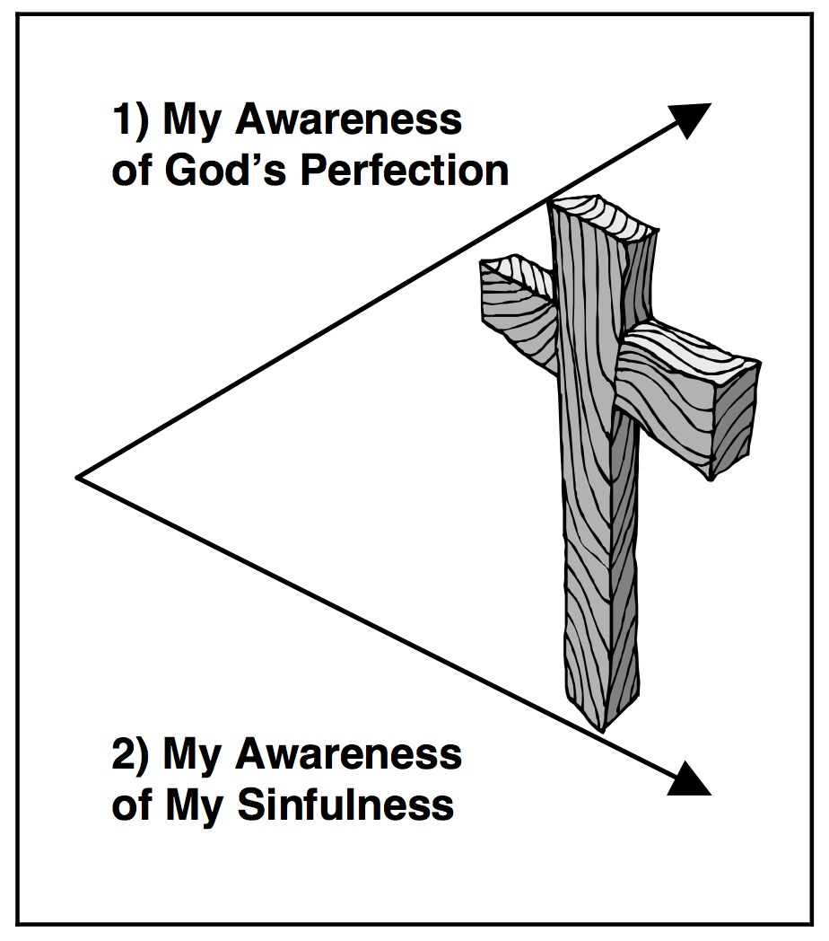
HIs increasing closeness to God revealed more and more where he lacked.
This is part of the spiritual growth process.
This leads us to the next part:

The Resulting Gap
Realisation of the gap that exists between sinful man and Holy God was, of course, what brought us to faith in Jesus in the first place.

The cross fills the gap whenever a person is saved.
But even after we come to know Christ as Saviour, we should still continue to grow in our knowledge of God’s holiness and in the awareness of our own sinfulness.
This can be a very fearful experience. To know God and His holiness is to invite self-exposure, and this is a terrifying experience for those who wish to hide their faults and shortcomings.
And that may very well be the reason so many Christians ignore it, avoid it or deny it.
However, for the growing Christian, the gap shows the continued need for Christ and the magnitude of what He has done on the cross.
So the cross continues to increase in importance to us as we grow to know God in His greatness.
It’s not that the cross is just needed for Salvation and then somehow becomes less important. Not at all.
The greater we know God, the more we feel unworthy before Him. This is a very normal response. It’s like the closer you get to the edge of a high cliff or building, the more awesome the view but also the more vulnerable you feel.
As this knowledge grows, we see the significance of our forgiveness and reconciliation to God through Jesus Christ. As we discover the greatness of God, (as Isaiah did when he saw the glory of the Lord in the Temple, or as the nation Israel did when they met God at Mount Sinai), we discover the true glory of our Saviour.
His blood washes sinners clean and clothes us with white garments so that we may draw even closer to this God of glory.
The more we see God, the more we can see our sin and lack, the more we understand about the Gap and the more we can see how amazing the work of the cross is in our lives. And the more we grow.
The more we see God’s holiness, the more we see our lack… the bigger the cross must become to us.
Seeing our lack and seeing God’s Holiness are not bad things. It’s a sign of growth to see these things. And the way we should respond to that is to increase the importance of the cross in our lives.

- HINDRANCES TO CHRISTIAN GROWTH
Having at some point accepted the fact that Jesus paid the price to bridge the gap, we strive to move on in our Christian growth.
I’m assuming we want to grow. I think even those Christians who don’t seem like they want to grow really do, but have lost their way or simply don’t know how.
Many Christians have one of two basic problems growing in their faith.

Phariseeism—the problem of pride.
Many believers get caught up in actions and thus fall into the trap of seeking to gain acceptance from God and others through performance. We talked about this a lot last time.
Often, the focus shifts off of the work of Christ on the cross onto their service to God. Like the Pharisees in New Testament times, they live as if the Christian life consists only of what we do for God.
The problem here is that they don’t realise that there are other, even more important aspects of the Christian life than service, such as knowing God and having a personal relationship with Him (Lk 10:38-42) - which of course is exactly the same problem the Pharisees had. The same problem Martha had.
Modern day Pharisees falsely believe that they can close the gap that exists between themselves and God with their own good works.
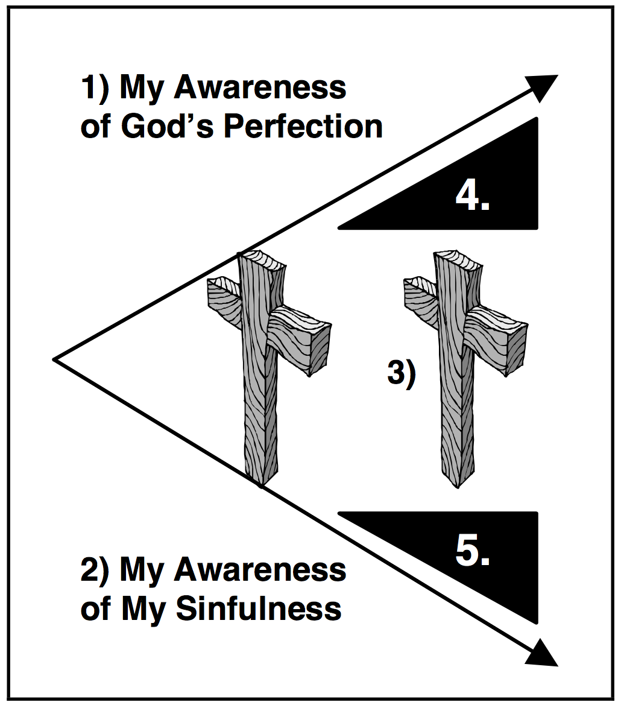
Pride, or a desire to look good in the eyes of others, may motivate this. That say it may not - it can come out of a genuine desire to see that gap close and not have the full understanding of what the cross means. Taking it back to Galatians again, they didn’t deliberately move into a gospel of works… but it still happened.
Performance becomes the foundation upon which these people build their reputations.
Sin also influences the modern Pharisee in other ways.

He/she (as we can see in the picture) may think that his sin does not matter to God (notice wedge number 4). In such a case, the importance of the cross is diminished. What he is actually doing here is reducing God in his mind to be less than He truly is.
Others may think, “I’m not really that big of a sinner!" These people put a wedge (number 5) in the bottom space beneath the cross.

Question:
What effect do those two wedges have on us?

Isn’t it much easier to see someone else’s sin than our own sin? Why is this? Is it true that we have less of a problem with sin than others do?
If we think this, we are deceiving ourselves. Because we think too highly of ourselves, again the importance of the cross diminishes.
Maybe part of the reason we do this is very simple - it’s far easier to point out the faults of someone else than to admit your own. And when you do point out the faults of others it’s very easy to think you are doing a good thing, that your are doing God’s work. And maybe in some cases you are, but there is nothing to be gained in doing that and ignoring your own lack. You will often find the most judgemental people are the ones who have not dealt with things in their own lives - but instead transfer the impulse onto other people’s lives.
Jesus was really specific about this kind of attitude.

Matthew 7:3-5
Why do you see the speck that is in your brother's eye, but do not notice the log that is in your own eye? Or how can you say to your brother, ‘Let me take the speck out of your eye’, when there is the log in your own eye? You hypocrite, first take the log out of your own eye, and then you will see clearly to take the speck out of your brother's eye.

In order to avoid the pharaseeism, we must grow in understanding of the true holiness of God AND the true sinfulness of our own hearts.
Seeing this will humble us and reveal our need for God’s grace.

Despair—Lack of belief
Others have a different struggle. They recognise God’s holiness, and thus their own sinfulness, and they despair because they do not know what to do about it.
They try to fill the gap with good works, but they feel that they can never do enough good works to really please God.
They may strive to spend time in God’s Word each day, but on days that they fail, they feel terribly defeated about their walk with God. They try to keep their tongues in check, but when they fail, they wonder how God could really love them. Because of all their failures, they conclude that they can never please God. Thus they despair.
This can lead to a very up and down Christian life, rollercoaster Christians. When they are doing well, when they’ve been in great worship, when they’ve had a victory over something they can be on top of the world.

Question:
Are there any ways in which you identify with / recognise that feeling in yourself. Discuss how that makes you feel.

But then on days where they have failed - on days where that gap shows how big it is, then can be so far down into gloom and doom that they don’t even seem like the same person.
That’s not a full Christian life.
The problem here is a lack of faith in what God has done. God has provided all we need to be acceptable before Him in the sacrifice of Christ Jesus

Heb 10:14
For by a single offering he has perfected for all time those who are being sanctified.

What a verse. What an offering He has made! That He has perfected FOR ALL TIME, that includes now, ALL THOSE who are being sanctified. That includes you.
We cannot add to what he has done.

The Answer: The Cross must grow
The two problems described above are really similar to one another.
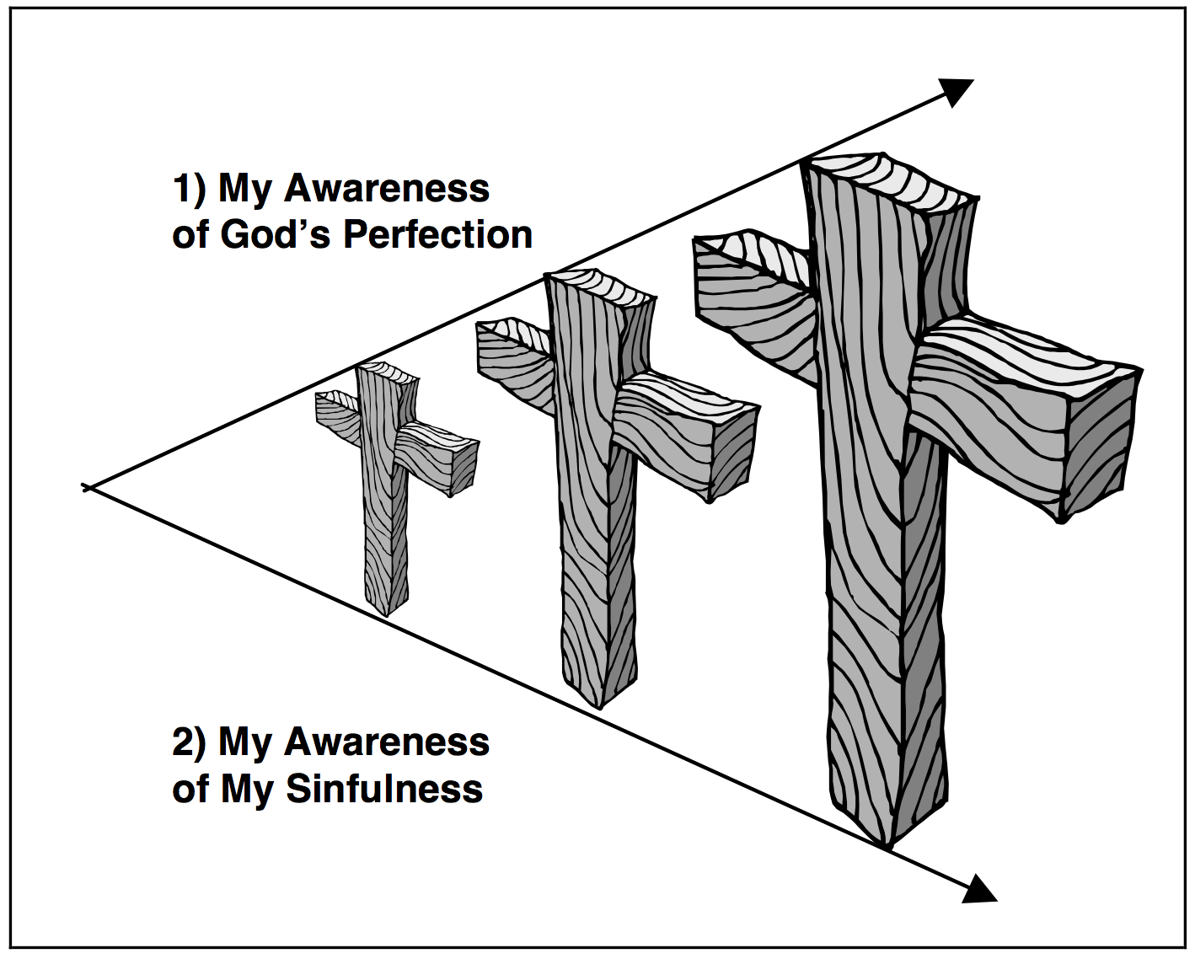
The Pharisee incorrectly believes he can earn God’s favour with his own works while the one who despairs correctly knows he cannot earn God’s favour by his works.
But in both cases the standard is wrong. The focus on earning God’s favour is the foundational problem.
Both are based on the same misunderstanding of God’s favour and the cross.
Since the problems are similar, the solutions are quite the same.
Basically, in order for the gap to be closed, the cross must grow. Nothing we do can bridge the gap. As Paul said,

Gal 6:14
But God forbid that I should boast, except in the cross of our Lord Jesus Christ

Jesus Christ and His work on the cross become more and more important to us. The more we understand the true nature of the cross as we grow, the more we depend up it.
We must believe the new realities of our life in Jesus Christ.
Though we are still prone to sin, God is gracious and forgives our sin. We stand perfectly righteous in Christ only because of His work on the cross.
We have become children of the living God and are loved by Him. He delights in us and is committed to making us into the image of Christ.
The more we grow - the larger our view of the Cross should be.

Conclusion
The cross is our only hope for peace with Him. There is no other place that sinners, even justified sinners, can meet God except at the cross.
None of us ever get so good that we are above the need for the cross. And none of us ever get so bad that we are beyond the help of the cross.
In order to grow spiritually, our focus should be on understanding more fully the realities of Christ’s accomplishments on the cross rather than on trying harder.
Day by day, and moment by moment, we must remember what Christ has done for us on the cross by taking away our sin and giving us new life.
In this view of sanctification, we understand that our flesh remains evil until the day we die. But we also recognise the life of Christ in us.
We work out our salvation in partnership with God, not on our own. That means we get closer to Him. When we fail, instead of pulling away, we press closer to Him.
As we grow in knowing God, we are also being changed more and more into His image. Our inability to do this on our own becomes clear and we develop total dependence on Christ.
The Gospel becomes much more relevant to us, and our need for Christ becomes much greater.
We understand more deeply what we first believed. We remind ourselves of the truths of the Gospel. By faith we are making the accomplishments of Christ’s death and resurrection more of a reality in our lives.
It is my hope and prayer that we are all growing in our walk with God. That first, we get closer and closer to God - that He is our pursuit.
As we do so I pray we see our sin for what it is. That the more we see of His holiness we realise the lack in our own lives.
And as we do so, I pray we rely ever more on the cross and nothing else.
We then, instead of been confirmed to the patterns of like world are transformed but the renewal of our minds. We become more and more a reflection of Him. Our moral lives change and get closer to Him.
The cross does not become less important as we grow - it becomes so much more important.
Every Christian should be living this dynamic, changing, life.

