Our Spiritual Character
Part 009 - Justified by faith - the foundation for everything

Leaders Notes

Lesson Purpose
The purpose of this lesson is to teach the group member how to be set free from guilt, denial, and a life compelled to maintain his or her reputation, as Christ’s righteousness becomes the foundation for Christian living.

Main Points
- Justification is an exchange of our nature with the nature of Christ.
- Justification by Faith is the foundation for our relationship with God.

Desired Outcomes
When the content of this lesson has been mastered, each participant should:
- Know what justification by faith means.
- Have a deep appreciation and assurance of God’s grace that is rooted in the righteousness of Jesus Christ.

INTRODUCTION
As believers, our relationship with God is the focal point of our lives. Nothing matters more than how we relate to God and how He relates to us. But in this relationship we have many questions:

- How can we know God intimately?
- Does God truly accept us?
- Where does our acceptance before God come from?
- How can we live a life that is pleasing to Him?
- What happens when we sin?

You may even have more - but these ones are extremely common ones. You will find when you are discipling people - these ones come up a lot.
Questions like these and how we deal with them in our lives has a big effect on us. It effects how we see ourselves - how we think God sees us and as a result effects how we see God. That makes them pretty important questions.
To answer questions like these, we go back to the very beginning—to the Gospel, the foundation of our relationship with God. It’s here where we end the answer to all the question on how God thinks about us and how He accepts us.
The New Testament describes salvation as a matter of “justification by faith.”
This is a huge phrase. One that was significant enough to start an entire reformation in the church. But without coming back to it and re applying it, we forgot it’s significance and get stuck into the same religious performance trap that so many have before.
It’s all very well to say we believe we are justified by faith - but we really need to apply it into our lives, or it will find ourselves stuck.
In this lesson, we will consider what justification by faith means and how this foundation, built upon the righteousness of Jesus Christ, is the only sure foundation for our relationship with God.

JUSTIFICATION IS NOT...
Simply stated, justification means being declared righteous. It means to be absolved or aquitted.
There are at least two errors that people make concerning this great doctrine.

Justification is not by works
The great philosopher Aristotle believed that people could become good (be justified) by practice.
Many have agreed with him. In Jesus’ day, it seems the Pharisees would have agreed with Aristotle. For them, the way to be good, to be acceptable before God was by practice— specifically by living according to God’s law.
Now you’d think a line of thinking that comes from a Greek philosopher and the Pharisees would not find it’s way into Christianity. And you’d be wrong. It does, because it’s a way of thinking that comes very naturally to us.
The well-known theologian Thomas Aquinas agreed with Aristotle; thus a system of salvation by works remains a cornerstone of many followers of Aquinas.
Aquinas was actually a big admirer of Aristotle and wrote commentaries on his work.
It’s interesting that the Catholic church to the day regard Aquinas very highly - in fact he is used as a model teacher for anyone who enters the priesthood and regarded as the greatest theologian. So built right into the teaching of every Catholic priest is the idea of salvation through works.
Those who follow Aristotle’s view and the view of Thomas Aquinas could be classified as following religion.
Here, we are defining religion as an attempt to reach God. The Gospel however, teaches something entirely different about how we become good.
According to the Bible, the only way to be justified is to accept by faith the salvation provided by the death and resurrection of Jesus.
The Gospel, including justification by faith, stands in direct contrast to all other religious systems of acceptance before God.
And it’s so important that we as Christians understand it.

Table 1 - The Gospel and Religion
Gospel | Religion
(God’s Supernatural attempt to reach man) | (Man’s natural attempt to reach God)
Grace | Works
Faith | Obedience
Unconditional Love | Judgementalism
Transforming Holy Spirit | Personal Effort
Grace leads to Obedience | Obedience leads to grace

Bible-believing Christians will quickly understand that the Gospel is true and that religion is false.
Aquinas and Aristotle are all about religion - not the Gospel.
Religion brings with it a focus on works, a judgemental attitude that is usually entwined with guilt about our own lives - it means effort from self and a frustrated life.
Now we know this - we teach this. But unfortunately our default setting is to go back to religion.
We do not want to replace the Gospel with religion, but we are tempted to mix the two. And it’s easily done.
But when we mix the Gospel with anything, we destroy it.

Gal 1:6-7
I am astonished that you are so quickly deserting him who called you in the grace of Christ and are turning to a different gospel— not that there is another one, but there are some who trouble you and want to distort the gospel of Christ.

The Galatians were doing this very thing - they were taking the Gospel and adding works to it - specifically in this case the law on Circumcism.
The second you add anything of the law to the cross, you’ve missed it.

Gal 5:4
Christ is become of no effect to you, whoever of you are justified by the law; you are fallen from grace.

An easy way to think of this is:

Jesus + Anything = Nothing.

We cannot add to the cross. And often we are tempted to do so.
Someone may be quick to say, ”We do good works." True, but we do not receive God’s favour by it. Rather we have received God’s favour and therefore we do good works.

Question:
- Why do think the focus on good works is such an easy trap for Christians?
- Can you think of any examples of ways people today try and add to the work of the cross?

Justification is not a pardon
Many believers correctly understand that justification before God is by faith and not by works, but they incorrectly conclude that justification is really simply a pardon in which God chooses to overlook our sin.
This is a great mistake.
God does not simply choose to ignore our sin. His holiness prevents that possibility. Sin must be paid for. Justification is an act by which someone is declared righteous. We are declared righteous on the basis of the fact that Jesus paid the price for our sin.
Those who think of justification as merely a pardon fail to realise the great price that was paid on our behalf and can tend to take their salvation for granted. However, our justification came at a great price that should inspire us to live out of gratitude for what God has done.
And remember - although it does not decide our salvation - at the Judgement seat we must give an account for everything, right down to every careless word.

JUSTIFICATION IS …

The Righteousness of God: Romans 3:21-24
Romans 3:21-24 is one of the clearest passages concerning justification by faith. Studying the passage phrase by phrase reveals many of the various aspects of justification by faith and how Christ’s righteousness forms the foundation of our relationship with God.

Rom 3:21-24
But now the righteousness of God has been manifested apart from the law, although the Law and the Prophets bear witness to it— the righteousness of God through faith in Jesus Christ for all who believe. For there is no distinction: for all have sinned and fall short of the glory of God, and are justified by his grace as a gift, through the redemption that is in Christ Jesus,

- “apart from law”
The righteousness of God is not obtained on the basis of our obedience to God’s Law. Why not? Because not one of us keeps the Law of God perfectly—which is what God requires if we are to be justified by our obedience to the Law (Gal 3:10 - For all who rely on works of the law are under a curse; for it is written, “Cursed be everyone who does not abide by all things written in the Book of the Law, and do them.”).

- “a righteousness of God ... has been made known”
The righteousness of God expresses His “perfect purity." Righteousness for us is exact conformity to this perfect purity of God. If we take the context into account and the fact that justification by faith is being explained here, the “righteousness of God“ means a perfect purity that comes from God or is given by God.

- “to which the Law and the Prophets testify”
In the Hebrew mind, the two primary divisions of the Old Testament were the Law and the Prophets.
In both we find God’s revelation speaking of this righteousness obtained apart from our obedience. In other words, the whole Bible testifies to this profound truth.

- “this righteousness from God comes through faith in Jesus Christ to all who believe”
Faith is the means by which we obtain this righteousness. The object of our faith must be Jesus Christ, because He is the One who died in our place, paying the penalty of sin.
He alone was able to pay for our sin in full, because He is the perfect Son of God. This is why it is essential to put our faith in Him.

- “for there is no difference; for all have sinned and fall short of the glory of God”
All of us need this righteousness through faith in Jesus Christ. There are no exceptions, because we have all sinned and our sin has caused us to fall far short of God’s perfection that reflects His true glory.

- “being justified freely by his grace"
The perfect righteousness required to be right with God is imputed to us when we believe. It is a gift given because of the gracious character of God, not because we deserve it. It is a gift in the truest sense; not deserved, not expected, but accepted.

- “through the redemption that came by Christ Jesus”
In love, God wanted to impart this gift of forgiveness and righteousness to us, but His holiness required that the penalty of sin, which is death, be paid. So Jesus Christ came and died in our place, paying our penalty.
As a result, He fulfilled the righteous requirement for God to forgive us and to declare us as righteous in His eyes. The redemption from sin was the price paid to purchase our justification.

The Great Exchange
In summary, justification is the gracious act of God in which He causes a great exchange to take place. As a sinner approaches God in repentance and faith, God removes the guilt of his or her sin and gives it to Christ.
He also takes Christ’s perfect righteousness and gives it to the new believer. The result is that the new believer's sin is completely forgiven and he or she receives from Christ the perfect righteousness needed to stand righteous before God (2Co 5:21, Is 61:10, Ro 4:3- 5, 8:1, Eph 4:22-24).
Revelation 20:12 speaks of a day when God will open the books that contain the records of our lives and He will judge us according to our deeds. What do you think we will find in our books? The prophet Isaiah explains that under the judgment of a holy God, “all of us have become like one who is unclean, and all our righteous acts are like filthy rags“ (Isa 64:6).
Most people will be surprised to discover that their books contain long records of sin. However, when we look at Jesus’ life, we see that He was perfectly obedient to God for he lived a righteous life without sinning.

Hebrews 4:15
For we do not have a high priest who is unable to sympathise with our weaknesses, but one who in every respect has been tempted as we are, yet without sin.

He was tempted in every way - but DID NOT SIN.
When we repented of our sins and accepted, by faith, Jesus Christ as Lord and Saviour, God took away our sins and gave them to Christ. He then took Christ’s righteousness and gave it to us. The result is that our record of sin was given to Christ, and Christ's record of righteousness was given to us. Justification can be pictured as the exchange of our "record of sin" for Jesus Christ’s "record of righteousness."

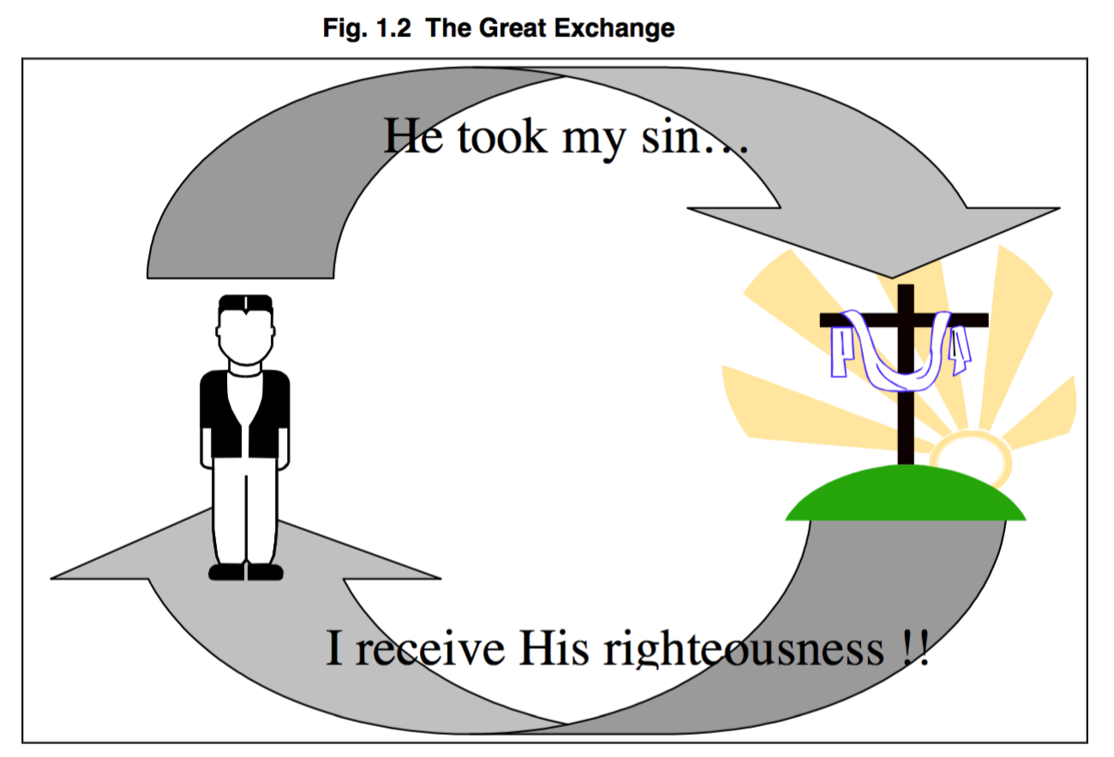
The Great Exchange illustration (Fig. 2) helps us understand justification by faith.

THE CRUCIAL ISSUES OF JUSTIFICATION BY FAITH

We Cannot Justify Ourselves
Observing these key aspects of justification as a whole, there is an important truth that is woven through these ideas.
When we are told that justification is a righteousness given apart from our obedience to the Law, that it is given through faith in Jesus Christ, that it is given to sinners by God’s grace, and that it is paid for by the redemption of Christ... all of these ideas express the truth that man has nothing to do with this righteousness.
And that is a very good thing - because if it was down to us we would keep on failing. We’d never be able to do it!
Explaining the true nature of justification, Martin Luther has rightly described it as "passive righteousness", because we have nothing to do with producing it.
Jesus Christ earned this righteousness for us and we may only receive it by faith. This truth is the foundation of man’s justification before God and this is where true Christianity finds its great difference with all other religions, as well as with the false forms of Christianity. And the bible is really, really clear about this.
This is also where we have the greatest difficulty ourselves, because justification by faith expresses to us the degree of our true sinfulness and our infinite need for grace. It tells us that to be righteous before God, we must look outside ourselves because we do not have this righteousness, and we must humbly accept the only means through which we may be right with God through faith in Jesus Christ.
This is the key issue of justification. It doesn’t work without humility - and with that humility comes repentance. True repentance.
If we think that we can stand righteous before God by anything other than the provision of Christ, then we grossly miscalculate the true holiness of God and the depths of our own true sinfulness.
If we ever think we can earn our way to heaven we have a low view of heaven and a high view of ourselves. That’s the kind of thinking that leads to the self righteous - judgemental - proud person.
How can we think that we are worthy in ourselves to have peace with a perfectly holy God? This is the worst kind of arrogant presumption because it reduces God to the level of sinful man and lifts up corrupt man to the level of a perfect God.

We Cannot Take Credit for What God has Done
In giving his life, Jesus paid the penalty for all lawbreakers. Because of who Jesus is, we can trust God to justify us.
Not fully trusting in the death of Jesus Christ on the cross as the basis of our forgiveness and our relationship with God is insulting to God to say the least.

Example:
Consider a man who has done a terrible crime, and is awaiting the penalty of death. As he is waiting, one of his friends goes to the judge and asks for his pardon.
The judge replies, “I will let him go, if you give me your son to die in his place." The friend says, “This is ridiculous. How could I ever do this?" But the judge says, “This is the only way that I will let him go free.”
After much agony, the father decides he will sacrifice his son for the friend...knowing it is the only way.
In obedience, the son goes to the judge and agrees to die in the place of his father’s friend. The next day the judge executes the son and sets the man free.
Soon after this, the father happens to overhear a conversation between the released prisoner and a friend.
When asked, “How were you set free from your penalty of death?” the released man replies, “Well, while I was in prison I kept myself clean, behaved well, and did what the guards asked. Then they let me go because of my good behaviour.”

How do you think this man responded to what his friend said? How could this man think that his behaviour had anything to do with his release after his son had given his life for him?
When we put in these terms we can really see how - silly - yes silly that view is.
It is not because of our behaviour, or even the greatness of our repentance, that God forgives us of our sins.
Even though God’s Word teaches that true faith will be demonstrated by our love for and obedience to God, we should not confuse this with the truth that God has pardoned our sin solely because He is loving and gracious, giving His only Son to die in our place on the cross. Jesus Christ paid the penalty for our sin, and it is His sacrifice that bought our freedom from God’s wrath.

We Must Trust God Completely
Those who believe in religion, and therefore in justification by works, build their relationships with God on their obedience to Him.
The problem then is, their conscience keeps telling them that they aren’t doing a very good job of obeying Him, and therefore it convicts them that they have no right to believe that God overlooks their sin or will pardon it without justice.
This creates a crisis, in which they either conclude that they are not so bad (searing the conscience), or that if they do something that pleases God, God will overlook their sin (compromising the true righteousness of God).
Even Christians face this problem. Our conscience tells us that we do a poor job of pleasing God.
At this point, we are tempted to turn to false cures to soothe our conscience and solve the problem of sin.
Sometimes we try to soothe it by thinking that we are not as bad as someone else is; therefore, we must not be very bad.
Or we seek to do much better, trying to make up for our failure. This is a very subtle error because resolving to obey God better is not wrong. But what we are inclined to do is base our relationship with God on our performance, on religion instead of on the Gospel.
We can get in the position where we think God looks at us based on how well we are doing. If we have failed we think God must not love us as much. And as a result we can sulk and do more wrong and get caught in this awful place where we feel anger towards God for turning away from us and anger towards ourselves for messing up. We end up in a totally distorted way of thinking.
We commit a critical error when we shift the basis of our trust in salvation away from the work of Jesus Christ on the cross, and onto our performance or obedience.
This wrong thinking can cause us to hide from our real sinfulness or become discouraged, and even depressed.

CONCLUSION
As we live the Christian life, we cannot move our faith away from the forgiveness and righteousness Jesus Christ earned for us. The death of Jesus on the cross paid the penalty and allows us to stand just before God.
Justification by faith must remain the foundation of our relationship with God. The cross is our only hope for peace with Him. There is no other place that sinners, even justified sinners, can meet God except at the cross.
Building our life upon justification by faith in Jesus Christ should set us free to serve God in bold ways, not because we always obey God perfectly, but because we have the confidence that our relationship with God is built upon Christ’s work for us.
Justification is not a matter of our own personal effort—but instead is by grace through faith. Justification by faith puts grace before our obedience, which is the way God relates to us in Christ. As we learn that our relationship with God always has been and always will be- based upon His grace, and as we trust in the finished work of His Son, we realise how truly great His love is.
We can be free of guilt and uncertainty - free from our own reputation and effort. Because it’s all about His righteousness, not ours.
We have been saved by grace, and we can only live by grace.

Questions

- Can you simply, yet clearly, define justification by faith?
- What does it mean when we describe justification by faith as a “passive righteousness"?
- In our daily walk with the Lord, why is it so hard for we who began in grace to continue in grace, trusting in the finished work of Jesus Christ on the cross?
- How does justification by faith affect the way you relate to God and the way you think He relates to you?

