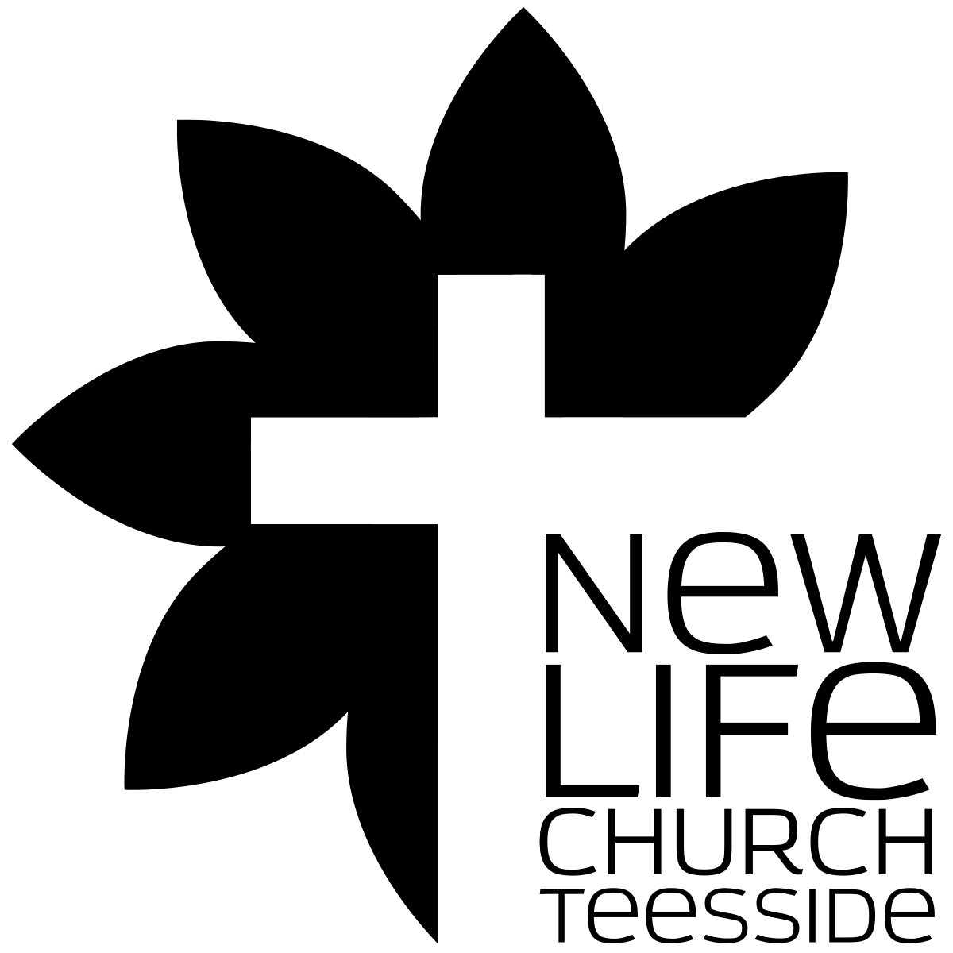
What’s church all about?
Part 008 Defining The Local Church “WHAT ARE WE BUILDING?”

Leaders Notes

Lesson Purpose
The purpose of this lesson is to explore the definition of the local church and how we view it.

Main Points
- An inadequate definition of the local church will hinder church growth.
- Biblical functions are key to a definition of the local church.

Desired Outcomes
When the contents of this lesson have been mastered, each participant should:
- Understand the importance of developing a biblical definition of the local church.
- Know how personal understanding of what a local church is can enhance or hinder the church planting process.

Introduction
No matter what we are doing in church work, whether we are church planting or leading or working as part of an existing church, we must have a clear conviction about what the church is.
It’s something we all need an understanding of in a church - otherwise we can all be going in different directions - even well intentionally, all trying to help grow the church but but actually making it harder because we all have a different definition of what a church actually is.
This basic question, “What is a local church?” cannot be taken for granted. To be sure we are on track, we must ask it often.
But not just ask it, we also need to ask further question - what is a local church and are we line with that definition?
A lot of people talk about the need to redefine church. And often that’s taken as an excuse to throw everything out in the name of progress. And that’s not what I mean - but we need to keep revisiting the question of what is a local church to make sure we are keeping on track with that.
Because sometimes we can get caught up with things that are not essentially what the church is about.
Perhaps the following illustration will demonstrate why this lesson is important.

Swiss Watches:
Before World War II, Switzerland made and produced almost 90% of the world’s watches.
By 1970, the Swiss still had 60% of the market, but by the early 1980’s, their share dropped to below 10%.
What happened?
The quartz watch was introduced in the late 1960’s. This was a new way to power watches other than to wind them up.
And the Swiss did not utilise this technology while other watchmakers (Seiko and Texas Instruments) did.
The Swiss watchmakers rejected the quartz because of their understanding of what a watch was. They could not imagine a watch without gears, springs and wheels. Since the quartz watch did not use these, they rejected it.
To them - a watch was about the mechanism. If it didn’t have this, it wasn’t a watch.
In summary, we could say they lost sight of the function of watches (to tell time) and instead defined watches by the forms they were familiar with. Therefore they missed out on a great marketing opportunity.
What they were doing - they were doing well. There was no denying the craftsmanship of it. But when you lose sight of the function - then that doesn’t matter.
Swiss Watches now DO use Quartz.

Just as the Swiss’ working definition of watches resulted in their missing of a great opportunity, so the definition of the church can affect the success of the church planting process dramatically.
The definition of the church reveals what we are expecting to produce and determines strategies and forms we use.
Sometimes in church we get obsessed with the cogs and the mechanism, we get right into this detail about how it works and forget what it works for. Our definition of what church is therefore is very important. Are we looking at the cogs or how we tell the time?
The definition will be the reference point, the measuring stick for any sense of success or failure. If we start with a poor definition of the church then it may lead to failure.
Not only that - if we continue - even if we are doing a good job - to operate with a poor definition, then we shall fail in our commission.
We will never know if we are really building the church if we have the wrong definition of what church is.
This is how dying, dry and dusty churches can think they are doing well - because their definition is wrong. It’s also how shallow but entertaining churches that have no real maturity in their congregation can also think they are doing well.
It all comes down to the definition.

Question:
What unnecessary items are typically added to people’s working definition of the church?

- THE DIFFICULTY OF DEFINING THE CHURCH
Churches can be very different from one another. Note the following observations:

- Some churches meet in large buildings. Some churches meet in small buildings. Some churches do not meet in any building. Some churches meet in homes.
- Some churches meet one time a week. Some churches meet two times a week. Some churches meet three times a week. Some churches meet just about every day of the week.
- Some churches have a man who preaches. Some churches have a man who just talks. Some churches have a man who teaches like in school.
- Some churches seem to be fun to be in. In some churches no one smiles.
- Some churches have active services, with people moving around and responding verbally to everything that happens. Some churches have very quiet services in which most of the people sit quietly and listen.

With all these variations, how is it possible to describe the core elements that must exist before a group can be called a church?
It’s entirely possible for some of these completely different ways of doing church to be all correct. It’s also possible for them all to be incorrect.
Are there some basic norms that should be true of local churches in any time and in any culture? And if so, what do we consider to be those core elements?

QUESTION:
Take several minutes and talk and answer these questions. For Question 3 use the scenarios below:

- When is a group of people a church?
- What are the criteria for deciding whether it is a church or not ?
- Respond to the following situations. Is each a church? Why or why not?

Scenario 1
Eight believers in Wingate meet every Tuesday night for Bible study and fellowship. They have no official pastor although one man facilitates the gathering. They have been doing this for years. Some of the participants also attend a church on Sunday.

Scenario 2
In a medium-sized city, there is a beautiful historical church building with a rich history of great preachers and community involvement. On tours of the church which are offered twice a day, one can learn about the unique architecture and history.

Scenario 3
An evangelist has led 10 young people to Christ in the past year. He would like to see these new believers assimilated into an existing church but the nearest one is 50 miles away. Instead, they meet in his apartment every Sunday evening for worship and Bible study.

Scenario 4
A man and his immediate family are the only believers in their city. The family takes time every Sunday morning to worship the Lord.

- EXAMPLES OF CHURCH DEFINITIONS

QUESTION
Discuss the following definitions and answer the related questions.

Example #1
The following definition is an attempt to define the church by using only specific references from Scripture that describe how God’s people are to relate to one another. This definition emphasises the relationships that should exist between believers.
“A church is a group of people who are devoted and give preference to one another (Ro 12:10), accept one another (Ro 15:7), care for one another (1Co 12:25), carry each others burdens (Gal 6:2), forgive one another (Eph 4:32), encourage and build up one another (1Th 5:11) spur each another on to love and good deeds (Heb 10:24), confess their sins to one another (Jas 5:16), pray for one another (Jas 5:16), serve one another (1Pe 4:10), and love one another (1Jn 4:11)."

- How would this definition enhance or hinder the church growth and planting?
- What kind of a church would be produced by a group of people who subscribed to this
definition?
- Is this definition adequate? Why or why not?

Example #2
“A New Testament local church is an organised assembly of baptised believers, in which the unique presence of Jesus Christ dwells; who gather regularly for worship, instruction, fellowship, the Lord’s Supper, and baptising new believers, under the obedience to the Word of God, supervised by elders who are assisted by deacons putting into action the equipping gifts that God has given its members to build up that local congregation, resulting in a Gospel witness locally and world wide.”
- How would this definition enhance or hinder church growth and planting?
- What kind of a church would be produced by a group of people who subscribed to this definition?
- Is this definition adequate? Why or why not?

Example #3
The following definition is much more traditional and may be the definition you would hear from the average non-believer on the street.
“The local church is a building where people gather to receive religious services from professional ministers who have been specifically trained to lead meetings each Sunday morning as well as the other activities for the people such as weddings and funerals."

- How would this definition enhance or hinder church growth and planting?
- What kind of a church would be produced by a group of people who subscribed to this
definition?
- Is this definition adequate? Why or why not?

Example #4
“A local church is an organised body of baptised believers, led by a spiritually qualified shepherd, affirming their relationship to the Lord and to each other by regular observance of the Lord’s Supper, committed to the authority of the Word of God, gathering regularly for worship and the study of the Word, and turned outward to the world in witness.”
- How would this definition enhance or hinder church growth and planting?
- What kind of a church would be produced by a group of people who subscribed to this
definition?
- Is this definition adequate? Why or why not?

Did we decide if any of these were adequate alone?
If we combine elements from all of there do we find an adequate definition?

Question:
How can buildings help or hinder the growth of the church?

- GUIDELINES FOR DEFINING THE CHURCH

Avoid prescribing forms, structure and programs in the definition of the church
There is a tendency to focus on forms and structure rather than on biblical functions when defining the local church.
Our last session was on form and function - if you missed it let me know and I will try and email you the notes. They were a revelation to me.
When we do this, they can become like the Pharisees, concentrating on the outward appearance of spirituality and not on the internal spiritual reality that reflects a right heart towards God and right relationships toward others, both in and outside of the church.
Forms, then, can become a false reference point for success, suggesting that a local church equals such things as choirs, hymnbooks, a piano, a sound system, a building with pews, a Sunday school program, a constitution, etc.
While there is nothing wrong with these things, they do not define the church as a spiritual people. They are just the forms that it can take.
When forms, structures and programs are part of the definition of the church, it severely limits the church’s ability to be a dynamic force of change, witnessing to a constantly changing society of God’s saving and unchanging love.
When biblical functions are key ingredients in the definition of the church, we are on solid ground for designing ways and means for church ministries that are indeed winsome. Then we can find forms that are going to bring people in.
And that’s a key question we have to ask - what new ways and forms can bring people to Jesus?

Question
Why is it wrong to focus on forms when defining the local church?

Stress the biblical functions that the church must perform
The most helpful definitions of the local church focus on the functions of God’s people as revealed in Scripture instead of the particular forms the church follows.
The church is a collection of God’s own children. The relationships of God’s people to God and to one another then should be the point of reference out of which congregational programming flows.
Beginning church planting with a focus on programs can result in structures that do not meet relational needs. It is wiser to focus on biblical relationships and let the organisational structure and programs develop accordingly.
That is why we are placing such a high importance on discipleship. This is spare to develop and relate.
For example, a church planter determined that a Wednesday night prayer time was important for every church. Early in the life of the church which he had planted, he initiated a Wednesday night prayer time, but there was little interest since community commitments kept many church members busy at that time.
This was very discouraging to the church planter because he interpreted the poor response as a lack of interest in prayer. However, if he had allowed the function of prayer to take a different form, then perhaps there would have been a greater response.
That is one reason we keep changing the form and time of our prayer events. It's not just to keep variety - the function of prayer in what is important. The form can keep changing to keep everyone engaged.
Another church planter was convinced that a beautifully adorned church building was necessary for worship. After one year of church planting ministry, with 15 believers committed to his church, he decided to establish a building. This required permission from the city officials, raising funds, purchasing land, hiring a construction company to build, etc. This project consumed all of the church planter’s time so that he was unable to focus on ministering to the 15 believers in his flock. Furthermore, funds were very difficult to come by and city officials seemed to be doing everything possible to hinder the building process. He wondered if he would ever see the church established.
When we let form rather than function dictate our definition we will be frustrated and ploughing energy into building the wrong thing.
So the important thing is to find the correct functions first.

- WRITING YOUR DEFINITION OF THE CHURCH
So we are now going to write a definition of the church. it may not be a definitive definition right now, but it’s a start.
To prepare to develop your definition of the church, read the following passages looking for principles that explain what the church is. Write the principles in the space provided. Use other biblical references if you believe they are helpful.

Ac 2:42-47, Ac 11:26, Ac 14:23, Ac 20:7, Ac 20:28 1Co 1:2, 1Co 12:28, 1Co 14:33, Eph 1:22,
Eph 4:11-16, Eph 5:27, 1Ti 3:15, Heb 10:24-27

In the space below write your definition of the church.

Consider the following questions concerning your definition:

Is it understandable?
Is it compatible with Scripture?
Is your definition basic enough to describe all churches everywhere and at all times?
Does your definition allow for a church that is reproducible?

Share your definition with others and carefully note their reactions.

