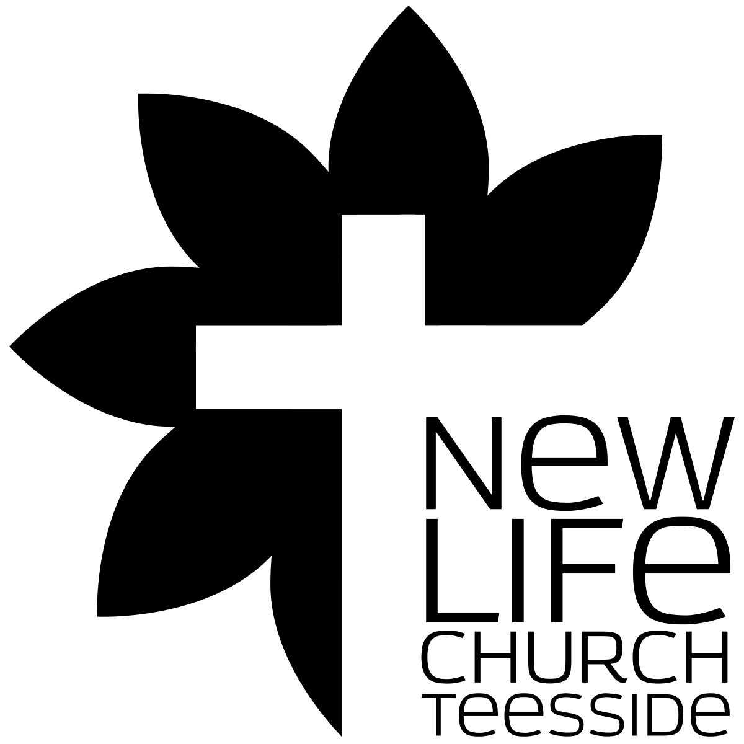
What’s the Church all about?
Part 007 - Form and Function - A biblical View

Leaders Notes

Lesson Purpose
The purpose of this lesson is to explain the important concept of form and function in the church, from a biblical and cultural perspective.

Main Points
- Biblical function is what must be done—it was given by God and should not be altered.
- Biblical form is how we do the function—it is cultural and should be adjusted as needed.

Desired Outcomes
When the content of this lesson has been mastered, each participant should . . .
- Understand the concept and issues of ‘form and function.’
- Recognise how cultural dynamics and personal experience affect the expression and forms of the local church.
- Be motivated to establish church forms based on biblical function and cultural relevancy.

INTRODUCTION
An understanding of form and function is fundamental to how we understand the purpose, mission and shape of the church we are part of.
Our experience largely shapes our understanding of, and dedication to, the forms our churches take.
It doesn’t matter who we are, or how long we've been part of a church - this is true of us. It’s as true of the 90 year old who is part of a very traditional church as it is to the 18 year old who is part of a church that feels more like a concert. Both will defend their version to the end. But both need to understand the difference between form and function.
We must be challenged to ask why we do what we do to accomplish the mission God has given His Church. If you can get your head around this, it can transform the way you view what we do at Church.

- FORM AND FUNCTION ILLUSTRATED
So what do we mean by forms and functions?
In society, a function is an activity that needs to be performed. This activity can range from one as difficult as getting food or raising children, to something as easy as sleeping. These are things that need to be done.
A form is the method chosen to carry out that function.

Function = an activity that needs to be performed

Form = the method chosen to carry out the function

Here’s an example: Getting Food.
The function is getting food so you can eat it. That is an absolute. The form however, has to be adaptable.
In the primitive days, you could hunt or you could grow crops. These are two very different methods, both are two different forms that fulfil the function of getting food.

The question is: how do you decide which is the best form for you?

- Some of the factors for the decision come from internal sources, such as abilities and preferences. Do you have a good eye and donʼt mind being alone for long periods of time? Then you might do better as a hunter. If not, stick with farming.
- Some of the factors are external, depending on your environment. Do you live on or near good productive land? If so, you might do well to be a farmer.
- Some of the factors are cultural, depending on the ideas of the society you are in. Are farmers prized because they add to the amount of crops in the village, or are hunters prized for their skill in case of war?
- Some of the factors may be moral. Is the killing of animals looked upon as immoral?
- Another factor is tradition. What did your parents and their parents do?

All of these things have an effect on the form you choose. They don’t change the function - to get food. But the form can be different depending on all those circumstance.

Forms depend on many factors and can also change with time.
Your field may no longer produce, or the game may become sparse and you are forced to choose a new form.
With time, new inventions may change your ability to carry out your profession, or make you choose a new profession that had not been available before, such as a shopkeeper, where you sell goods to obtain money and buy food - still meeting the same function but a big change in form.

Transportation is another example of the principle of form and function in society. Transportation is a function that can be fulfilled through many possible forms such as: bicycle, subway, automobile, and horse & cart. The question is:

- What will determine the means of transportation you use? Why?
- What makes one way better than the others?

So to fulfil the need of the function of transportation, we ask questions.

“How far am I travelling? Is it raining? Do I even own a horse?”

And these answers determine the form my transport will take.

- FORM AND FUNCTION IN THE CHURCH
Form and function can be defined broadly as in the examples mentioned, or it can focus on a particular area.
For example, there are also biblical forms and functions described in both the Old and New Testaments.
However, in order to understand the importance of this concept in church, we will focus the definition even more tightly, and look only at church forms and church functions. So that takes us to the New Testament.

Church Functions
The New Testament includes many commands, laws, instructions, precepts, prohibitions, and principles that the church must carry out.
These functions are timeless and supra cultural. What does that mean? Supra means above - outside of. It means that it’s above cultural changes - not effected by them. Some things change - supra cultural things do not.
The New Testament functions of the church do not change and are mandatory for all believers, regardless of race, culture, age, or language.

QUESTION:
Can you come up with some examples of Church Functions?

LEADERS - HERE ARE SOME EXAMPLES: Worship, fellowship, service, spiritual discipline, prayer, evangelism, discipleship, giving, teaching, communion.

A Church Function is an activity that the Lord has commanded His church to carry out. These are unchanging and not optional. If you don’t do these, you are not a church.

Forms
Church forms include all the structures, traditions, methods, and procedures that the church chooses in order to carry out the functions in a particular age, culture, or situation.
These forms can and do vary greatly among local churches—resulting in many acceptable forms for every church function.

QUESTION:
Can you come up with some examples of Church FORMS?

LEADERS - HERE ARE SOME EXAMPLES: Offerings for Missions, the Jesus Film, greeters at the front door, paid preachers, Wednesday (e.g. “once-a-week”) evening Bible study, Praise reports, Stage Lighting, Connect Groups, tea and coffee before a meeting and so on.

Form and Function Together
The life of any local church cannot be taken out of its particular cultural / historical context. Our ʻexperienceʼ of church is not based solely on biblical teaching.
The way we ʻdoʼ church is based upon a mix of historical traditions, cultural (and sub-cultural) practices, and biblical convictions.

We often speak of how we “do church” and compare it to the new testament. But we need to consider what forms the church took both then and now were and are down to the surrounding culture and the best way of reaching that culture, which means some forms in the new Testament may very well not be the best forms to use now.

Here’s the problem. We find it hard to separate form and function.

When we speak of biblical functions (such as worship, prayer, fellowship, teaching, sacraments, evangelism and ministry), it is difficult to do so without describing the forms, traditions, methods, structures and organisations in which these functions find expression and life.

The task of the church as they look at these is to forge church forms first from a biblical basis, then in the light of culturally relevant practices.
Otherwise we can find ourself saying we “have to” do some things that we really don’t and forget some of the things we do have to do.

Figure 1
In Figure 1, we see that there are a number of church functions that are mandated by the Scriptures.
These do not change with time or culture.

However, the bottom row of the figure demonstrates that each local church may need to adopt completely different forms to fulfill these functions in their context and over time will need to change. The forms need not resemble those of other churches—they must only fulfil the church functions.

Question:
Can you think of some functions that have different forms in different cultures / times in history?

- EVALUATING FORM AND FUNCTION IN THE CHURCH
It can be difficult to distinguish between forms and functions in the church unless we take the time to analyse them.
In the following chart, a number of functions are listed on the left, and some of the many possible forms of each are on the right.
Table - Forms and Functions
Biblical Function | Possible Form
Prayer | Keeling or Standing
 | Silently or Aloud
 | Small Group or Individual
 | Before Meal or at close of Service
 | Confession or Supplication
Teaching the Word | Sermon
 | Small Groups
 | Bible Study
 | Family Devotions
Evangelise | Friendship Evangelism
 | Crusades
 | Altar Call in Service

Please note that the list of forms on the right side of the chart is not exhaustive—there are many, many other possibilities.
Is one form better than the others are? No. All of them may be appropriate or inappropriate in a given circumstance and cultural setting. Some are not right for certain contexts - but are good for others.
None of these forms are commanded in the Bible as the only method. Only the functions are commanded. We must choose the form as needed.

In the table below, two sample biblical functions are listed. Take a few minutes to fill in possible forms on the right side. Then compare your ideas with others in the group.

Function Vs Form
Function | Form
Give
Worship

In the table below, a number of forms are listed on the right side. For each form, decide what biblical function it fulfils and write that in on the left side. Then compare and discuss your responses.

Forms Vs Functions
Function | Form
 | Youth Camp
 | Church Prayer Meeting
 | Church Choir
 | Passing an Offering Round
 | Church Buildings
 | Music in Services
 | Kid’s Church
 | Church order of service
 | Reading Poetry in Church

- PRINCIPLES REGARDING FORM AND FUNCTION

The Function Is More Important Than the Form
In the Bible, functions are stressed. Jesus was more interested in function than in form. Those who gave Christ the most resistance were those who were addicted to form, rituals and traditions.
Forms are not usually prescribed in the Bible.
There is the exception of the temple service, where the design of the tabernacle and its furnishings are spelled out in some detail, but this was done for a different purpose. They were used to teach about God, His work and His attributes.
It is not a form that has been carried over into the New Testament Church because the knowledge already exists.

Functions Are Absolute and Trans-Cultural; Forms Are Non-Absolute and Variable
When forms are described in the Bible, we see changes being made in them.
The Passover was a reminder of Godʼs deliverance of His people from Egypt. Jesus changed this at the Last Supper and used it to highlight the deliverance that God was about to accomplish in the death of Jesus.
In the first century church, this again changed and became the Love Feast. But this began to be misused (1Co 11:17-34), so the practice was reduced to the sharing of the cup and bread.
But even this takes on many different forms.
Some use a common cup and some use individual cups. Some use wine and some use grape juice.
The form may be different as long as the function is served.

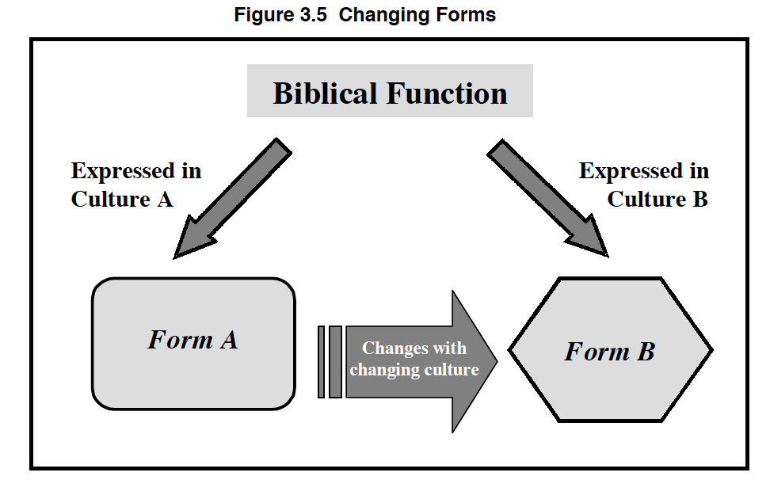
The forms that are described in certain passages are changed or left out in others. They vary from situation to situation.

• Stewardship (1Co 16:1-2; 2Co 8-9)
• Spiritual gifts (1Co 12-14; Ro 12; Eph 4)
• Discipline of church members (Mt 18; 1Co 5; 2Co 2)
• Baptism (Mt 28; Ro 6; Ac 1)
• Day of Worship (Ex 20:8; Ac 20:7)
• Church government (1Ti 3; Tit 1; 1Pe 5)

QUESTION:
How would this principle affect the way you develop forms in your church, based on Scripture?

LEADERS _ HERE IS THE ANSWER YOU ARE LOOKING FOR:
It would mean that the way we express forms needs to consider the surrounding culture. You don’t pick the form then adapt the culture to it - you look at the culture and adapt the form.

People Often Identify More with the Forms Than with the Function

It is unfortunate, but people tend to get attached to the form and miss the function.
They can perpetuate forms that have lost vitality in their respective cultures (e.g. the way a worship service is run). This is how churches die.

There is an old story told about a newlywed bride who cooked her first roast for her husband. When she served the roast to him, the prime pieces on both ends were cut off. He asked her why. She replied her mother always cooked the roast this way.
When the new husband asked the mother-in-law why she did it this way, her reply was, “I donʼt know. Mom always did it that way." When the husband asked grandma why she cut off the ends of the roast, her response was, “The pan was too small for it."
You get the point.

When people believe there are absolutes governing form, they tend to become legalistic in their approach.
Often, resistance to the changing form is caused more by insecurity and fear of change than from theological truth.
This can be a form of idolatry. An understanding of form and function can help people see that change is not always threatening.

Question:
Can you think of some forms people get attached to?

Forms Should Not Be Changed Carelessly

Here is the polar opposite of keeping things the same because we like them. And this one can be just as damaging.
It is not unusual for a young man, just out of seminary or Bible college, with no real pastoral experience, to become the pastor of a church and think that he knows exactly how everything should be done.
He has an idea of what the perfect forms are and is determined to change everything to fit his ideas. He has no idea of what the people are like, nor does he know what they want to do. He may not even know whether the ideas have been tried before and the results.
This can lead to a situation in which the people begin to feel that their pastor does not value them but sees them as part of an experiment and come to resent him.
They also feel as if the church no longer fits them and either the pastor must go or they will.
You would be surprised by how often this happens.

Forms should be changed only to highlight the function.

Here is an example.
One time, in order to highlight worship (a function), a pastor started the service with a hymn (as usual) and then gave the sermon.
The sermon was normally at the end of the service after the special music, extended singing, greetings and announcements, but this pastor chose to speak about God and His wonderful works, then invited the congregation to worship and thank Him through prayer, singing praises (hymns) and the Lordʼs supper.
The change was very effective.
This does not mean that he did it every Sunday.
It was done that one time in order to get people to stop and think in a new pattern about the worship part of the service.
They then returned to the usual form.

Sometimes forms need to be changed for good, because they are either no longer effective to because of changes in the surrounding culture or because they were not actually that effective in the first place but become habit. We need not fear that.

When Forms Freeze, Churches Die
The purpose of the church is to glorify God through the edifying of the members and the evangelising of the lost. This is the eternal, unchanging purpose.
The functions are how we accomplish this purpose. They are also given by God, who has told us how He wants us to glorify Him. They are also eternal and unchanging.
A form is only one of many acceptable ways to fulfil a particular function. Forms can change because they are an expression of society.
There are times when the importance of forms can grow to be so great that people will not let them be changed.
When forms become so important that they cannot be changed, the church will soon die because the society will change and the church will appear irrelevant.
If the church cannot change its expression of the eternal functions, then the church will become irrelevant to that society and will not reach it.

There was a church that chose to reach out to a certain ethnic group in its neighbourhood. The congregation was very comfortable with the forms that grew up for this group. But the forms became too important. The neighbourhood changed and there were fewer and fewer of this ethnic group in the neighbourhood. By the time the church realised that they needed to change, it was too late. They were known as a church that had nothing to offer to the people of that neighbourhood and the church building was closed and the remaining membership disbanded.

Forms, because they should never freeze - therefore must be regularly reassessed.

- IMPLICATIONS OF FORM AND FUNCTION
The forms that you choose will largely influence what section(s) of your society you will attract.
You can say you want young people in the church all you want, but if you are not willing to change the form to attract them - it’s not going to happen.
Forms should emerge naturally from the culture so that the target people can understand what they mean with little or no explanation.
Part of research is looking at who lives in your target area, who is not being reached by churches already present, and finding out how to attract them to your church by choosing forms that will be meaningful to them and faithful to biblical functions.

- Biblical function is what must be done—it was given by God and should not be altered.
- Biblical form is how we do the function—it is cultural and should be adjusted as needed

QUESTIONS
Do the forms in your church experience serve a purpose / biblical function?

Which forms are a hindrance to bringing the Gospel to the lost? To bringing a new convert into the life of the church?

In what ways are your forms strange and foreign to new converts?

How could you develop forms that would be more comfortable to new converts without compromising biblical principles? Describe how these forms are relevant to your target group culture in worship, fellowship, sacraments, tithing, and biblical instruction

When are forms sinful? Why? Give examples and validate with a biblical principle.

Additional Study - maybe to do at home, maybe for a new week. Judge this how you see fit

For additional study, read Acts 6:1-5, and see how the early church leaders dealt with a structural problem, and how they were able to adjust form to create a structure to better serve the need.

INDUCTIVE STUDY OF ACTS 2

OBSERVATION

Read Acts 2:42-47 and note the primary activities and actions of the believers. List each of these activities in the left column of the chart below.

Activities | Function or Form

INTERPRETATION
Decide which of these activities is “form” and which is “function” and write your answer in the column on the right. If you decide that an activity is a form, decide what the corresponding function would be and write that in the column with the form. What were the circumstances that led to the choosing of that particular form?

APPLICATION
Look again at the functions behind each of the forms noted in the table above.
List at least one other form that could have been used.
What form does your church use for that function?
Are there other appropriate forms that could fulfil those same functions today?
How would you go about introducing a change of form to a congregation or in a cell group?
What are important issues to consider when trying to introduce change?

