What’s the Church all about?
Part 006 - Different ways to understand the purpose of the church

Leaders Notes

Lesson Purpose
The purpose of this lesson is to describe how the Church is intended to be a force for the propagation of the Gospel in the world.

Main Points
- The Church is the agent for mobilisation rather than the object of ministry.

Desired Outcomes
When the content of this lesson has been mastered, each participant should . . .
- Recognise that the Church’s purpose as an agent for reaching the world requires church planting and ministry.

INTRODUCTION

PARADIGMS FOR UNDERSTANDING THE PURPOSE OF THE CHURCH
A paradigm is simply a way of looking at something. It’s a big word to describe something pretty simple. Everybody will look at the world and at the things we do in a certain way.
A paradigm provides rationale and explanation for how a particular system, process or object is and ought to be.
A Paradigm Shift is when something makes you look at things in a new way, and therefore you reassess the things you do, because you have a different view of them. In many ways, the church is in need of a huge paradigm shift.
Our Paradigm of the purpose of the church effects everything we do together as a body. Understanding your purpose effects everything that you do.
The following sets of contrasting paradigms are ways of looking at the church in light of its nature and purpose.

The Program-Centred Church Compared To The Great Commission Church

Program-Centred Church
Churches often struggle in practicing their multifaceted purpose. They know why they exist but they find themselves in reality not living them out. One way this can work itself out is the church becomes very program driven.

Question: What is the 3 fold purpose of the church?
(THIS WAS IN THE LAST SESSIOn - ITS GOOD TO ENSURE PEOPLE REMEMBER THAT. JUST FOR YOUR BENEFIT THE ANSWER IS: Exalt the Lord, Evangelise the Lost and edify the labourers)

God requires all 3 from His church. Failing to integrate all that God has called us to do can lead to a program orientation consisting of various components, each component competing for resources and participants (See Figure 1).

In this program- centred view, the church may resemble a secular training institution or small business in its structure and organisation. Every area is isolated, doing it’s own thing.
The bible study for example, just exists because “there has to be a bible study”. There’s no real purpose or end goal to it. There’s nothing wrong with the bible study in itself but it’s not connected to a central mission or purpose.
In this Model evangelism happens but it’s just regarded as “one of those things we do”.
Over time, the church becomes more concerned about itself and less concerned about the lost, becoming irrelevant to the society in which it exists.

The Great Commission Church
The biblical view of the Church, shown in Figure 2, places the Great Commission at the heart of the Church's purpose, and from it proceed programs and equipping ministries.
You don’t loose any of the programs - you don’t lose anything that the church actually does… but you change the focus and the reason for doing them.
In this model the elements and programs of the gathered church community serve to prepare the believer for the outward task or purpose—evangelism and Great Commission work.
The needs of the believers are still taken care of but in their proper perspective in light of God's purpose to bring the lost to Himself.

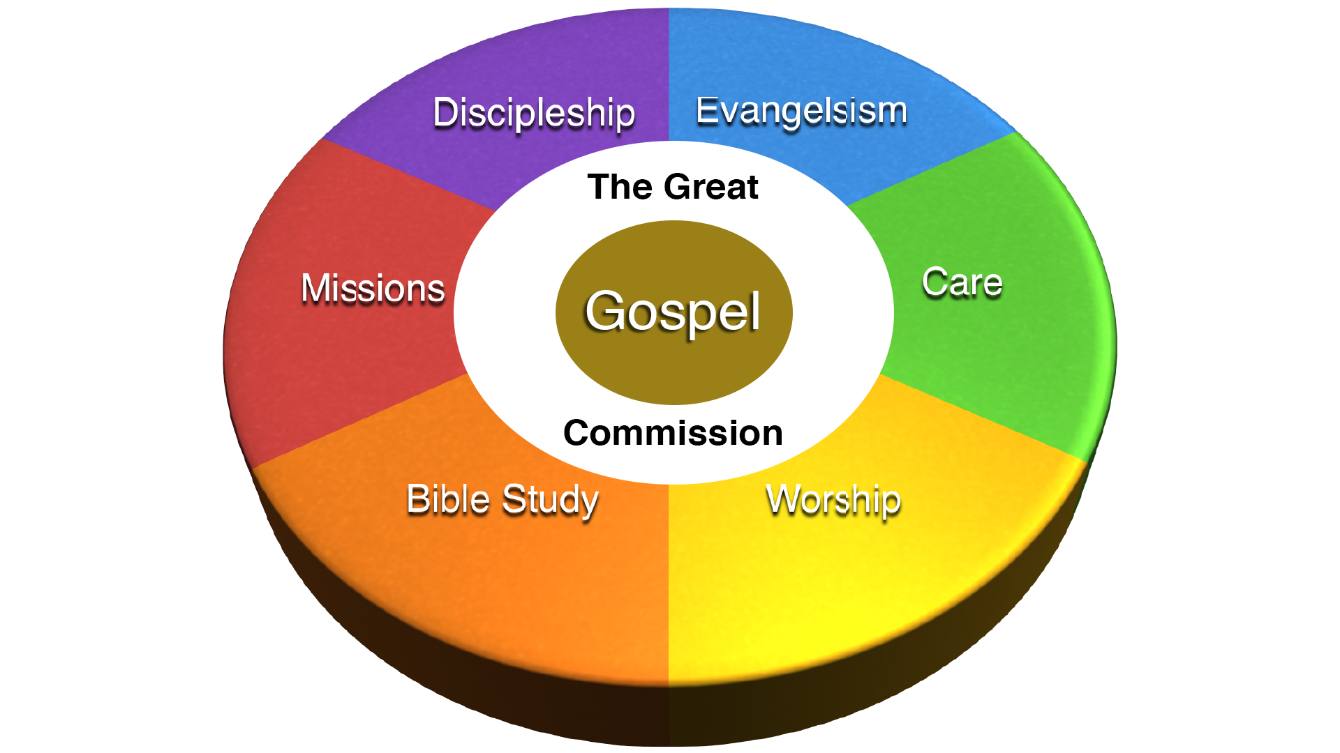
Fig 2 - The Great Commission Church

Bible study is still there - but now it has a purpose - to would people up so they can take part in the great commission and preach the Gospel. That’s what these life groups are - a bible study with a purpose.
Evangelism happens, not because it’s a thing we do, but because it’s intertwined with our purpose and focus. Everything is therefore linked together as it’s working towards the same result.
In essence - what we do does not change - but what it’s based around does.

Questions:
- What are the ramifications for these two approaches to church structures?
- What happens to a church when it recognises that its ‘reason for being’ is to spread the Gospel?
- How can a church lose it’s focus on the great commission and become more program orientated?

The Church as an 'Object of Ministry' Compared to the Church as an ‘Agent for Mobilisation’

The Church as an Object of Ministry
Some believers think of the church as a gathering place to be with other believers and to be ministered to by the pastor (see figure 3).
This is perhaps the most common paradigm for viewing the church - it’s how most of those outside church see it and indeed most of the in it too. It may well be your view…
This paradigm is partly true. Church is indeed a gathering where we enjoy fellowship as well as receive spiritual nourishment from spiritual leaders.
However, this paradigm fails to put the outward purpose of the church in proper perspective and supposes a non-biblical clergy / laity distinction.
The trouble is, because this has certainly in recent history been how the church works, it’s a paradigm we just assume to be correct. But it’s lacking and can distract from the main purpose of the Church.
This is how it looks:

Fig 3 - The Church as an object of ministry

The Church As An Agent For Mobilisation
The church is not an object of ministry, but rather an agent of mobilisation for the Gospel into the world. That is a huge shift in the way we need to see church.
Church is not there for US. We are all here to serve the kingdom of God together.
Church | Pastor | World
Members are called “laity."  The laity supports the pastor to do the work of ministry. The laity show their support by attending services, tithing, and agreeing with the pastor’s decisions and actions.  The laity sees the primary purpose of the church as taking care of the needs of the church members. The laity do not see it as their responsibility to evangelise the lost. | The pastor is recognized as the professional minister. He is called “Father, “Reverend,” or “Pastor." He is “The Minister.”  Usually in this system the pastor dominates the worship service since he views the members as “only laymen." | The pastor is the only one at the front lines of battle in the world.  The pastor usually is not taken seriously by the world. He is “paid to do this,” the people say.  The world is not won to Christ, and the pastor wears himself out in trying to do the entire ministry.
As shown in the figure 4, the role of leadership in the church is to equip (to train and to empower) church members for service in the world.
This is the edification purpose of the church. Believers gather together to worship the Lord, to grow in their faith, to learn God's Word, to encourage, pray for, and practically help one another.
These church members develop the spiritual character and servant skills needed to evangelise the lost (the outward purpose of the church).
Fulfilling the Great Commission is not just the pastor's job, or the job of a few individuals in the church, but it is the function of the entire body of Christ (the church).

Fig 4 - The Church as an agent of Mobilisation

Questions:
- Why should the church be a force and not just a field?
- What is the role of leadership in a purpose-driven church?
- How does this second model make the church more effective?
- How has looking at this topic made you change the way you look at the purpose of our church.

CONCLUSION
A clear sense of purpose helps the church to be effective. Without understanding its purpose, church leaders and workers can waste energy and resources doing things they have not been called to do. Every church planter should understand the biblical purpose for the Church and think through this purpose in the light of his own church planting work and mission.
Leaders | Church | World
The primary work of the leaders is to equip the church members so that they can minister in the world (Eph 4:11-16).  Leaders must get to know the needs and spiritual gifts of their church members so that they can properly equip them to minister effectively. | The laity are trained by the leadership to be “ministers." Therefore, a church with 100 members should expect to have 100 ministers (not pastors).  Church members are released to use their spiritual gifts to minister to one another and to evangelise the lost.  Penetration of the world with the Gospel is the primary responsibility of the church members. The church leadership provides the equipping for the members to take up this responsibility. | The world is where the members live.  Church members are full-time ministers where they live and work.  All levels of society are being penetrated with the Gospel (Mt 28:19- 20).

