What’s the church all about?
Part 005 - The purpose of the church

Leaders Notes

Lesson Purpose
The purpose of this lesson is to show how the biblical foundations for the Church relate to God’s
Kingdom and redemptive purposes and how that role works today and to describe how the Church needs to understand why it exists and the there is a 3 fold purpose in church.

Main Points
- The Church is God’s instrument for spreading the Gospel to everyone.
- The Church has three purposes—ultimate, outward, and inward.

Desired Outcomes
When the content of this lesson has been mastered, each participant should . . .
- Be aware of the biblical purposes for the Church.
- Consider the role our church work has in the bigger picture of God’s purposes.

Suggestions to Leaders
Be sure that participants can clearly articulate the inward and outward purposes of the church. It would be good if you can use big visuals to impress upon trainees the various paradigms of church purpose. You could make drawings on poster paper. Or, in your context, perhaps a chalkboard or an overhead projector might be more appropriate.

INTRODUCTION
Let’s do church on purpose.
‘Purpose’ might be described as ‘the end to which our efforts take us.' Any organisation has a purpose.
A business exists to make money through the sale of goods or services rendered. The government of a country exists to protect its citizens and rule its people.
Purpose is the answer to the questions - what are we for and what are we doing here? It’s good to know our purpose.
If we do not know our purpose we don’t know why we are here. It’s hard to be dedicated and excited about something if we don’t know what it’s for. Most people re not excited about church because they don’t fully get the purpose.
The Lord Jesus serves as a great model in the area of purpose. He knew why He came to earth and where He was going. He had a great purpose.

Luke 4:18-19
‘The Spirit of the Lord is on me, because He has anointed me to preach good news to the poor. He has sent me to proclaim freedom for the prisoners and recovery of sight for the blind, to release the oppressed, to proclaim the year of the Lord’s favour’

For churches to be truly effective in today’s world, they must have a clear sense of purpose. Without it, church leaders and workers can waste energy and resources doing things they have not been called to do.
People don’t want to come to something if they don’t know what it is for. Why give up your time, energy and commitment for something if you do not know it’s purpose?

A clear understanding of biblical purpose can make a church:
- purposeful and expectant.
- faithful and flexible, innovative yet true to Scripture.
- gracious and relational, emphasising God’s love and forgiveness.
- joyful and celebrate (people are looking for this).
- vital and dynamic, equipping people for real life ministry.
- growing and reproducing, planting new churches

THE ROLE AND NATURE OF THE CHURCH TODAY

The Church—A Called-Out People With Both A Local And A Universal Manifestation
Ever since the fall of mankind, the ultimate purpose of God has been to call out a people unto Himself in what today we call the church

Eph 1:9-10
And He has made known to us the mystery of His will according to His good pleasure, which He purposed in Christ as a plan for the fullness of time, to bring all things in heaven and on earth together in Christ.

The Greek word, ‘ekklesia’ is commonly used to describe the church in the New Testament. ‘Ekklesia’ means a society or assembly of free citizens called out of their homes or businesses to assemble together and give due consideration to matters of public interest
We see the word used in acts to describe a legal gathering - here when a city clerk was trying to bring calm during a Riot in Ephesus, because people who were making idols were getting put out of business because so many were getting saved:

AcTS 19:38-41
So if Demetrius and his fellow craftsmen have a complaint against anyone, the courts are open and proconsuls are available. Let them bring charges against one another there. But if you are seeking anything beyond this, it must be settled in a legal assembly. For we are in jeopardy of being charged with rioting for today’s events, and we have no justification to account for this commotion.”
After he had said this, he dismissed the assembly.

It’s the same word. The very word church means therefore a group. More than one. You cannot assemble on your own.
The idea of a ‘called out people’ has its roots in the Old Testament (Ru 4:11; Jer 33:7), with Israel as the called people of God. In the New Testament ekklesia is never used to denote a building or a denomination (two of the most common ways we use the word “church” today) but always refers to a group of people.

Question
Why has the word “church” got so many incorrect interpretations? What did you think of “church” before you were saved and how did you change your opinion?

Of the 109 times ekklesia refers to the church in the New Testament, it most often denotes a group of believers in a particular place or 'a local church' (at least 63 times).
Believers are responsible to gather in local fellowships (Heb 10:25). In fact, it was the normal pattern of the Apostles to win people to Christ and gather them into new churches.
So whilst there is ONE church, there are many “local” expressions of that church. This has been the pattern since the start.

Note that the local church may be defined in different ways:
- A house church: 1 Corinthians 16:19 (Church that meets in house of Aquila and Priscilla) Colossians 4:15 (Church that meets in house of Nympha)
- A city church: 1 Thessalonians 1:1 (Church of the Thessalonians) 1 Corinthians 1:2 (Church of God in Corinth) Acts 13:1 (Church at Antioch)
- Regional churches: Galatians 1:2 (Churches in Galatia) Acts 9:31 (Churches throughout Judea, Galilee and Samaria) 1 Corinthians 16:19 (Churches in the province of Asia)

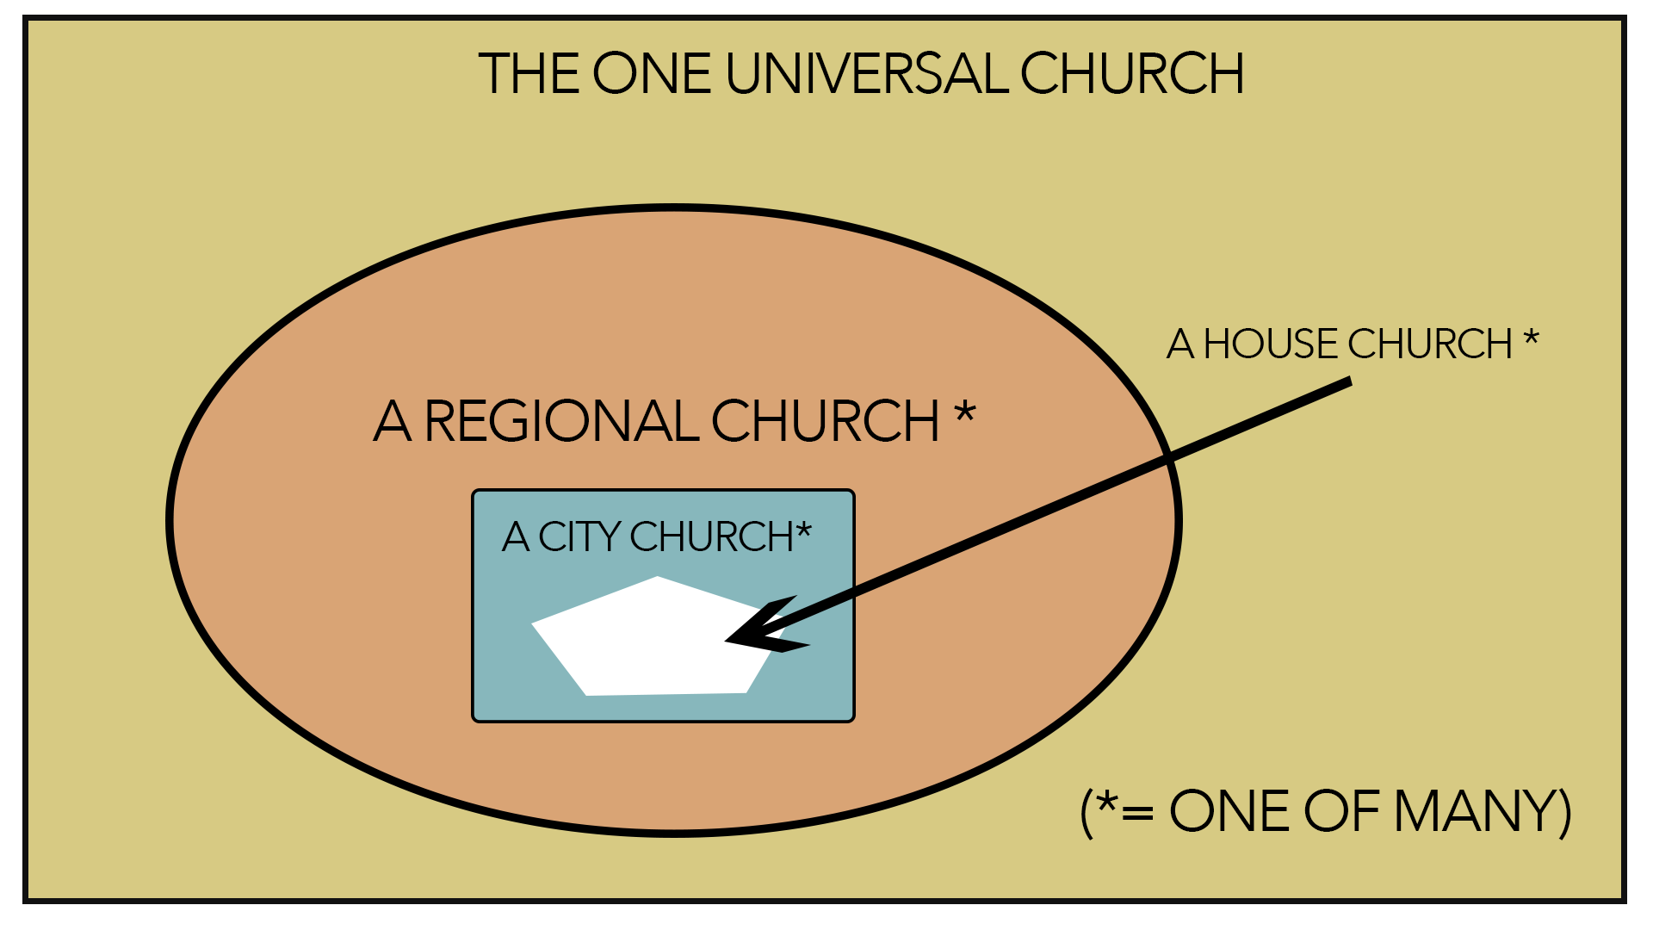
Figure 1: One Church and Many Churches

Ultimately, there can be only one ekklesia (1Co 12:13, Eph 4:4-5). Thus, (at least 27 times) we see ekklesia denoting the universal Church which is that body of believers in Jesus Christ, living and dead, from every tribe, language, people and nation.
BUT this doesn’t mean you can be part of the “Universal” church and not the local church.
Being part of the universal Church and not being involved in a local church is a concept that is not found in the New Testament. On the contrary, the universal Church is made visible through local churches everywhere.
As ‘called out people,’ the church is not simply a group of people united by religious faith. It is a creation of God through the Holy Spirit.
Church is God’s idea.

The Church Is The Body Of Christ
The church is described as His body several places in Scripture (Ro 12:4-5; 1Co 12:12-31; Eph 1:22-23; 4:4-16). When Christ works in the world today, he does so through His Body, the church, us! (Eph 1:22-23; 3:10-11). Note the following implications of this metaphor:

The Body Is Interdependent
As the body of Christ, the church has many parts that work together in a very complex and interdependent way. The parts do different things but have the same ultimate purpose, much like the various parts of a human body (Ro 12:3-8, 1Co 12:12-31). The church needs all the parts to function according to their design in order to properly do what God desires.

The Body Has One Head
Christ is the head of the church (Col 1:18). Like a body the church cannot have more than one head. No pastor or church planter is truly the head of the Church he serves. All the parts of the body, including the leaders, are subject to the headship of Christ. The body does not function well otherwise.

The Church Is God’s Number One Instrument For Spreading The Gospel
The Church is the instrument of God chosen to bear the good news of the Gospel to the ends of the earth.
Before the cross the nations were separated from the hope of salvation (Eph 2: 11-13). But after the death and resurrection of Christ, the church has the responsibility to take the Gospel to the nations (Mt 28:19-20). It is clear from the New Testament that the early Church took this responsibility very seriously, for it is impossible to separate the spread of the Gospel and the expansion of the Church in the book of Acts. It was the mission of the Church to take the Gospel from Jerusalem to Judea and Samaria and to the ends of the earth. Today it is unfortunate that we talk about churches and missions as if they are separate. In the New Testament, the mission was the church and the church was the mission.
Evangelistic strategies that are not connected to the church are misguided from the beginning. Follow-up and long-term growth, for example, are common problems when people are evangelised through non-church initiated efforts.
God has established the Church through which the nations are to be discipled. The Scripture declares: ‘Through the church the manifold wisdom of God should be made known to the rulers and authorities in the heavenly realms according to His eternal purpose which He accomplished in Christ Jesus our Lord' (Eph 3:10-11). The Church is God’s plan to reach the world today, to manifest His progressive victory over Satan, and to enfold those who would be part of the ‘people of God.'

- THE PURPOSE OF THE CHURCH
Jesus has established His Church with a purpose in mind. It is a wonderful purpose, fixed in eternity past, destined for a glorious future. We could summarise the purpose of the church by saying the Church exists to glorify God through edifying the believers and evangelising the lost. Figure 1 shows this three-fold purpose of the Church.

Fig 1 - The Three Fold Purpose of the Church
Ultimate Purpose | Outward Purpose | Inward Purpose
Exalt the Lord | Evangelise the Lost | Edify the labourers
The Church Exists for the Lord | The Church Exists for the world | The church exists for itself

Exalt the Lord
The Bible teaches that there is an ultimate purpose to which all creation moves; it is God’s own glory. God’s glory represents all that is true of Himself: His nature, attributes, character and actions. God’s own glory is His chief aim for eternity and man’s chief purpose for existence. He is working out His eternal purposes toward this end. God’s own glory is the final purpose of the Church (Ro 15:6,9; Eph 1:5ff; 2Th 1:12; 1Pe 4:11).
God is glorified (revealed, made known) when we worship Him (Jn 4:23), offer prayer and praise to Him (Ps 50:23) and live a godly life (Jn 15:8). ‘Whatever you do, do all to the glory of God’ (1Co 10:31). This is true for individual Christians and for His Church.

Questions:
- What does it mean for you to glorify God?
- How does the Church glorify God?

Evangelise the Lost
The Bible clearly teaches that there is an outward purpose for the Church, to be accomplished in this age. It is a purpose that places the Church‘s focus and efforts outside itself. It is the reason Jesus came to reach a lost and dying world (Lk 19:10). Jesus said, ‘As the Father has sent Me, so I now send you’ (Jn 20:21). This outward purpose of the Church is outreach to the lost— evangelism and mission.
Perhaps no portion of Scripture better states the outward purpose of the Church than the ‘Great Commission’ passage of Matthew 28:18-20
Questions:
- What comfort is there in the truth that "all authority" has been given to Christ?
- Since He is the Sovereign Lord, what has He asked us to do?

Read Mark 16:15-20
- What warning do you find here for the unbeliever?
- What will be the evidence that follows believers?
- What fears do I have that need to be overcome by the realisation of the sovereign authority of Christ?
- How can the Gospel be proclaimed in “all the nations” in my country?

Edify the Labourers
The Bible teaches that the Church also has an inward purpose. It is the edification or building up of its members. The bulk of the New Testament epistles were written to believers to strengthen them in their Christian life and ministry so that they could accomplish the outward purpose of reaching a lost and dying world.
Ephesians 4:11-16 best explains the inward purpose for the Church. The church exists to edify the believers. The training and equipping of God’s people as a gathered community (in worship, teaching, fellowship and nurturing functions) leads to the accomplishment of the outward purpose, making disciples.

Question:
- Leadership is given (v. 11) to equip the saints for ministry (v. 12), not just to do the work of ministry themselves. What are the implications of this vital truth for our church?
The purposes of the church can be simply stated as exaltation, edification and evangelism. The people of God gather for worship and edification, in order to scatter to do the work of evangelism. These are interrelated purposes. None of them should exist apart from the others. The inward purpose (edification) serves the outer purpose (evangelism) and both purposes serve to glorify God (worship). As followers of Jesus gather for the inward purpose of edifying one another (Eph 4:11- 16), loving one another (Jn 13:34-35), and practicing the functions of the New Testament church (Ac 2:42-43), they are better equipped for the outward task of outreach and ministry to the lost world.
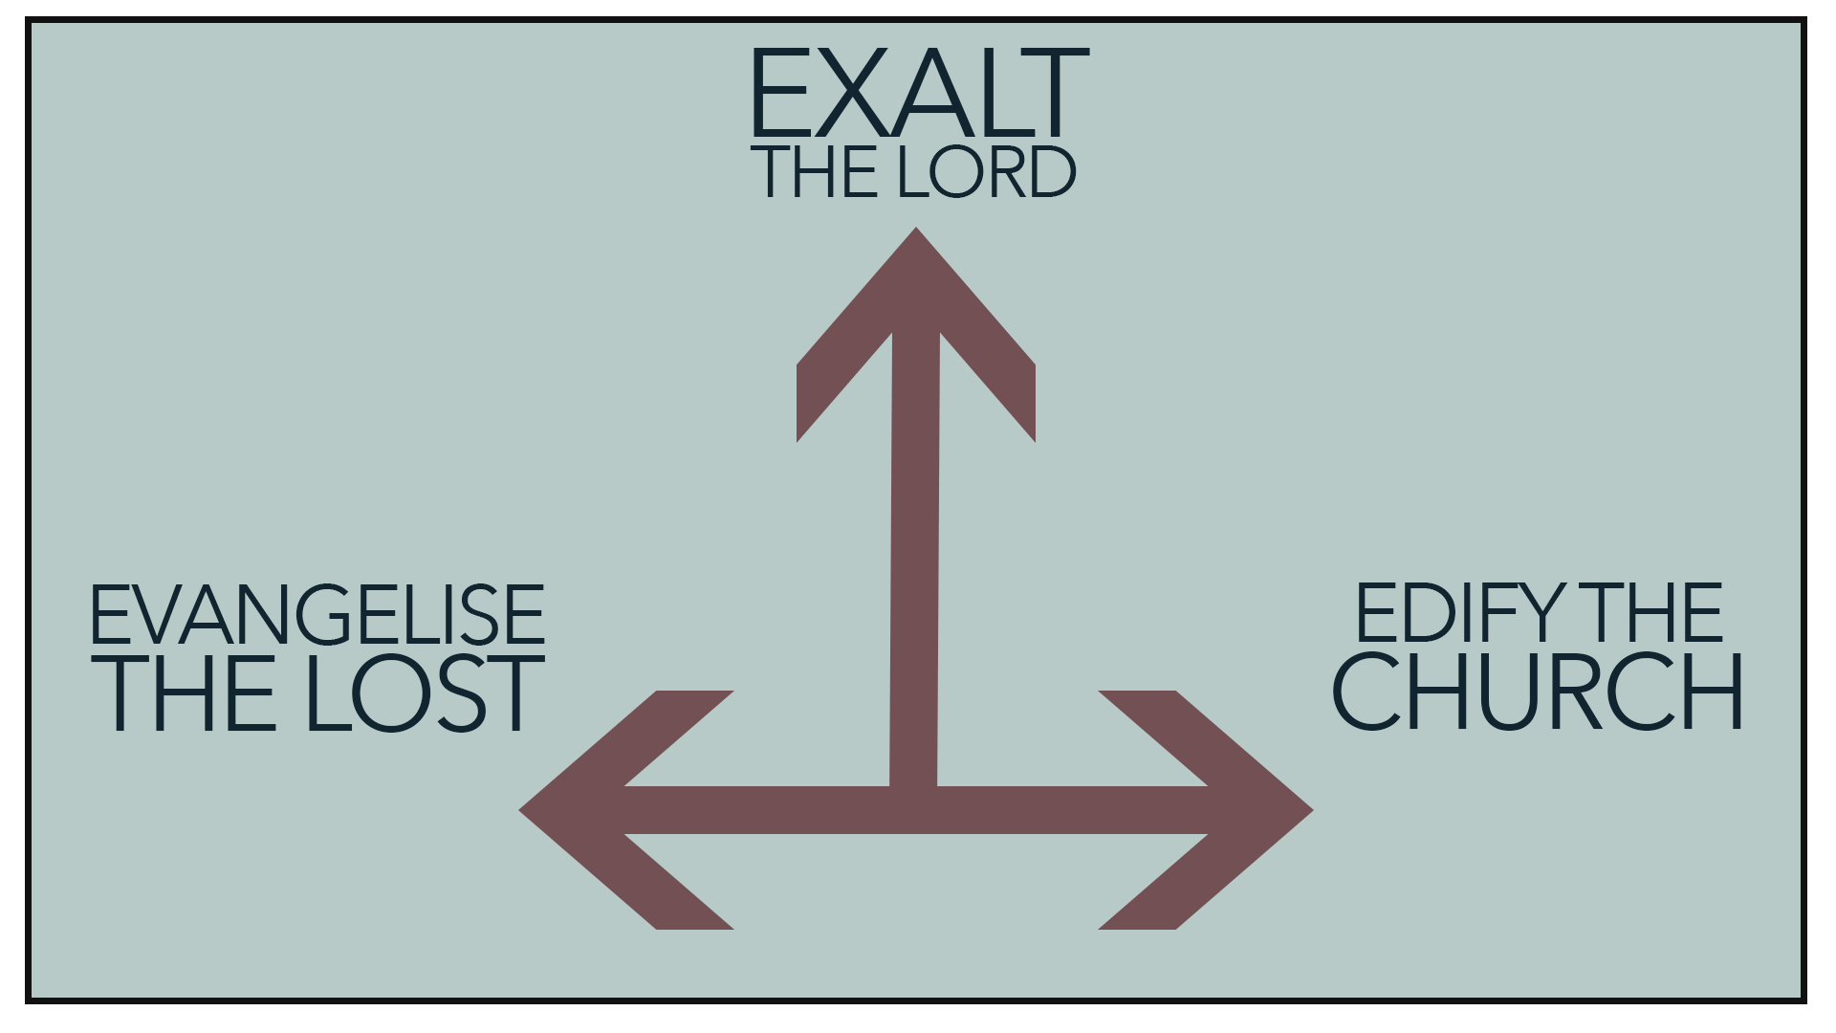

CONCLUSION
In Jesus Christ, God is reconciling people to Himself, restoring their relationship with Him (Eph 1:9-10). God has given this ministry of reconciliation to His church (2Co 5:18-20). So that the Church is God’s plan to reach the world today, to manifest His progressive victory over Satan, and to enfold those who would be part of the people of God.
The establishment of the church with this purpose is the most recent step in God’s redemptive plan. Involvement in establishing and strengthening the church is no small task. It is an essential activity for every believer and yields eternal results. Never underestimate your role concerning planting or leading the church!
A clear sense of purpose helps the church to be effective. Without understanding its purpose, church leaders and workers can waste energy and resources doing things they have not been called to do.
The church has 3 purposes - it’s not an either or - all three are vital to the existence of the church. Miss one and you’ve missed the purpose.
Exalt the Lord - Evangelise the lost - Edify the Church.

QUESTIONS
- Christ is the head of the Church. What are the practical implications of this? (Eph 1:23; Col 1:18). How do we let Him be both Lord and Master on a practical level?
- Can a believer be part of the universal church and not part of the local church?
- What does it mean for the church to be indigenous?
- Study some of the metaphors used to describe the church (Eph 2:15, 19, 21; 1Pe 2:9-10). Which of these is most meaningful to you personally?
- Why is it important that the church understand its purpose? What happens when churches do not understand their purpose?
- How would you summarise the purpose of the church? And specifically, our church?
- Do you know what our Church’s mission statement is?
- How does the Great Commission relate to the purpose of the church? What other passages in the Bible help us understand the purpose of the church?

