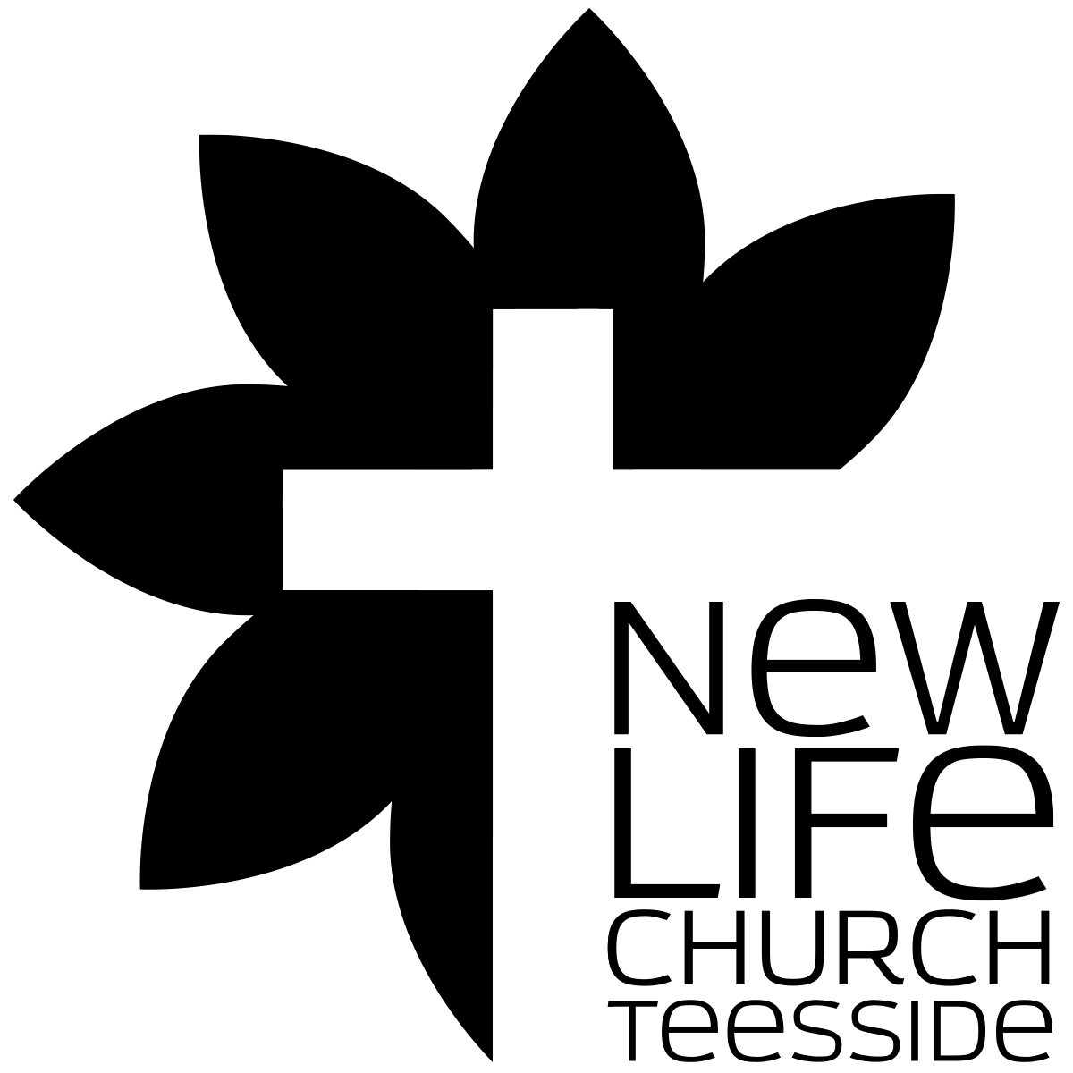
What’s the church all about?
Part 004 - The Foundation of the church.

Leaders Notes

Lesson Purpose
The purpose of this lesson is to show how the biblical foundations for the Church relate to God’s
Kingdom and redemptive purposes.

Main Points
- The Church was God’s plan from eternity past.
Unlike Israel, the mission of the Church is to GO and be salt and light among the nations.

Desired Outcomes
When the contents of this lesson have been mastered, each participant should:
- Understand the place of the Church in the light of God’s Kingdom and redemption program, and consider foundational concepts regarding the Church.
- Be grateful to God for His Sovereign plan for the ages, and for his own personal participation in this plan.
- GOD'S PLAN FOR THE AGES
As we look over the next few weeks at “The Church” and ask what it’s for - it’s helpful to start by looking at God’s overall plan for all of creation.
The church is God’s idea. Part of God’s plan - so looking at the bigger picture helps us see where the church fits into that.
Let’s have a look at the history of God’s kingdom and His plan - “A brief history of the cosmos”:

God’s Eternal Kingdom

Ps 10:16
The LORD is king forever and ever; the nations perish from his land.

Ps 103:19
The LORD has established his throne in the heavens, and his kingdom rules over all.

The Bible describes God as the Eternal King, sovereign over all creation. God’s Kingdom can be described as the realm over which He rules, exercising sovereign and kingly authority.
The display of His glory in His rule was the supreme good (Ps 29:10; Da 2:20-21; 4:34-35; 5:21).
Before there was ever time there was God and His kingdom.

The Cosmic Rebellion
All of God’s creation was good, but at some point, sin entered into creation.
When and how this happened is not clearly stated in the Bible, but certain passages seem to allude to this fact (Isa 14:3-21, Eze 28:11-17).

(Get someone in the group to read these if you’d like - but only if you want to)
The prophet Isaiah, in addressing the king of Babylon, seems to be making an analogy between the pride of the king of Babylon and that of a fallen ‘morning star’ (Isa 14:3-21).
This morning star tried to make himself like the Most High. Many biblical scholars see this as a reference to the fall of Satan, a created angelic being who wanted to be like God.
A related passage is found in Ezekiel 28:11-17 where the King of Tyre is being addressed. The description seems to go beyond him to address a guardian cherub who was on the mount of God and was blameless in all his ways.
Because of his pride, he was cast down.
Some of the parts of these passages are referring to earthly kings. Some parts cannot possibly be applied in that way. Both authors are using a present situation for God to reveal a heavenly truth.

The Earthly Rebellion
When God created the earth, authority to rule over it was delegated to Man (male and female)

Ge 1:26
Then God said, “Let us make man in our image, after our likeness. And let them have dominion over the fish of the sea and over the birds of the heavens and over the livestock and over all the earth and over every creeping thing that creeps on the earth.”

Man, created in God’s image to have fellowship with Him, had freedom of choice (Ge 1:28; 2:7). Because true fellowship involves moral choice, the man and woman were tested by being forbidden to eat a certain fruit in the garden.
Tempted by Satan to be like God, they chose deliberate disobedience over compliance. By this deliberate act, Man declared his independence from and opposition to the will of God. Results of Man’s sin were:

- Fellowship with God was broken.
- The image of God in the man and woman was marred.
- Man experienced physical and spiritual death.
- The woman would experience suffering in childbirth.
- The man would experience painful toil.
- The ground (nature) was cursed (Ro 8:21-22).
- Fellowship between the man and the woman was broken.
- Rule over the earth was usurped by Satan who became ‘the god of this world.’

God's Redemptive Plan
Since the fall of man, God has been working throughout history to restore fellowship between God and man.
He chose a man (Abraham), who gave birth to a nation (Israel) among whom was born a messiah (Jesus) to conquer the work of Satan and restore man’s true fellowship with God. God’s ultimate redemptive plan includes:

It may be helpful to get people in the group to read the verses that go with these
- The redemption of Man, restoring him to the image of Christ (2Co 3:18).
- The restoration of fellowship between God and Man and between men (1Jn 1:3-7).
- The restoration of God’s reign over the earth (Rev 11:15) and man’s reign with him (Rev 22:5).
The creation of a new earth (Rev 21:1).
God announced His solution over sin with His judgment of the serpent in Genesis 3:15.

Genesis 3:15
I will put enmity between you and the woman, and between your offspring and her offspring; he shall bruise your head, and you shall bruise his heel.”

This was a prophetic statement about the coming of the Saviour from the offspring of Woman. (Note not of man - the Virgin birth hinted at here).
Isn’t it amazing - Mankind fell in Genesis 2 and in the very next chapter God is already talking about His solution to the problem! Right int he middle of God telling mankind about the consequences of sin He is laying the groundwork for the one who will take that sin away!
God’s solution to man’s sin is the redemptive work of Jesus Christ (Col 1:20; 2:9).
In Jesus Christ, God is reconciling people to Himself, restoring their relationship with Him (Eph 1:9-10).
This ministry of reconciliation He has given to His church. In fact, the establishment of the church is the most recent step in God’s redemptive plan (2Co 5:19).

It could be helpful to have a brief discussion on this “History of the Cosmos” to make sure everyone understands it.
- THE ESTABLISHMENT OF THE CHURCH

The Background For The Church: Israel
The Church is not mentioned in the Old Testament. Paul refers to it as a 'mystery' (something previously unrevealed—see Eph 3:9-10; Ro 16:25-26; Col 1:25-26).
Much discussion has centred on the relationship between the Church and Israel. Some emphasise their similarity, viewing them as one people of God in different times. In this sense, Israel is a ‘spiritual’ people, and the Church is the New Israel.
Others view Israel and the Church as distinct phases in God’s kingdom and redemptive programs, with both being the people of God.
We need to be very careful here - there is a line of thinking which is called “Replacement Theology” which suggests the Church has Replaced Israel as God’s chosen people. That would mean all the promises directed at Israel can be lifted and given to the church - which is not correct. (Notice we only ever go after the promises in this instance, not the warnings). New Life Church, Teesside does not hold with replacement theology - Israel are still God’s people and His covenant with them is everlasting.
The Church was born out of Israel - that’s where Jesus established it, with Jewish people to begin with and it expanded to reach and bless the whole world - with the message of reconciliation.
Regardless, it is important to understand the difference between Israel and the Church, as it relates to evangelistic strategy.

The Nation of Israel
In Genesis 12:1-3 God promised Abraham that through him He would build a great nation and that through him all the nations of the earth would be blessed. The nation He had promised was Israel. One of Israel’s kings, David, was promised that his kingdom would be eternal (2Sa 7:8-16). The New Testament declared that Jesus was the ‘son of David’ through whom these promises would be fulfilled.
One of Israel’s purposes was to be the bearer of the Messiah (King). Paul summarises it like this: “... the people of Israel. Theirs is the adoption as sons; theirs the divine glory, the covenants, the receiving of the law, the temple worship and the promises. Theirs are the patriarchs, and from them is traced the human ancestry of Christ, who is God over all, forever praised!” (Ro 9:4-5).
It’s amazing to think that all of the circumstances Israel found itself in - the Roman occupation at the time - the protection of their faith in that occupation (Rome was not often as tolerant of that in other nations - and can owe some of the tolerance actually to the father of Herod helping out Julius Caesar) would provide the perfect place for Jesus to be born, to teach and to die as well as the perfect environment to allow the message to travel so fast across the world. It was the perfect time and place in History - appointed and planned.

The church
The period of time between the first and second coming of Christ has been called ‘the Church Age,’ or the time when God is at work to accomplish His Kingdom and Redemptive purposes through His Church.
The Church is not a plan ‘B’ after Israel’s ‘failure’ to accomplish a plan ‘A,’ or an afterthought in the mind of God.
He planned for it in eternity, provided for it by the death and resurrection of His Son, Jesus (Eph 1:19-23).
Christ prepared for its formation and development by instructing His followers as to their mission (; Mt 28:18-20).

Jn 16:5-15
But now I am going to him who sent me, and none of you asks me, ‘Where are you going?’ But because I have said these things to you, sorrow has filled your heart. Nevertheless, I tell you the truth: it is to your advantage that I go away, for if I do not go away, the Helper will not come to you. But if I go, I will send him to you. And when he comes, he will convict the world concerning sin and righteousness and judgement: concerning sin, because they do not believe in me; concerning righteousness, because I go to the Father, and you will see me no longer; concerning judgement, because the ruler of this world is judged.
“I still have many things to say to you, but you cannot bear them now. When the Spirit of truth comes, he will guide you into all the truth, for he will not speak on his own authority, but whatever he hears he will speak, and he will declare to you the things that are to come. He will glorify me, for he will take what is mine and declare it to you. All that the Father has is mine; therefore I said that he will take what is mine and declare it to you.

This passage is the basis for the mission statement of New Life Church:

Matthew 28:18-20
And Jesus came and said to them, “All authority in heaven and on earth has been given to me. Go therefore and make disciples of all nations, baptising them in the name of the Father and of the Son and of the Holy Spirit, teaching them to observe all that I have commanded you. And behold, I am with you always, to the end of the age.”

He created it on the Day of Pentecost (Ac 2:1-13) and empowered (Ac 1:8) it with His forever indwelling Holy Spirit.
The Church is the instrument of God chosen to bear the good news of the Gospel to the ends of the earth.

Eph 3:10-11
'Through the church the manifold wisdom of God is made known to the rulers and authorities in the heavenly realms, according to his eternal purpose which He accomplished in Christ Jesus our Lord’.

The Church is God’s plan to reach the world today, to manifest His progressive victory over Satan, and to enfold those who would be part of the people of God.

Comparison between The Nation Of Israel And The Church (Figure 1)
Figure 1.1 Israel and the Church

The Nation of Israel | The Church
The orientation of the ‘Nation’ was centripetal. God’s plan placed Israel as a light to the nations, to which the nations would COME to see and hear of His glory. To participate in His glory meant to come to the Nation.  - Growth by addition (birth, take by force, God-fearers)  - Centralised plan ‘when they come to this House’  - God’s glory temporarily residing in Jerusalem (1Ch 28; 2Ch 6-7) | The orientation of the Church is centrifugal. God’s plan places the Church as a Light to the nations. The people of the Church are to GO and be salt and light among the nations (Mt 5:13-14; 28:18-20).  - Growth by multiplication (conversion, church planting)  - Decentralised plan ‘... into all the world’  - Released and empowered by the eternally indwelling Holy Spirit (Ac 1-2); God’s glory residing in the hearts of men (2Co 3)
 | 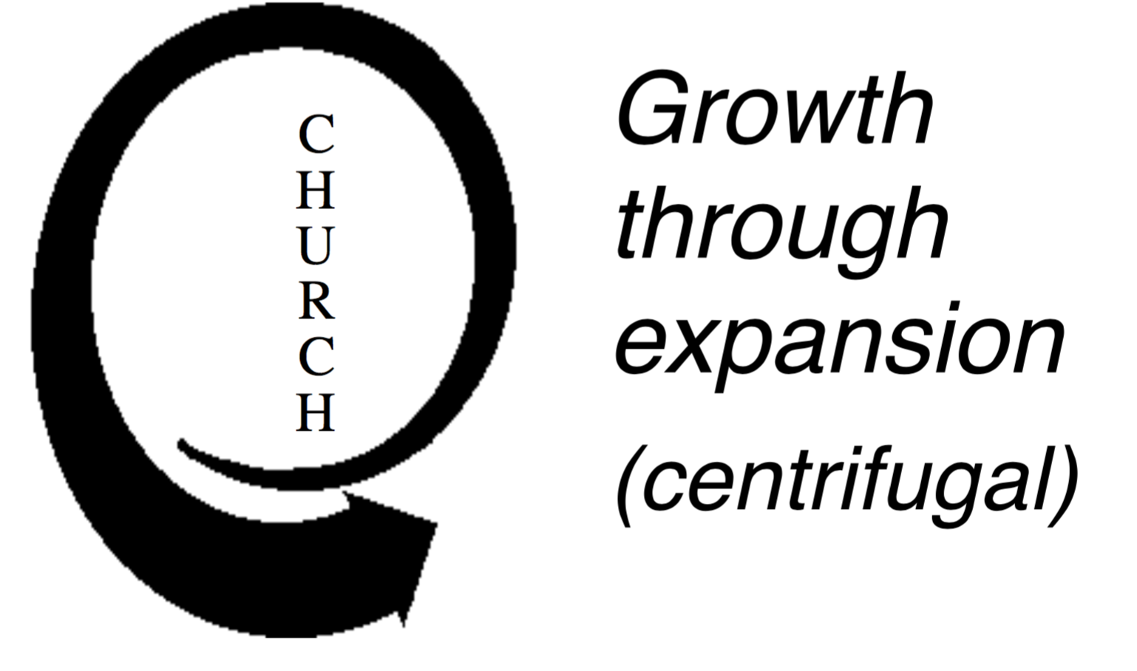

We see here an interesting problem.

QuestioN:
In what ways do you see the church sometimes making the mistake of falling back into Israel’s model?

The Prediction Of The Church: Matthew 16:18-19
Jesus predicts the establishment of the church in Matthew 16:18-19. The following is a review of Matthew 16:18-19.

Matthew 16:18-19
And I tell you, you are Peter, and on this rock I will build my church, and the gates of hell shall not prevail against it. I will give you the keys of the kingdom of heaven, and whatever you bind on earth shall be bound in heaven, and whatever you loose on earth shall be loosed in heaven.”

The church is built on the rock: “Upon this rock”
The meaning of “the rock” in Matthew 16:18-19 inspires much discussion. The controversy centres on the interpretation of petra, the Greek word for ‘rock’ from which the name Peter comes.

Petra = ‘large rock, bedrock’ (Mt 7:24-25; 27:60; Mk 15:46)
Petros (Peter) = ‘a detached stone’ that might be easily moved

Major interpretations of ‘the Rock’
- Jesus the Messiah: Petra used of Christ (1Co 10:4; Ro 9:33; 1Pe 2:8)
- The confession of faith by Peter about Christ
- Peter himself
Question:
Why has this verse caused so much misunderstanding? Maybe discuss these 3 interpretations.

Most evangelical theologians have historically interpreted the rock to be the confession of faith by Peter about Christ.
In any case, the metaphor of a rock conveys the importance of a solid foundation, a very important lesson for church planters.

The Church belongs to Christ: “I will build My Church.”
Jesus owns the Church. He created it and it belongs to Him.
He gave Himself in death on the cross, that the Church might be born (Eph 5:25; Jn 12:24). He purchased the Church with His own blood (Acts 20:28).
He calls His Church out of the world, fits its members together, and sanctifies it in preparation for its final presentation and purpose (Eph 5:26-27).
In the future, Jesus will glorify His Church in the presence of the Father and the holy angels (1Th 4:13-18; Rev 4-6).
Paul said he was given authority by Christ to build His Church, not tear it down (2Co 10:8).
hough church leaders ought to feel the deepest sense of obligation and participation in their ministry, no pastor or church planter ever owns his ministry. Jesus, not the church planter or pastor, is the head of the church.

Jesus builds His Church through us: “I will build my Church.”
Building the Church is Jesus’ major mission on earth today. Jesus uses born again people as His building material (1Pe 2:5).
Jesus will fit and build these living stones as God’s building (1Co 3:9), a dwelling of God in the Spirit (Eph 2:21-22).
Jesus uses gifted leaders to equip His people to build His Church (Eph 4:11-12; 1Co 3:12).

The Church will be triumphant: “the gates of hell will not prevail against it”
This important phrase spoken by Jesus is packed with meaning and is the basis for the overcoming faith and hope that church workers should possess.
It tells us that Christ is building His Church as a military force to storm the gates of Hell and be victorious over the powers of evil.
Even though we struggle now, someday the Church will be completely victorious (Ro 16:20). Until then, we are to put on the armour Christ has provided and depend on His strength for leadership and victory (Eph 6:10-18; 2Co 2:14).
Paul said he fought the good fight (2Ti 4:7) and so should we.

The Birth Of The Church: Acts 2
The prediction of Jesus came true in Acts 2 when the empowering Holy Spirit was poured out on people from many nations giving birth to the church.
The miracle of tongues on the day of Pentecost symbolised that this new event in God’s redemptive plan would reach the entire world, uniting men and women of every tongue into the Church.
The church then is international from its birth.

Conclusion
The church has been a part of God’s redemptive plan from the start - and it has a role to play. It is an army - sent out on a mission.
It is not a replacement for Israel - and should not have the same aims. With he temple - people had to come to that special place - with the church, we are meant to go out and reach the world.
With Christ as it’s head - we follow His lead. And as we go - He goes with us.

QUESTIONS
- What are the implications of the Church as centrifugal?
- How does an Old Testament (centripetal) understanding of the Church affect its vitality? When is such an understanding of the local church appropriate? Why?
- The Church exists for the world (Eph 3:1-10). What are the implications?

