
EVANGELISM
Part 003 - THIS IS WHAT GOD DID FOR ME!

Leaders Notes

Lesson Purpose
The purpose of this lesson is to explain the value and preparation of a personal testimony.

Main Points
- A personal testimony is an effective and non-threatening way to witness to the lost.
- A personal testimony will be more effective if it is carefully prepared to include the most important information.
- A personal testimony tells what God has done in your life—it is not a sermon!

Desired Outcomes
When the content of this lesson has been mastered, each participant should:
- Understand the potential spiritual impact of a personal testimony.
- Develop a three - five minute personal testimony to share with others.

Suggestions to Leaders
This is a two-part lesson. The first part should introduce the participants to what a personal testimony is and help them write their personal testimony. The second part should be used to practice sharing their personal testimony.
You may want the two parts to take 2 weeks, you may not - that’s something you will have to judge with how the night is going.
Be sure that the testimonies are not longer than five minutes. Consider using a stopwatch to ensure that this is not violated.
It takes great discipline to keep a testimony short, but there will be situations where you will only have time to share a short testimony, so it’s good to encourage that and to focus people on how to keep it short.

THE NATURE OF A TESTIMONY

We are Called to be Witness
In Acts 1:8, Jesus promises His disciples that they will receive power when the Holy Spirit comes upon them and that they will be His witnesses.
But what is a witness? In a legal courtroom, a witness is one who is called upon to tell others what he has observed. He tells the truth about a critical event, as he has perceived it.
A witness is not expected to know every detail or have various perspectives on truth. He is expected to tell what he remembers accurately and honestly. The content that a witness communicates is his testimony.

We are Called to Give Testimony
Each of us who has placed our faith in Christ also has a testimony to share. What has been your experience with Christ?
Our testimonies are as individual as fingerprints and snowflakes. Our testimonies provide valuable insight to others about the way God works among men.
This is vital information unbelievers need to make an informed decision about Christ. Our testimonies also provide encouragement to those who love God. As we tell of Christ’s work in our lives, others are stimulated to greater faith and obedience.
Every person’s testimony is vital. It’s easy to think only the more “colourful” testimonies are the good ones. This is not true. Every testimony is a story about how God changed a life and can reach someone.

THE VALUE OF A TESTIMONY

Overcoming resistance to the Gospel
People listen selectively. The people you want to win to faith may resist a theological discussion about salvation.
But they will easily and readily hear your personal story of how you came to faith in Christ. People like to listen to interesting stories. Stories are powerful.
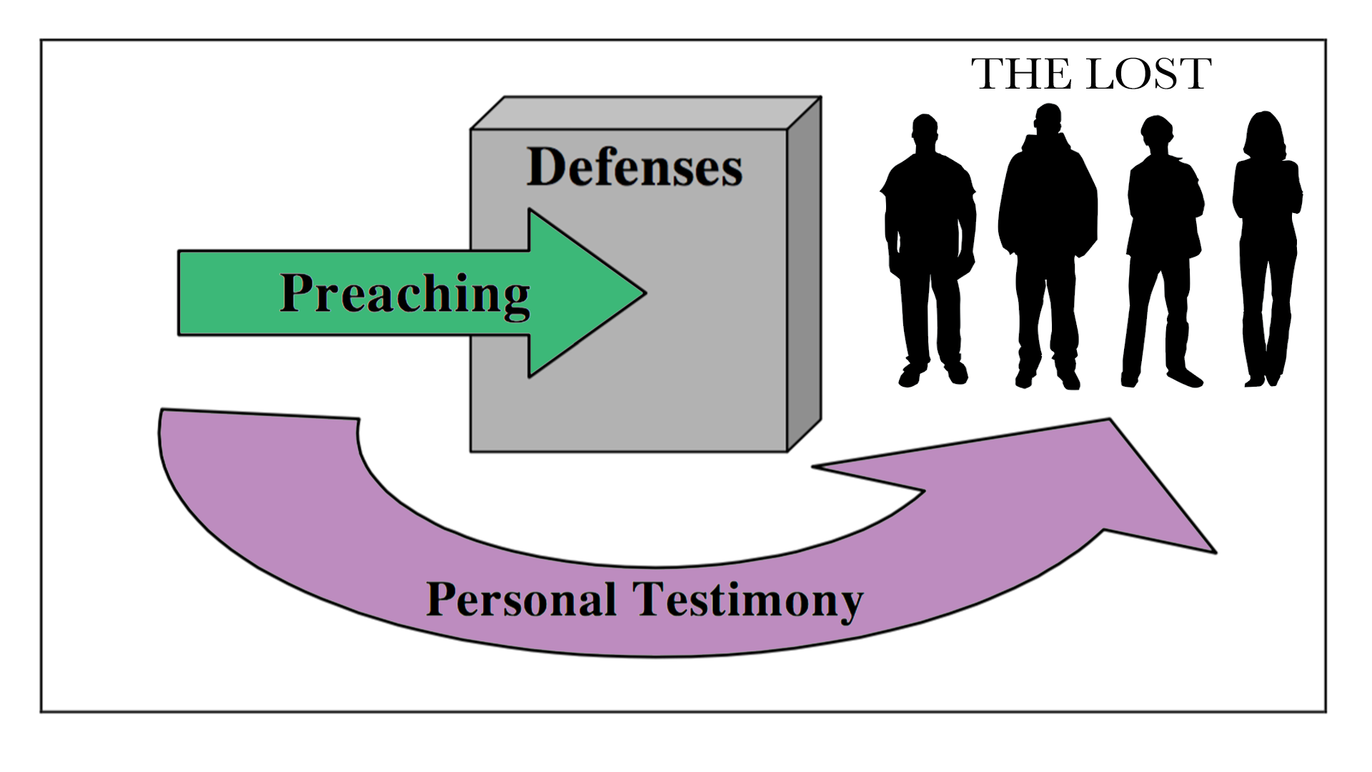
Whether they admit it or not, they want you to give them a good reason to believe. Your testimony, shared honestly, briefly and creatively, can be used by the Spirit to open up their eyes and minds to see spiritual truth in a fresh way.

Overcoming Satan in spiritual warfare
When we are sharing our faith with others, we are engaged alongside God in spiritual warfare, assaulting the kingdom of the devil. In Revelation 12:10-12, we read the following:

“... Now have come the salvation and the power and the kingdom of our God, and the authority of His Christ. For the accuser of our brothers, who accuses them before our God day and night, has been hurled down. They overcame him by the blood of the Lamb and by the word of their testimony; they did not love their lives so much as to shrink from death. Therefore rejoice, you heavens and you who dwell in them!”

Note the means by which the accuser of our brethren, Satan, was overcome ... “the blood of the Lamb” and “the word of their testimony.”
The finished work of Christ and our relationship to Christ are two things God uses to defeat the evil one. Your testimony of faith in Christ and faithfulness to Christ is an important tool God uses to build his church.
Even if we have to experience hardship, suffering or ultimately death for our faith, we win and Satan loses! So tell people what God has done in your life!

EXAMPLES OF TESTIMONIES
Scripture is filled with accounts of people giving their personal testimony. Read the following as examples of personal testimonies and see what you can learn from them.

The woman at the well (Jn 4:28-29)

So the woman left her water jar and went away into town and said to the people, “Come, see a man who told me all that I ever did. Can this be the Christ?”

Questions:
- What did she say?
- To whom did she witness?
- Why did she choose this particular form of testimony?

The man born blind (Jn 9:13-34)

They brought to the Pharisees the man who had formerly been blind. Now it was a Sabbath day when Jesus made the mud and opened his eyes. So the Pharisees again asked him how he had received his sight. And he said to them, “He put mud on my eyes, and I washed, and I see.” Some of the Pharisees said, “This man is not from God, for he does not keep the Sabbath.”
But others said, “How can a man who is a sinner do such signs?” And there was a division among them. So they said again to the blind man, “What do you say about him, since he has opened your eyes?” He said, “He is a prophet.”
The Jews did not believe that he had been blind and had received his sight, until they called the parents of the man who had received his sight and asked them, “Is this your son, who you say was born blind? How then does he now see?”
His parents answered, “We know that this is our son and that he was born blind. But how he now sees we do not know, nor do we know who opened his eyes. Ask him; he is of age. He will speak for himself.” (His parents said these things because they feared the Jews, for the Jews had already agreed that if anyone should confess Jesus[a] to be Christ, he was to be put out of the synagogue.) Therefore his parents said, “He is of age; ask him.”
So for the second time they called the man who had been blind and said to him, “Give glory to God. We know that this man is a sinner.” He answered, “Whether he is a sinner I do not know. One thing I do know, that though I was blind, now I see.” They said to him, “What did he do to you? How did he open your eyes?”
He answered them, “I have told you already, and you would not listen. Why do you want to hear it again? Do you also want to become his disciples?” And they reviled him, saying, “You are his disciple, but we are disciples of Moses. We know that God has spoken to Moses, but as for this man, we do not know where he comes from.” The man answered, “Why, this is an amazing thing! You do not know where he comes from, and yet he opened my eyes. We know that God does not listen to sinners, but if anyone is a worshipper of God and does his will, God listens to him. Never since the world began has it been heard that anyone opened the eyes of a man born blind. If this man were not from God, he could do nothing.” They answered him, “You were born in utter sin, and would you teach us?” And they cast him out.

Questions:
- To whom did he witness?
- What did he say?
- What was the occasion for the testimony?
- How was the testimony received?
- How did he deal with opposition?

Paul’s conversion (Ac 9, 22, and 26)
In these passages, note how Paul emphasises different aspects of the same experience to impact different audiences.

- Chapter 9 is Luke’s account of Saul’s conversion.
- Chapter 22 is Luke’s record of Paul’s interrupted testimony before the Jerusalem Jews.
- Chapter 26:2-23 is Luke’s record of Paul’s testimony before King Agrippa.

Paul’s testimony about events in Jerusalem (Ac 24:10-21)

And when the governor had nodded to him to speak, Paul replied:
“Knowing that for many years you have been a judge over this nation, I cheerfully make my defence. You can verify that it is not more than twelve days since I went up to worship in Jerusalem, and they did not find me disputing with anyone or stirring up a crowd, either in the temple or in the synagogues or in the city.
Neither can they prove to you what they now bring up against me. But this I confess to you, that according to the Way, which they call a sect, I worship the God of our fathers, believing everything laid down by the Law and written in the Prophets, having a hope in God, which these men themselves accept, that there will be a resurrection of both the just and the unjust.
So I always take pains to have a clear conscience towards both God and man. Now after several years I came to bring alms to my nation and to present offerings.
While I was doing this, they found me purified in the temple, without any crowd or tumult. But some Jews from Asia— they ought to be here before you and to make an accusation, should they have anything against me.
Or else let these men themselves say what wrongdoing they found when I stood before the council, other than this one thing that I cried out while standing among them: ‘It is with respect to the resurrection of the dead that I am on trial before you this day.’”

THE PREPARATION OF A TESTIMONY
Please take the remainder of this session to prepare a 3-5 minute version of your personal testimony.
Ask God to help you recall your conversion clearly. Make some notes about key ideas or verses you want to be sure to include. It is best if you can isolate one particular thing that moved you to faith in Christ—something that others, non-Christians, could relate to.
Always remember - you are not sharing your testimony just because it’s a good story or to tell people about yourself, but so they can see God and be moved to repentance themselves. It’s telling your story with an aim - therefore do all you can to persuade through your story.
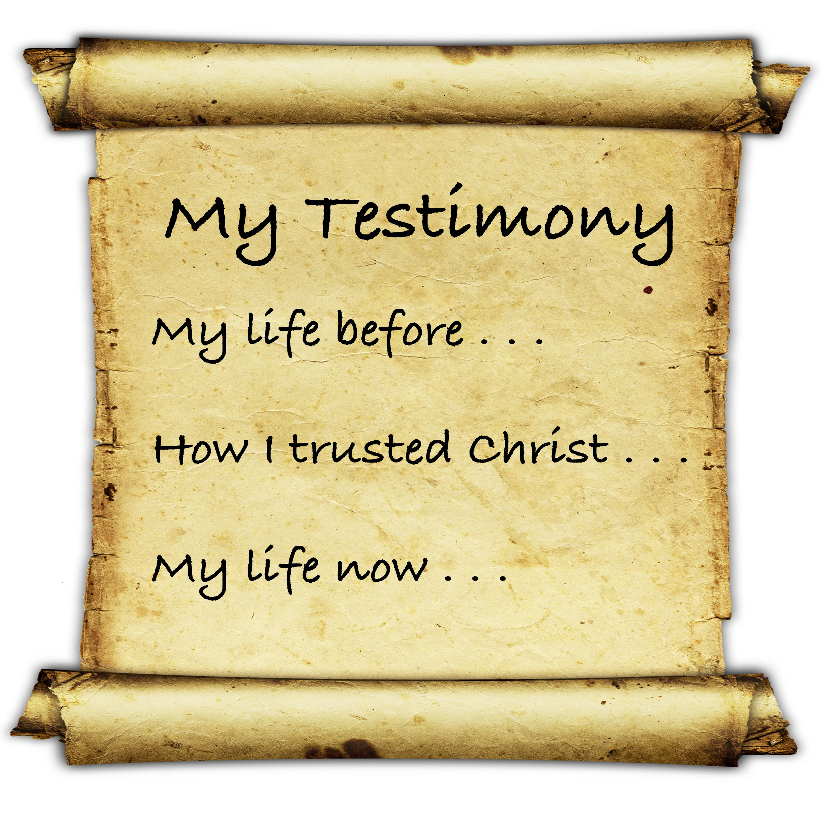
In your testimony, share in these three broad categories:

What was your life like before you met Christ?
This will point to areas of need that you believed Christ would meet in your life. It provides a sense of common ground between you and the person you want to win to faith. Why did you need Christ? Try to isolate the prominent issue that led to your repentance.

How did you come to Christ?
What actually happened? Where were you? When did you trust Christ? What did you do? What Scripture did the Holy Spirit use in your life? Did someone help you in this process? Make this as basic as possible; assume that the hearer is a God-seeker and your experience will be used as a plausible scenario that he could relate to.

How has knowing Christ changed your life?
What impact has your faith had on your life? In what practical ways was your life changed? Were there changes that surprised you? Were your expectations met? Do not only talk in the past tense—tell what the Gospel is doing in your life today. Do not necessarily avoid talking about difficulties—non-Christians need to know that Christians have problems because they, the non- Christians certainly have problems. Listeners need to know that Christ is a solid anchor in the storms and that the Christian life provides power for life.

THE SHARING OF A PERSONAL TESTIMONY
Now that you have prepared your personal testimony, take some time to share it with the others.
Before you share - give people a chance to work through their testimony. If you’d like to split this teaching into two parts - then this would be the stage to do that so people can think about it through the week.

Each group member needs a chance to share his or her testimony. Take five minutes to hear each testimony and no more than five minutes to give feedback. As testimonies are shared, use the following points to consider the effectiveness of each.

- Complete
Does the testimony tell the whole story? Does it include the three parts?
- Life before Christ: What can the non-Christian relate to?
- Circumstances at the point of conversion: How is it like the non-Christian’s situation?
- Life since finding Christ: How is your life different than the non-Christian?

- Clear
Will the testimony be easy for a non-believer to understand, or is it filled with religious language that might confuse non-believers? Does it sound like a sermon or is it a helpful recommendation to a friend?

- Gospel
Are all necessary points of the Gospel message touched upon in the testimony? While it is impossible to go into detail concerning all of this in a short testimony, all or some of the following points should be properly treated.

- The Bad News
- We are sinners, and the penalty is death
- God is holy, and we cannot please Him
- Jesus—the Son of God—died in our place

- The Good News
- We are saved by faith—not by our works
- We are born again into God’s family as His children
- We have the assurance of eternal life

- Concise
These testimonies should be not longer than five minutes. Is there any unnecessary detail in the testimony? We do not need to tell the whole story now—evangelism is a process.

QUESTIONS
- Where are some places and what are some of the times in your day or week during which you could share your testimony?
- What topics of general conversation might readily provide “openers” for the casual introduction of your testimony? Do you travel on public transportation?
- Do you take breaks or eat a meal at work? Ask the Lord to arrange “divine appointments” for you to be able to share your testimony.

ACTION PLAN
- Share your testimony with at least three other Christians who will see if you are clear in your presentation.
- Be prepared to share your testimony again during the next training session or during this seminar.
- Prayerfully make a plan that will result in sharing your testimony with two non-Christian friends or existing contacts within the next two weeks. Ask God to prepare “divine appointments” for you to share your testimony (perhaps without advance warning) within the next four weeks.

