Introduction to Evangelism
Part 2 - The urgent need

Leaders Notes

Lesson Purpose
The purpose of this lesson is to introduce the need, motive and place of evangelism in the vision of New Life.

Main Points
- The Need for people to be reached
- The Motives we must have
- The balance in a church’s life

Desired Outcomes
When the content of this lesson has been mastered, each participant should :
- Recognise the urgent need of the lost and be increasingly motivated out of unconditional love to evangelise them.

- THE NEED FOR EVANGELISM
- People Are Spiritually Lost and Forever Separated from God without Jesus Christ
Not only is every person separated from God spiritually, but also each person is absolutely unable to redeem himself.
Because of sin the Holy God is inaccessible to him. Whether an individual is aware of his condition or not he is desperate and doomed apart from receiving the solution offered by Jesus Christ, and no one else.
This illustration, called “The Bridge” is a simple way to explain how Christ bridges the gap between God and us.

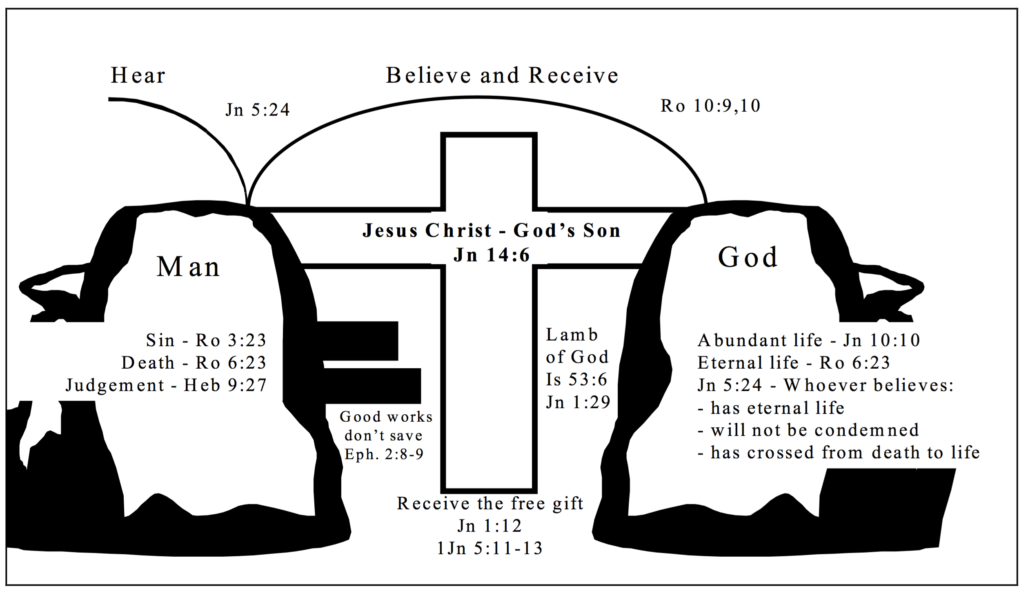
The Bridge
The Bridge diagram can be an effective evangelism method. You might find it helpful to gradually make a rough sketch of this on a blank sheet of paper while you share the Good News (with related Bible verses) with unsaved friends. A verbal and written presentation is often more powerful than using either medium alone.

There are many verses that explain this need that all mankind has:

Read through these verses as a group:
- Romans 1:18ff
- Romans 3:9-20,23
- John 14:6
- Ezekiel 3:16-21
- Romans 6:23
- Ephesians 2:1-3

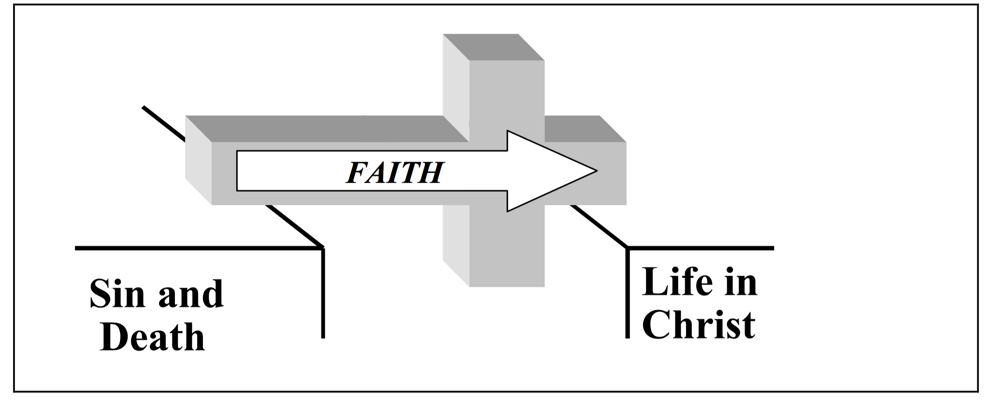
Here’s a diagram to give us a picture of how evangelism works. Through faith (which comes by hearing - we move because of the cross from Sin and Death to a New Life in Christ.
- We Are God’s Method of Reaching the World
Since the time of Christ, followers have been charged with the responsibility to represent the Lord and His kingdom in the world.
The apostles were the first to receive the charge. They understood that they were to be witnesses—that they were to be spokesmen and ambassadors of Christ.
These roles imply a faithful presentation of the truth as we understand it and a faithful representation of the God who has won us and sent us out.
Paul understood this responsibility as a debt or obligation that he owed to the Lord and to the lost. While it is true that a person may be saved through the Word of God and the Holy Spirit only - without anyone sharing, this is highly unusual.
That means it CAN happen - but generally it does not.
In fact, even when Christ Himself spoke to Paul on the Damascus road, He sent Ananias to complete the evangelism process in Paul’s life. Paul met Christ! He experienced a miracle, but God knew he still needed someone to come along side him and help him through those early stages of faith.
God desires to use men and women who know Him as the means to reach the lost. It’s the way God has always done it and the way He will continue to do it.

Read these verses:
- 2 Corinthians 5:16-2
- Matthew28:18-20
- Acts 1:8
- Romans1:14-17
- Mark 16:15
- 2Timothy4:5b

- Many are Eager to Hear and Understand the Solution to Their Dilemma
French Philosopher Blaise Pascal noted that there is within man a God-shaped vacuum, which only God can adequately fill.
Through the ages, people have sought resolution for their spiritual dilemma - they gone searching for the truth.
The list below is just a sample of the many in the New Testament who would openly discuss their condition in the hope of resolving their problems. There are others like them who will listen to the Gospel if we will go to them and make it plain.
- Nicodemus—John 3
- The woman at the well—John 4
- Zacchaeus—Luke 19
- The man born blind—John 9
- Jerusalem crowd—Acts 2
- Ethiopian eunuch—Acts 8
- The Gospel Has The Power to Change

The Gospel changes spiritual realities.
The Gospel moves people from the kingdom of Satan into the kingdom of God, from darkness to light, from death to life. No longer enemies of Christ and slaves to sin, we (and those who come to faith through our testimony) have become a part of the household of God (Col 1:10- 14). It’s the greatest miracle that can every take place in a life.

The Gospel changes the whole world.
The Gospel is changing lives—in huge cosmopolitan areas, in obscure mountain villages, in steaming tropical jungles, among troubled youth, within struggling families, among hard- working businessmen and concerned political leaders.
Throughout every continent, the Gospel is having an impact. Families, communities and nations around the world are being changed by the Gospel of Jesus Christ. The gospel is not for one region or race - but the entire earth.

The Gospel changes society.
As people come to Christ and yield themselves to the indwelling Holy Spirit, the community of those who love Christ can exert a moral influence for good felt across the face of your nation.

The Gospel changes individuals.
All who have placed their faith in Christ upon hearing the Gospel message have a testimony of how God’s grace has profoundly changed them personally, making each one a new creation in Christ. Individuals and families are profoundly affected.

The Gospel changes life now.
Christ’s life-giving Gospel has delivered us. We have been saved from the penalty of sin! Moreover, we will be saved from the presence of sin.
However, right now we are being saved from the power of sin. The Gospel makes a difference today (1Co 15:55-56; Ro 5:8-10).

The Gospel changes our future.
Through those who come to faith because of the work of the Gospel in us, we can affect not only our generation but succeeding ones as well.
We can become the foundation of spiritual generations in and outside our own families.

The Gospel changes our eternity.
The change brought by the Gospel affects not only our temporal life, but our eternal destiny as well. We, as Christ’s bride, the Church, are an eternal testimony to the spiritual realm of God’s mercy and grace (Eph 3:10, 11).

- THE MOTIVE OF EVANGELISM

It Is Possible to Evangelise Out of a Sense of Duty or Obligation to God or Others
Paul wrote in Romans 1:14 that he was a debtor to those who had not heard the Gospel message.
He sensed an obligation to share that which he possessed, the Gospel, with others.
Men of God have often referred to themselves as His servants, implying that their activity was at least partially motivated in response to the authority of God, their master.
In Colossians 1:28, the apostle Paul speaks of the goal of his Gospel ministry, “ . . . so that we may present everyone perfect in Christ." Often that which motivates God’s servants to evangelism is the long-range goal of seeing God’s purposes in the world accomplished. That hope and satisfaction itself can powerfully stir us as we serve the Gospel.

It Is Possible to Evangelise Out of Fear of God and His Judgment
Perhaps from time to time the feelings of love for God and man are not there, and a sense of duty does not motivate us.
Sometimes the fact that we are accountable to God and will one day answer to Him for our service stirs feelings of fear in us. Even that fear can motivate us to service.
God warned Ezekiel in strong language to take His message to the people or bear the consequences (Eze 3:16-21). Jonah evangelised only after being terrorised by a whale (Jnh 2).

It Is Even Possible to Evangelise for Totally Inappropriate Reasons
In one of Paul’s letters to a young church, he noted that some had proclaimed the Gospel “out of envy and rivalry” (Php 1:15).
He went on to say that it did not matter! That the Gospel of Christ was being proclaimed is what was important to Paul. He rejoiced that the right thing was happening in spite of wrong motives! (Php 1:15-18)
Get your heads around that one!

- We Should Evangelise Out of Love for Christ and The Lost
Those 3 are are possible. None of them are ideal, or where we should end up.
The maturing believer increasingly finds himself growing in his love for Christ and, in turn, for those whom Christ loves—the Church and the lost.
Paul spoke of Christ’s love “compelling” him to persuade men (2Co 5:14).
It seems from reading 1 John that what motivated and stirred the apostle John to proclaim the Gospel was a desire to include increasing numbers of people in the fellowship of the Church.
Some of those others might get you started - but maturity really involves doing it for this reason.

- THE PLACE OF EVANGELISM IN THE VISION
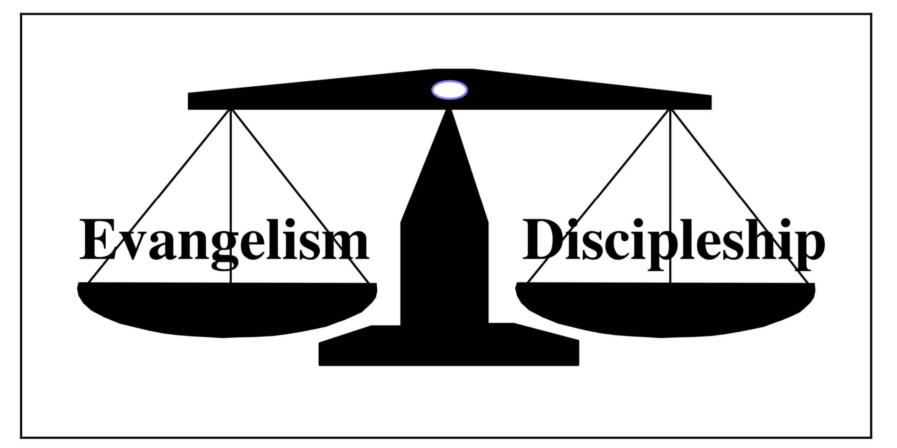
The vision of New Life is largely dependent upon focused evangelistic effort. The initial and foundational work of evangelism—winning people to faith in Christ—must be succeeded by the ongoing work of nurturing and equipping new converts and disciples.
But in that subsequent work, we dare not neglect the critical place of intentional, continuing evangelistic work, building bridges to the lost and moving them toward faith. There is a balance that must be maintained between telling the Good News and assisting those who have come to faith. To neglect either jeopardises the work of God in which we are involved.
We certainly need to help those whom God has given us to disciple, but we must never be satisfied with the number of those who have come to faith. We must not forget the task of evangelism. We must be committed to and diligent in our responsibility to reach the lost with the Gospel.
Without people continually being won to faith, there is no further establishing, no further developing of leaders, and no hope for on-going multiplication of churches.
It’s not either or - it’s both and.

QUESTIONS
- What most motivates you to share the Gospel?
- Can you think of ten people in your web of relationships who need a personal relationship with Christ?
- What plans do you have for increasing your evangelistic efforts?

